Chemical Wonders Worksheet

Please describe each of the following materials
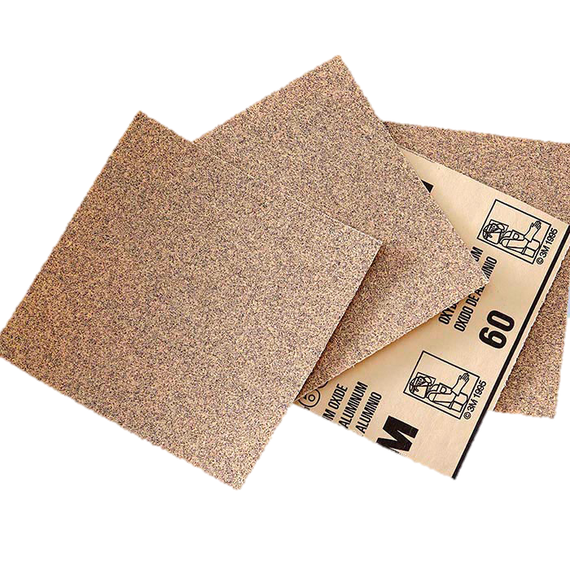
Sandpaper
TeachEngineering.org – Free STEM Curriculum for K-12
Size: _____________________________________ (ex. small, medium, big)
Color: _____________________________________ (ex. red, yellow, blue)
Texture: _____________________________________ (ex. smooth, rough)
State: _____________________________________ (ex. solid, liquid, gas)
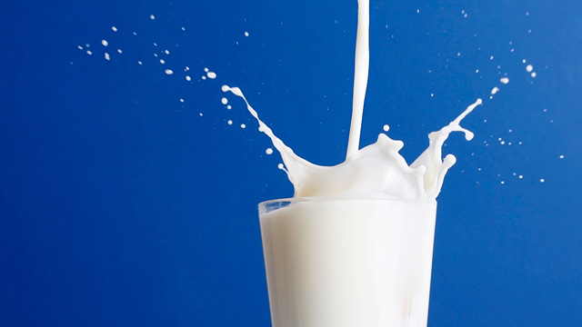
Milk
Size: _____________________________________ (ex. small, medium, big)
Color: _____________________________________ (ex. red, yellow, blue)
Texture: _____________________________________ (ex. smooth, rough)
State: _____________________________________ (ex. solid, liquid, gas)
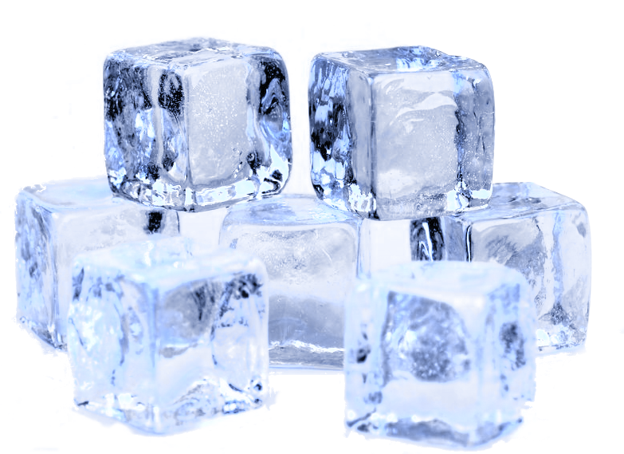
Ice
Size: _____________________________________ (ex. small, medium, big)
Color: _____________________________________ (ex. red, yellow, blue)
Texture: _____________________________________ (ex. smooth, rough)
State: _____________________________________ (ex. solid, liquid, gas)

