Photovoltaic Efficiency: Solar Angles & Tracking Systems
Fundamentals Article
The angle between a photovoltaic (PV) panel and the sun affects the efficiency of the panel. That is why many solar angles are used in PV power calculations, and solar tracking systems improve the efficiency of PV panels by following the sun through the sky.

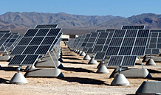
Real-World Applications
With PV solar power becoming popular in many different applications, more engineers are needed who understand how to maximize a PV panel’s power output so they can design PV arrays that create as much clean energy as possible from this technology. This energy can replace energy from non-renewable sources that pollute the environment. The optimal design of a PV array depends on the location and position of the panels, so engineers must understand the basics of solar angles to design the most-efficient systems.
TeachEngineering.org – Free STEM Curriculum for K-12
Figure 1. The solar power array at
Nellis Air Force Base in Nevada.
Introduction
From our perspective on Earth, the sun is always changing its position in the sky. It is pretty obvious that every day the sun moves from the east to the west between sunrise and sunset, but did you know that it also moves from north to south throughout the course of the year? If you were to measure the position of the sun every day at solar noon it would be at a different angle every day. The exact location of the sun in the sky depends on where you live, the day of the year, and, of course, the time of day. This effects the design decisions engineers make when they are installing photovoltaic (PV) panels.
It is important for engineers to know where the sun will be throughout the year so they can install PV panels at the ideal angle to absorb the maximum amount of sunlight during the course of a year. To improve PV panel efficiency, engineers also design creative ways so more sunlight hits the surface of the panel. Can you think of ways to improve PV panel efficiency that relates to the angle of the sun?

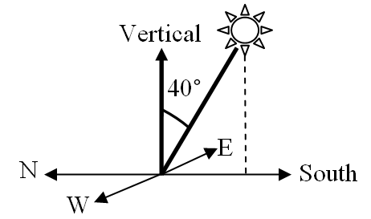
Using Solar Angles to Predict the Sun’s Location
On one day every year, called the equinox, the sun is positioned directly above our planet’s equator. On this day, the angle between a line that points to the sun and a line that points straight up (vertical) exactly matches the latitude of the place you are standing. If you live on the equator, then in the very middle of the day (solar noon) the sun will be directly above you, or at 0º from the vertical. If you live in Boulder, CO, which is in the northern hemisphere at the latitude of 40º, then on the equinox the sun will be 40º to the south from the vertical (see Figure 2). The sun’s position on the equinox is the average location of the sun throughout the year and is a great reference to use when designing a solar system for a specific location.
Figure 2. The angle of the position of the sun in Boulder, CO, on the equinox.
The latitude in Boulder is 40°.
But keep in mind, the sun is always moving. In the summer, the sun appears higher in the sky, which increases the duration of sunlight seen in a day, and in the winter it appears lower, which decreases the length of sunlight in a day. The sun is highest in the sky on the summer solstice. To be more exact, it is 23.45º higher than on the equinox, or at 40 - 23.45 = 16.55º to the south of vertical.
The winter solstice is the day when the sun appears lowest in the sky. On this day, the sun is 23.45º lower than on the equinox, or at 40 + 23.45 = 63.45º to the south of vertical in Boulder. So, if you live in the northern hemisphere at latitude higher than 23.45º, then the sun will never shine from the north. This means the north side of your house would be a bad place for a solar panel (or a garden).

Summary of Solar Angles
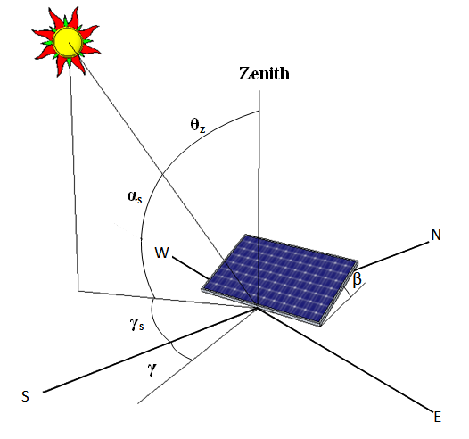
Below is an overview of the angles involved in calculating the amount of solar radiation that a PV panel receives at any given time (also see Figure 3). The angle at which the sun hits a PV panel is the basis for understanding how to design the most efficient PV array for a specific location. This is one of the first topics presented in solar engineering textbooks.

Figure 3. Solar angles used in power calculations for PV panels.

Zenith Angle, θ_{z}: This is the angle between the line that points to the sun and the vertical — basically, this is just where the sun is in the sky. At sunrise and sunset this angle is 90º.
Solar Altitude Angle, α_{s}: This is the angle between the line that points to the sun and the horizontal. It is the complement of the zenith angle. At sunrise and sunset this angle is 0º.
Solar Azimuth Angle, γ_{s}: This is the angle between the line that points to the sun and south. Angles to the east are negative. Angles to the west are positive. This angle is 0º at solar noon. It is probably close to -90º at sunrise and 90º at sunset, depending on the season. This angle is only measured in the horizontal plane; in other words, it neglects the height of the sun.
Angle of Incidence, θ: This is the angle between the line that points to the sun and the angle that points straight out of a PV panel (also called the line that is normal to the surface of the panel). This is the most important angle. Solar panels are most efficient when pointing at the sun, so engineers want to minimize this angle at all times. To know this angle, you must know all of the angles listed and described next.
Hour Angle, ω: This is based on the sun’s angular displacement, east or west, of the local meridian (the line the local time zone is based on). The earth rotates 15º per hour so at 11am the hour angle is -15º and at 1pm it is 15º.
Surface Azimuth Angle, γ: This is the angle between the line that points straight out of a PV panel and south. It is only measured in the horizontal plane. Again, east is negative and west is positive. If a panel pointed directly south, this angle would be 0º.
Collector Slope, β: This is the angle between the plane of the solar collector and the horizontal. If a panel is lying flat, then it is 0º. As you tip it up, this angle increases. It does not matter which direction the panel faces.
Declination, δ: This is the angle between the line that points to the sun from the equator and the line that points straight out from the equator (at solar noon). North is positive and south is negative. This angle varies from 23.45 to -23.45 throughout the year, which is related to why we have seasons.
Latitude, φ: This is the angle between a line that points from the center of the Earth to a location on the Earth’s surface and a line that points from the center of the Earth to the equator. This can be easily found on a map.

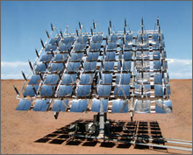
Solar Tracking Systems
Now let’s talk about how to apply all of this information. Figure 1 shows a small portion of North America’s largest solar PV power plant (as of 2010). The 14-megawatt power plant is located at Nellis Air Force Base in Nevada and is expected to provide more than 30 million kilowatt-hours of electricity each year. A typical compact fluorescent lamp (CFL) uses 15 watts, so when the sun is shining, this plant could power almost a million CFLs. At this site, 72,000 PV panels are placed across 140 acres of land. This power plant has more than just PV panels. Look at Figure 1 to see if you notice anything else that might affect the efficiency of the panels.
Figure 4. One of the most efficient PV panels in the world — this dual-axis PV tracking system uses small mirrors to focus sunlight on high-efficient cells. It supplies electricity to the Arizona Public Service grid.
It might not be obvious at first, but look closely at the bases supporting the panels. They are designed to move! SunPower Corporation, a German company that specializes in PV power systems, designed this PV power plant with an east-west single-axis tracking system. That means that the panels rotate from east to west throughout the day to follow the sun and optimize panel efficiency. Because of this tracking system, these panels produce 30% more power than they would if they were fixed facing south.
Further panel efficiency can be obtained by tracking the sun not only along a single axis, but on two perpendicular axes. Figure 4 shows one of the most efficient PV panels in the world (more than 40% conversion efficiency) created by Spectrolab. These PV panels are extremely expensive so this module uses very small panels and less expensive mirrors to reflect sunlight from a larger area onto the small PV panel. For this high-tech system, it is important to track the sun’s location exactly throughout the day to provide the maximum amount of sunlight for the module at all times. To do that, this module has a double-axis tracking system that moves from east to west and an adjustable collector slope, β, to follow the height of the sun in the sky throughout the year.

Summary
The energy output of a PV panel changes based on the angle between the panel and the sun. The angle at which the sun hits a PV panel determines its efficiency and is what engineers use in the design of an efficient PV array for a specific location.
Solar tracking systems designed by engineers help optimize the amount of sunlight that hits a PV panel over time (day, month, year). One example is the SunPower PV power plant with an east-west single-axis tracking system that has panels that rotate from east to west throughout the day to follow the sun and optimize panel efficiency — producing 30% more power than they would if they were fixed facing south. Whether a panel is fixed in one direction or integrated with a single- or double-axis tracking system, it is important to know the location of the sun throughout the year and the effect that the angle of sunlight hitting the panel has on its overall efficiency.

Vocabulary / Definitions
current | The flow of electricity (electrons) through a wire.
efficiency | The ratio of the useful energy delivered by a dynamic system to the energy supplied to it.
equinox | The days when the sun is directly above the equator. This happens twice a year.
latitude | The angle above or below the equator. The north pole is at 90º N and the south pole is at 90º S.
local meridian | The closest longitude of 15º increments. If you live in Boulder, CO, at a longitude of 105.25º W, then your local meridian is 105º W (this is the closest number divisible by 15º).
longitude | The angle of your location on the earth measured around the equator, west from the prime meridian (0º).
photovoltaic cell | A device that converts the energy of light into electric energy. Also called a PV cell or a solar cell (when the sun is the light source). Cells may be combined in a panel, or array of panels to generate more energy as part of a PV system.
solar noon | The time of day when the sun is highest in the sky. This is not always the same as 12 o’clock, because of daylight savings time and time zones. If the sunrise was exactly at 8am and sun set exactly at 8pm, then solar noon would be the same as 12 noon.
voltage | Electric potential. A difference in charge between two points in a circuit.

