Photovoltaic Efficiency: Maximum Power Point
Fundamentals Article
This article presents the concept of electricity through Ohm’s law and the power equation, and how it applies to solar photovoltaic (PV) panels. You’ll learn how to find the maximum power point (MPP) of a PV panel in order to optimize its efficiency at creating solar power.
Real-World Applications
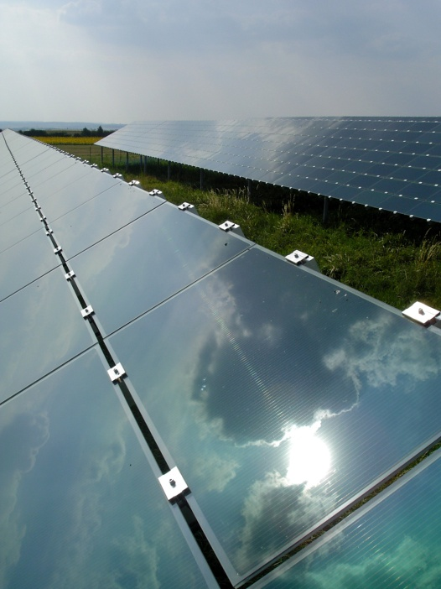
PV panels are becoming an increasingly common way to generate power around the world for many different power applications. This technology is still expensive when compared to other sources of power so it is important to optimize the efficiency of PV panels. This can be a challenge because as weather conditions change (even cloud cover, see Figure 1), the voltage and current in the circuit changes. Engineers have designed inverters to vary the resistance and continuously find new maximum power point (MPP) in a circuit; this is called maximum power point tracking (MPPT). An inverter can be hooked up to one or many PV panels at a time. It is up to engineers to decide the right balance of cost and efficiency when including inverters in their designs. By understanding the factors that affect electrical circuits and knowing how to control the elements in circuits, engineers are able to design solar power systems that operate as efficiently as possible in different environments with changing weather conditions.
TeachEngineering.org – Free STEM Curriculum for K-12
Figure 1. Cloud shadow dilemma.
Introduction
Solar energy technology is an emerging energy field that provides opportunities for talented and bright engineers to make beneficial impacts on the environment while solving intriguing engineering challenges. However, before attempting to design solar energy power systems, engineers must understand fundamental electrical laws and equations and how they apply to solar energy applications.
Background & Concepts
$\begin{aligned}\text{Ohm's law }:V=I⋅R \\ \text{Power : P}=V⋅I \\ V=\text{Potential Difference }[\text{Volts, V}] \\ I=\text{Current }[\text{Ampere, A}] \\ R=\text{Resistance }[\text{Ohm, }Ω] \\ P=\text{Power }[\text{Watt, W}]\end{aligned}$Every device, if it uses some electrical power source, such as electricity from a wall outlet, batteries or solar panels, was designed by engineers based on two fundamental electrical equations, Ohm’s law and the electrical power equation, which are also necessary for calculating the maximum power point of PV panels.

When a PV panel receives solar radiation, it produces power, the product of current and voltage. To find the highest possible power output for a panel under a certain set of conditions (amount of sunlight, temperature, etc.), the resistance in the circuit can be changed systematically by small increments, as shown in Table 1.

Table 1: Collected voltage and current data from PV panel trials, and calculated power data.
Trial # | Collected Data |  | Calculated
Trial # | Voltage (V) | Current (A) | Power (W)
1 | 0.000 | 0.124 | 0.000
2 | 0.624 | 0.122 | 0.076
3 | 1.248 | 0.120 | 0.150
4 | 1.872 | 0.118 | 0.222
5 | 2.497 | 0.116 | 0.291
6 | 3.121 | 0.114 | 0.357
7 | 3.745 | 0.112 | 0.421
8 | 4.369 | 0.110 | 0.482
9 | 4.700 | 0.103 | 0.485
10 [MPP] | 4.934 | 0.100 | 0.491
11 | 5.165 | 0.091 | 0.472
12 | 5.336 | 0.085 | 0.455
13 | 5.566 | 0.078 | 0.432
14 | 5.927 | 0.057 | 0.337
15 | 6.070 | 0.045 | 0.270
16 | 6.113 | 0.037 | 0.225
17 | 6.137 | 0.034 | 0.209
18 | 6.210 | 0.025 | 0.156
19 | 6.294 | 0.020 | 0.123
20 | 6.373 | 0.004 | 0.027
21 | 6.389 | 0.002 | 0.013
22 | 6.407 | 0.000 | 0.000

The values in Table 1 were obtained by using a potentiometer to vary the resistance in the PV circuit, which directly affects the voltage and current in the circuit. A potentiometer is a small device that changes the resistance with the turn of a knob. The changing resistance affects the overall power output of the panel. In this example, the short circuit current, I_{sc} = 0.124 A (or current when V = 0), and open circuit voltage, V_{oc} = 6.407 V (or voltage when I = 0). The MPP can also be found as the point at which the product of the current and voltage equal the greatest value. The power calculation shows that the MPP has a voltage of V_{MPP} = 4.934, a current of I_{MPP} = 0.100 A, with the power, P = 0.491 W.

This data can be visualized more clearly in a graph. Graphing the current and voltage creates a curve that is referred to as an I-V curve. The blue line in the Figure 2 graph is an I-V curve. The current is plotted in amps (A) on the left y-axis. The voltage is plotted in volts (V) on the x-axis. On the same graph, the power for each current-voltage combination is plotted in pink. The power is plotted in watts (W) on the right y-axis. This power curve clearly shows the maximum power point. A red line identifies the voltage and current associated with the maximum power point.

Figure 1: Example I-V (or maximum power point) curve.
Vocabulary and Definitions
efficiency | The ratio of the useful energy delivered by a dynamic system to the energy supplied to it.
I-V curve | The curve produced when the value of a panel’s current is plotted with respect to different voltages, from 0 to V_{oc} (I = current, in amps; V = voltage, in volts)
maximum power point (MPP) | The point on a power (I-V) curve that has the highest value of the product of its corresponding voltage and current, or the highest power output.
maximum power point tracker (MPPT) | A device that continually finds the MPP of a solar panel or array.
open circuit voltage (V_{oc}) | Voltage available from a power source in an open circuit, I = 0.
photovoltaic cell | A cell of silicone that produces a current when exposed to light.
potentiometer | A device that allows the user to vary the electrical resistances in a circuit.
short circuit current (I_{sc}) | Current drawn from a power source if no load is present in the circuit, V = 0.

