Photovoltaic Efficiency: Concentrated Solar Power
Fundamentals Article
This article examines how the total solar irradiance hitting a photovoltaic (PV) panel can be increased through the use of a concentrating device, such as a reflector or lens. When you design and build your own solar reflector with cardboard and aluminum foil, you will test your reflector design to determine the optimum angle for increasing the power output of a small PV panel.
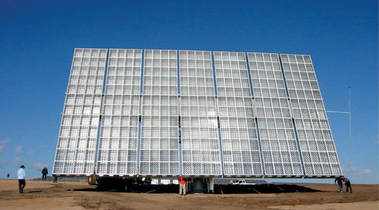
TeachEngineering.org – Free STEM Curriculum for K-12

Figure 1. An example concentrated photovoltaic (CPV) solar system that uses lenses to concentrate the sun onto solar cells behind it.

Real-World Applications
Engineers create concentrated photovoltaic (CPV) systems that use lenses or reflectors to concentrate light onto PV panels to increase the amount of power each individual panel can produce, and reduce the number of panels needed to produce a certain amount of power. Because solar panels are significantly more expensive than reflectors, this is a cost-effective way to generate clean, renewable energy with a smaller number of panels and a lower cost, which allows solar energy to be used in more applications. CPV systems produce clean, renewable energy that benefits our environment and health.

Introduction
We have learned about ways to increase the efficiency of photovoltaic panels. Factors that affect the efficiency of a PV panel include: 1. angle: a panel is the most efficient when it points directly at the sun; as it turns away, it is less efficient; 2. circuit resistance: a maximum power point exists for a specific condition [light level, temperature, orientation] of the panel; this can be found by changing the resistance in the circuit until the maximum power is achieved; 3. temperature: PV panels are more efficient when cold; they become less efficient as the heat up.
The angle, circuit resistance and temperature all affect the efficiency of PV panels. But one more important (and pretty obvious) factor exists — it is simply the amount of solar radiation that a panel receives! Even if you have just the right angle, resistance and temperature, if the panel is blocked by something, say the shade of a tree or a cloud, it will not be as efficient as it would be in direct sunlight. By using reflectors and concentrators, we can greatly increase the efficiency of a PV panel because they increase the amount of solar radiation that hits the panel, which makes it as if the panel is “seeing” multiple suns and thus increases the power output of the panel.
While the ground reflects some solar radiation back onto the panel, the amount of reflectance is small, especially as most panels are pointing towards the sky; reflection from the ground does not have a significant effect on the power output of a panel. But by placing a more reflective surface at a specific angle to the panel, or a lens over the panel, a significant amount of additional light can be directed onto the panel. Concentrated PV systems (or CPV systems) are beneficial because they can reduce the cost of generating a certain amount of power and can be built to any size needed.

Background & Concepts
All the different types of concentrated PV systems (or CPV systems) work by directing additional light onto PV panels to increase their power output. Irradiance is power per unit area of solar radiation on a surface (that is, W/m²). Engineers measure total irradiance on a PV panel as the sum of both direct and reflected irradiance over the surface of the panel.
Some CPV systems focus on concentrating solar irradiance equal to only “a few suns,” while others can concentrate irradiance equal to hundreds or even thousands of suns. With this high level of concentration, adequate cooling systems become important and complex tracking systems are required to optimize the system at all times, which adds to a system’s cost. Concentrating the sun onto a very efficient solar cell is a great way to maximize the efficiency of a solar power system.
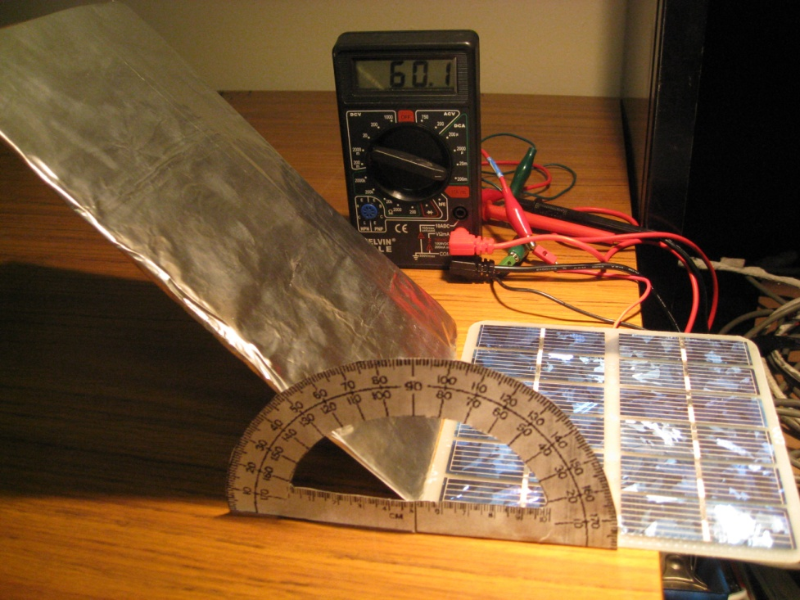
Figure 1 shows a CPV solar system that uses lenses to concentrate the sun onto solar cells behind it. Other systems use mirrors or curved metal reflectors to concentrate sunlight onto a panel. One of the most basic types of CPV systems involves a simple planar reflector placed next to the solar panel.
The Figure 2 shows a simple CPV system in which a planar reflector is placed next to a solar panel to reflect additional irradiance onto the surface of the solar panel. This is a simple construction using cardboard and foil that serves as an educational device to test different design aspects of a solar reflector.
Figure 2. A simple CPV system in which a nearby planar reflector reflects more light onto a solar panel.
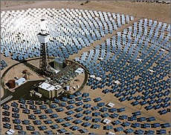
The size of the reflector in relation to the collector and the angle between the collector and reflector are important factors that affect the efficiency of the system. If the panel is pointing directly at the light source, then the best angle to place the reflector is not 45º, but somewhere between 60º and 80º, depending on the reflector size. The goal of any reflector is to bounce all the light from the sun unto the panel, so the best angle varies, depending on the relationship between the size of the reflector and panel and the angle of the sun. Most systems that use reflection or concentration also track the sun so that the angle of the sun can be controlled to optimize the amount of light reflecting onto the panel. Typically this requires an external system that moves the panels and concentrator, but engineers are constantly creating new inventions, such as a solar panel that has small lenses that move within the panel so no external system is needed.
Concentrated solar energy is becoming increasingly common for solar power plants. It is used to maximize the efficiency and minimize cost when using highly-efficient (and expensive) solar PV cells, yet it is also used in other types of solar power plants besides PV. Figure 3 shows a solar tower surrounded by thousands of heliostats (mirrors that track the sun). In this solar power plant, a liquid is sent though the top of the tower, heated by the concentrated sun rays, and used to boil water to run a steam-powered turbine.
Figure 3. Example solar tower power plant that uses mirrors to concentrate solar power, in Daggett, CA.

Summary
Many engineers are working to improve the efficiency of solar power by using concentrated photovoltaic systems. These systems use lenses or reflectors to concentrate light onto PV panels to accomplish two key benefits: 1. to increase the amount of power each individual panel can produce and 2. to reduce the number of panels needed to produce a certain amount of power.
These concentrated PV systems are used to create large-scale solar power plants as well as small rooftop solar arrays. Because solar panels are significantly more expensive than reflectors, this is a cost-effective way to generate clean, renewable energy using a smaller number of panels, which enables solar energy to be more affordable so it can be used in more applications.

Vocabulary and Definitions
concentrated photovoltaic (CPV) system | A system designed to concentrate sunlight onto a PV panel or series of panels in order to increase their power output
heliostat | A device that tracks the sun’s position in the sky.
irradiance | Power per unit area of solar energy hitting a surface
planar reflector | A reflective panel used to reflect sunlight in order to increase the power output of a photovoltaic panel.

