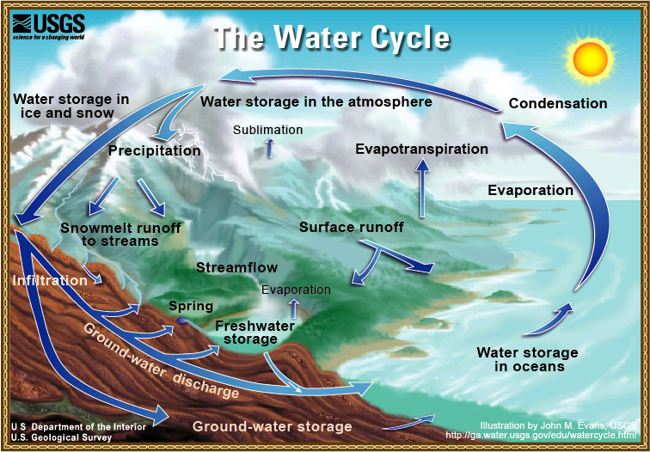
Source: U.S. Department of the Interior, U.S. Geological Survey, http://ga.water.usgs.gov/edu/watercyclehi.html
TeachEngineering.org – Free STEM Curriculum for K-12

