The Rock Cycle

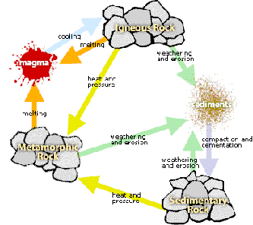
TeachEngineering.org – Free STEM Curriculum for K-12
Source: US Department of Agriculture, http://www.nj.nrcs.usda.gov/partnerships/envirothon/soils/images/rockcycle.gif
Igneous Rock
Metamorphic Rock
Sedimentary Rock
sediments
magma
heat & pressure
heat & pressure
weathering
& erosion
weathering
& erosion
weathering
& erosion
cooling
melting
melting
compaction & cementation

