Tectonic Plate Convergence

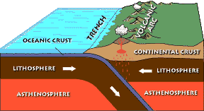

TeachEngineering.org – Free STEM Curriculum for K-12

Oceanic vs. Continental Plate Convergence

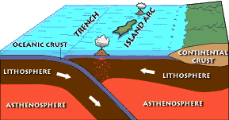

Oceanic vs. Oceanic Plate Convergence
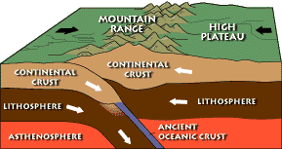

Continental vs. Continental Plate Convergence
Source: US Geological Survey, US Department of the Interior http://wrgis.wr.usgs.gov/parks/pltec/converge.html

