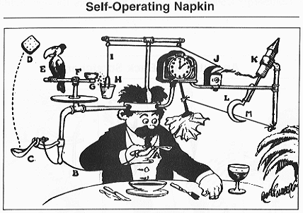
TeachEngineering.org – Free STEM Curriculum for K-12
A man, raises a spoon to his mouth (A), which pulls a string (B), thereby jerking a ladle (C) which throws a cracker (D) past a parrot. The parrot then jumps after the cracker, causing the perch (E) to tilt (F), upsetting seeds (G), which drop into a pail (H). The extra weight in the pail pulls a cord (I), which opens and lights an automatic cigar lighter (J), setting off a sky-rocket (K) which causes a sickle to cut a string (L), allowing a pendulum (M) with an attached napkin to swing back and forth thereby wiping off the man’s chin. (Text adapted from Argonne National Laboratory.) Rube Goldberg™ & © of Rube Goldberg, Inc. Argonne National Laboratory, http://www.anl.gov/Careers/Education/rube/rubenapkin.html

