**Rocket Worksheet**

Using words from the word bank (below), draw arrows and identify as many engineered components as possible as you can find in the rockets, space shuttles, satellite and spacecraft below





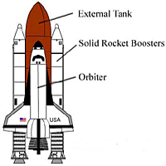





|  |
| --- |
| **Word Bank** |
| Wing, window, thruster, space shuttle rocket, solid rocket booster, solar panel, scientific instrument, satellite, rocket, parachute, orbiter, nozzle, nose cone, heat shielding, fin, external fuel tank, exhaust, capsule, antenna. |