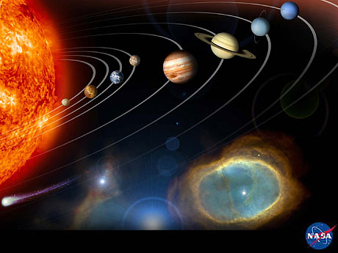

Source: NASA, http://photojournal.jpl.nasa.gov/index.html
TeachEngineering.org – Free STEM Curriculum for K-12
Sun > Mercury > Venus > Earth > Mars > Jupiter > Saturn > Uranus > Neptune

