Solar Power Energy Estimation Worksheet Answers
The following answers are determined using Boulder, CO in May as an example. This worksheet will help you evaluate the solar energy available at any location in the United States at a given time of year.
- Find the solar resource map that corresponds to your month in the Solar Radiation Maps Handout. For example, if it is May you will be using the “May” map to figure out the solar energy available. The May map would look like the following one. The green dot is Boulder, CO.
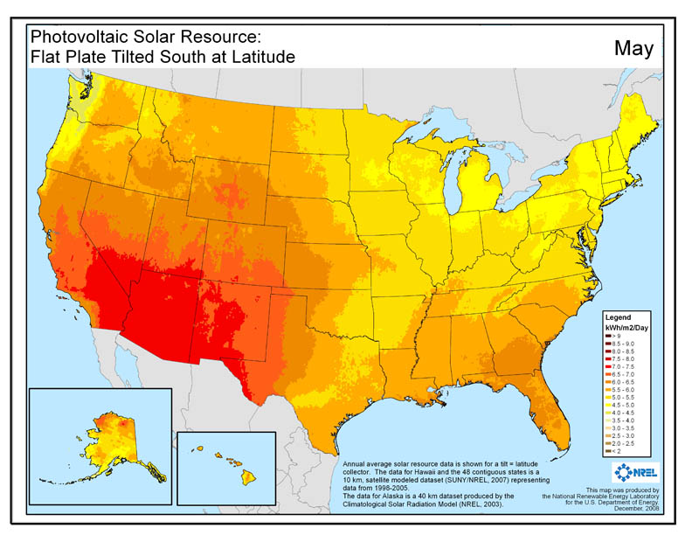

- On the map find your location and determine what color your area corresponds to. Use the Legend to find out the energy range in “kWh/m²/Day”. Once you have the range, you will average the highest and lowest values on the range to get your energy estimate. For example, in Boulder, CO the range for May is 6.5 – 7.0 kWh/m²/Day, the average value is 6.75 kWh/m2/Day.

Energy range for your location:________6.5 – 7.0_____ kWh/m²/Day

Average energy:_________6.75________ kWh/m²/Day

- Next, find the amount of solar energy available per unit area of your solar module (for example, a solar water heater), which depends on the time you expose your module to the sun. If you want to test your solar water heater for 1 hour, your duration of sun exposure is ‘1 hour’ (this can be less than one if you test for less than an hour → 45 minutes = 0.75 hours). If you do not already have these values for a solar module, just use the following example values.

Duration of sun exposure:____1 hour_______ hours (example: 1 hour)

Now you will need to find the energy in units of Watt-hours/m², referred to as ‘insolation’:

(kWh/m²/day) x (1 day/24 hours) x (duration of sun exposure [hours]) x (1000 Wh/1 kWh) =

(_6.75_ kWh/m²/day) x (1 day/24 hours) x (_1_ hours) x (1000 Wh/1 kWh) =

___281.25_____ Watt-hours/m²

- To find the solar energy used by your solar module you will also need its surface area (m²). Say you have a solar water heater that is 1 meter by 1.5 meters, the surface area would be 1.5 m² (you may need to convert feet to meters).

Solar module surface area:________1.5__________ m² (example: 1.5 m²)
Next, you need to use your surface area and insolation value to find out how much energy enters your solar module. This incoming energy is called heat energy (Q_{in}) and is in units of Watt-hours:

Q_{in} = [Insolation (Watt-hours/m²)] x [Surface Area (m²)]

Q_{in} = (___281.25____ Watt-hours/m²) x (____1.5____m²)

Q_{in} = ____421.86______ Watt-hours

- What would be the ‘tilt angle’ of your solar module? Why do you want your solar module to face south?

Entering the location of Boulder, Colorado into the NOAA Solar Calculator Web Page (or looking this up on an internet search engine) yields a Latitude of 40.1º , so the solar module should be facing south at a tilt angle of 40.1º from the horizon (the ground). If you are in the northern hemisphere, the solar modules (i.e. solar water heater or photovoltaic panels) should face true south because that is the direction that captures the most sun at any given time of year.

- How do you think the amount of solar energy available in Arizona for your same month would compare to the value for your location? (Hint: check out the maps, you don’t need to calculate anything) What about the solar energy available in Alaska? In which location (Arizona or Alaska) would it be easier for engineers to use the solar energy available for heating or electricity?

The amount of solar energy available in Arizona in May is much higher than in Boulder, Colorado (about 1 kWh/m²/Day). In Alaska, the solar energy available is much lower than Boulder, Colorado— in some places as little as 2 kWh/m²/Day! It would be much easier for engineers to use the solar energy available in Arizona for heating and electrical applications that it would be in Alaska. Engineers in Alaska might want to determine if solar energy is even a smart option for renewable energy.

