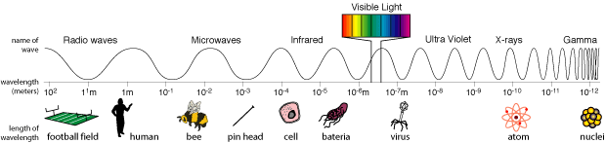
TeachEngineering.org – Free STEM Curriculum for K-12
TeachEngineering.org – Free STEM Curriculum for K-12

