Importance of Echolocation!
For the following animals, please write the name of the animal and how echolocation helps the animal survive, then answer the last two questions.
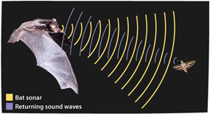
Animal:___________________
How does it help the animal?
_________________________________________________________________________________
TeachEngineering.org – Free STEM Curriculum for K-12
TeachEngineering.org – Free STEM Curriculum for K-12
___________________________

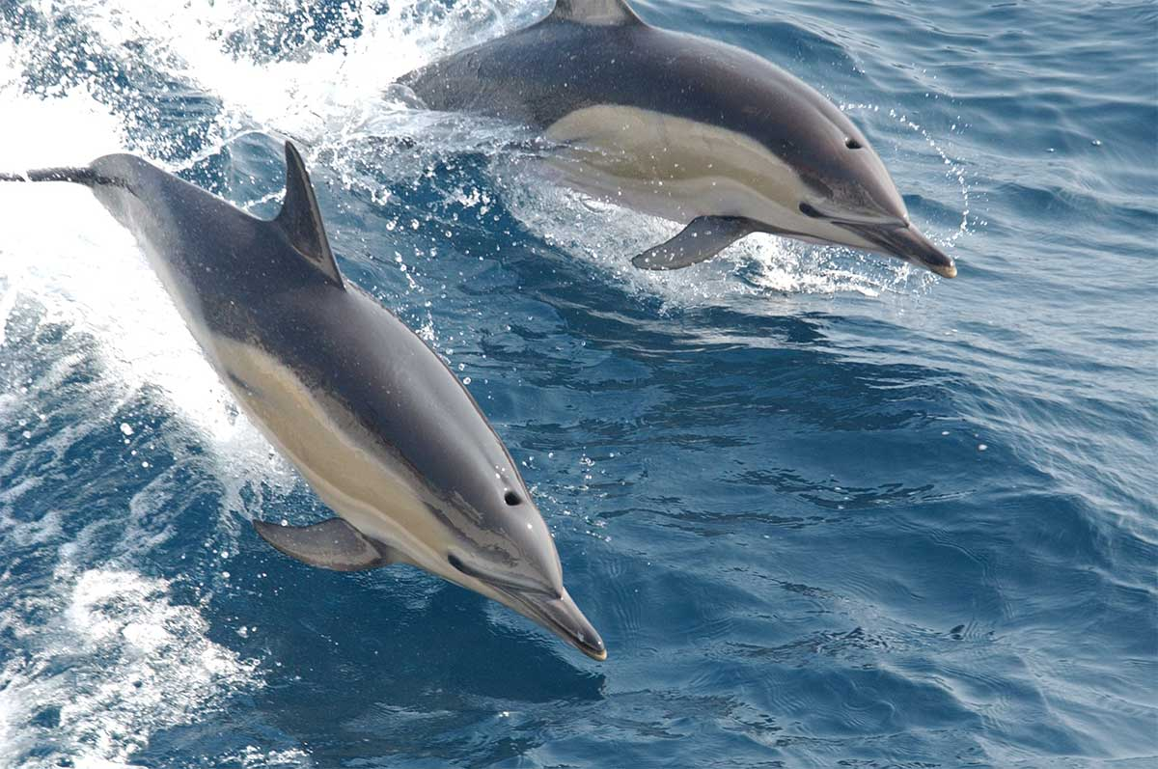
Animal:___________________
How does it help the animal?
____________________________________________________________________________________________________________

When an animal uses echolocation, it will send out a sound wave. When that wave runs into something, does it bounce off?
YES NO

Do the above animals sense the returning sound waves?
YES NO

Can this tell them where something is, and which way it is moving?
YES NO

