BioSand Filtration

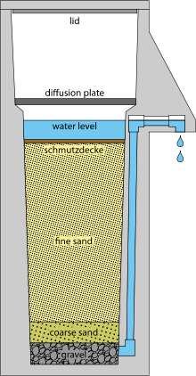
How Does It Work?
A biosand filter, or slow sand filter, relies on the physical and biological treatment of water. The sand itself acts as a physical filter. A layer of biofilm, called the schutzdecke, forms the first 1-3 cm of biosand filters and is the source of biological treatment. This biofilm is created from collected algae, bacteria, viruses, protozoa and small invertebrates that consume pathogens entering the system. The schmutzdecke must always be submersed in water to maintain the biological activity. For a household unit, which is typically intermittently used, the outlet pipe is raised to 1-8 cm above the sand to maintain the water level above the schmutzdecke in the filter.
TeachEngineering.org – Free STEM Curriculum for K-12
In Practice
The outer shell can be made from concrete, plastic or a metal drum. The diffusion plate can be metal, ceramic or created with PVC pipes. Different filter media can be used besides sand and gravel, such as burnt rice husks, shredded coconut husks, crushed stone waste from quarries, or crushed glass. Filter designs and materials should be evaluated on a case-by-case basis depending on the materials locally available.
Troubleshooting biosand filters can be tricky. First and foremost, the biofilm (schmutzdecke) must be kept alive. BioSand filters are cleaned by scraping the bio-film and/or the top sand layer, leaving some of the biological layer behind to continue consuming pathogens in the influent water.
Time to Treat:
22-25 L/hour for common household size filters
Cost: $20-$10
Advantages | Disadvantages
Simple design | Requires a large area
Commonly available materials | Slow flow rates
Can remove turbidity, organic matter, and microbes | Requires maintenance
Simple to maintain
Usually no taste & odor or appearance issues
Can function as sole treatment
Can remove particles larger than pore spaces

