Simple Coulter Counter Lab Handout
Introduction
The first Coulter counter was patented in 1953 to count blood cells in blood samples. Today, the Coulter “electric sensing zone method” is used in many different fields whenever the number or size of small particles must be known. In this lab, you will build a simple Coulter counter and use it to test a sample of “paint” from Riverside Paint & Supply to see if the concentration of dye particles per ml meets the expected standard.
Part 1: Construct Coulter Counter
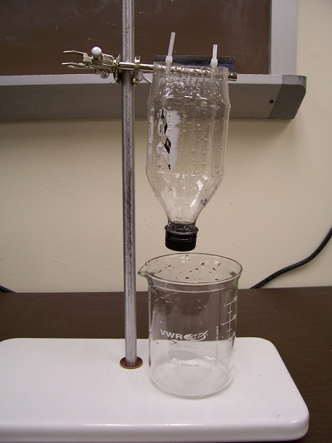
Materials:
- plastic beverage bottle with hole drilled in cap
- hole punch
- 2 plastic cable ties
- ring stand with clamp holder and rod
- scissors
Procedure:
- Cut the bottom 5 cm from the bottom of the bottle.
- Punch two holes 4-5 cm away from each other near the cut end of the bottle.
- Attach the metal rod to the ring stand using the clamp holder.
- Hang the bottle on the metal rod using the cable ties through the punched holes. Not too tight.
Part 2: Assemble Circuit
Materials:
- 1 kΩ resistor
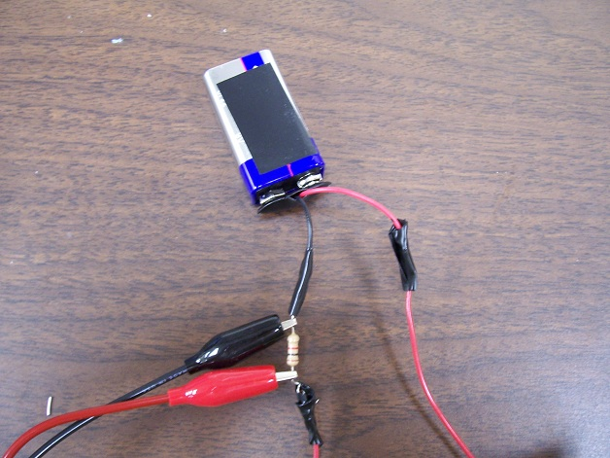
- 9V battery
- electrical tape
- insulated wire
- snap connector
- wire strippers
Procedure:
- Attach the snap connector to the 9V battery.
- Cut two lengths of 30 cm insulated wire.
- Strip the ends of the wire.
- Attach the battery, 1 kΩ resistor, and wires, as shown to the right. ➔
- Secure connections with electrical tape.

Part 3: Set Up Data-Taking Equipment
Materials:
- computer
- data-taking equipment
- voltage probes
Procedure:
- Connect the measurement device to the computer.
- Open the data-taking software application.
- Attach the voltage probe leads to the circuit (as shown above).
- Change the data-taking settings:
  - Sampling rate: (number provided by teacher)
  - Record length: 30s
- Record a trial run.
- Adjust the horizontal scale to show only data from 10s to 11s.
- Adjust the vertical scale so that your data takes up at least one-third of the screen.
- Ask the teacher to check your work. Teacher’s initials:__________
Part 4: Make Salt Solution
Materials:
- 600-ml beaker
- liquid soap
- NaCl salt
- stirrer
- water
Procedure:
- Fill a beaker with 500-ml of water.
- Add 0.3 g NaCl.
- Add 2-3 drops of liquid soap.
- Stir.

Part 5: Run Coulter Counter without Particles
Materials:
- Coulter counter set-up
- salt solution
- additional 600-ml beaker
- printer
Procedure:
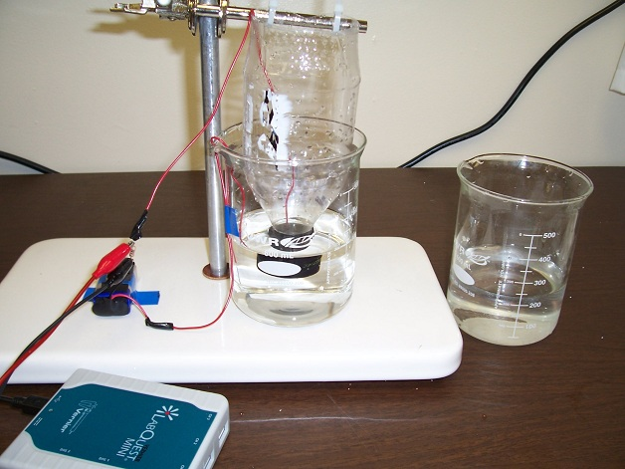
- Place a second beaker beneath the bottle.
- Lower the bottle until its cap is a few cm above the bottom of the beaker, as shown to the right. ➔
- Fill the beaker with the salt solution, until its cap is covered.
- Place one wire from the circuit in the beaker so that its end is below the water level and secure with tape. Place the second wire in the open end of the bottle so that its end is covered in water.
- Pour 100 ml of the remaining salt solution into the end of the bottle. The water will slowly flow through the aperture in the bottle cap.
- Record the voltage over the resistor for 30s.
- Save the file as “flowing_no_particles.”
- Print and label the graph.
Part 6: Test Paint Sample
Materials:
- vial with “paint sample”
Procedure:
- Repeat steps 1-6 above.
- Immediately after beginning the 30s recording, pour the vial of “paint” solution into the end of the plastic bottle. As each particle passes through the aperture, the current through the circuit will drop and a “dip” will appear in the voltage measurement.
- Watch to make sure all particles pass through the aperture before the 30s is finished. If they do not, estimate how many particles were left in the bottle at the end of 30s.
_________ particles left over
- Save the file as “flowing_with_particles” or “paint_sample.”
- Print and label the graph.

Part 7: Count Particles
(No additional materials required)
Procedure:
- Look at your graph. At what time do the first “dips” indicating particles moving through the aperture appear? __________ s
- Count the number of particles that passed through the aperture. Tips:
  - If the dips are too clustered to count, change your graph to look at smaller time intervals.
  - If the dips are too small, adjust your vertical axis so your data takes up more of the screen.
# of particles counted __________
- Add the above number to your estimate of the number of particles left over in bottle (Part 6, step 3).
Total # of particles in 5 ml sample __________
Analysis
- What was the concentration per ml of dye particles in the 5 ml vial of paint?

- To meet product standards, the paint must have at least 100 dye particles per ml.
Does this sample of paint meet product standards?

- How well did your Coulter counter work? Provide support from your data or observations.

- How could your device be improved?

- Attach to this report the graphs you printed during the experiment.

