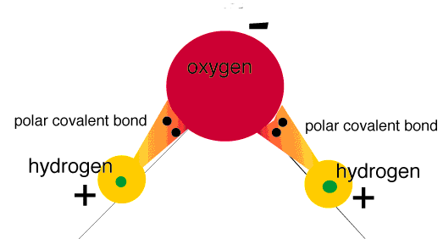
The Charges of Water

- The diagram to the right shows the charges on a water molecule. Water is known to undergo cohesive forces, meaning it is attracted to other water molecules. Based on the diagram, why do water molecules become attracted to one another?
Figure 1: http://academic.brooklyn.cuny.edu/biology/bio4fv/page/image15.gif

- An adhesive force is when two dissimilar molecules are attracted to each-other. Discuss which glass treatment has the strongest adhesive force, and what this tells you about the polarity of the molecules in that glass treatment.

- Below is the molecule Polydimethylsiloxane (PDMS): the primary ingredient in Rain-X. PDMS likes to form long polymer chains (right). How do you think the shape and structure of the PDMS molecule helps it to repel water?

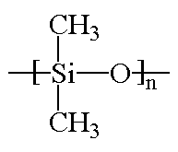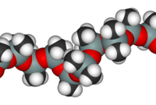
Figure 2: http://chemsrv1.uwsp.edu/macrogcss/silicone.html, http://soft-matter.seas.harvard.edu/index.php/Polymer_molecules

