Protect the Pump! Worksheet

Engineering Problem: Many hospitals around the world cannot afford to buy new medical equipment or the parts to make repairs! One important machine used in hospitals is called a suction pump. It is used to suck up and contain bodily fluids such as blood, mucus and pus. It is important that these fluids are contained in the pump’s collection jar. If fluids get sucked into the pump, it destroys the pump!
Your engineering challenge is to design a protection device that keeps the suction pump from clogging. Your designs may even be used by Engineering World Health on suction pumps in countries such as Nicaragua, Tanzania and Rwanda. Help these hospitals protect their pumps!
Background: Biomedical engineers design and create medical devices to help people who are sick or have special needs. They develop new drugs, prosthetic devices, surgical tools and a wide variety of other devices and equipment. The suction pump is a device developed by engineers that is used in hospitals such as during surgery and to care for premature babies. Suction pumps work like a straw. The motor creates a vacuum that draws fluid up through the tubing. Think about how a straw works:

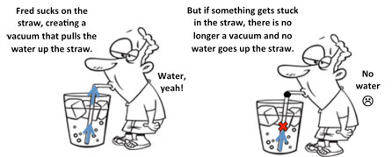

To make sure a suction pump works correctly, only air must reach the pump. No fluid should reach the pump and motor; If it does, the pump could be ruined and quit working in the middle of a critical surgery! We need an engineering solution to help solve this problem!
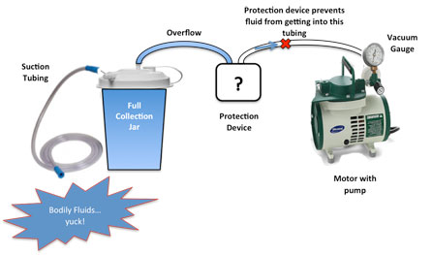
Diagram of a medical suction pump.

This diagram shows how most suction pumps work. A vacuum between the motor and collection jar draws up fluid from the tubing. When the collection jar fills up, it overflows into a protection device that shuts off the vacuum and keeps the overflow from getting to the motor. If the collection jar overflows and no protection device is in place, fluid can get into the motor and destroy the pump.
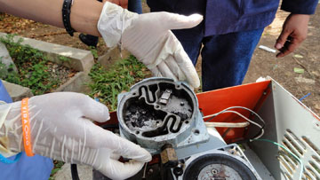
Engineering World Health is a nonprofit biomedical engineering organization that repairs these suction pumps for hospitals around the planet; they want you to develop a solution to prevent clogged pumps! The photograph below shows a clogged suction pump that Engineering World Health students fixed in Nicaragua. The black matter that you can see in the pump is dried blood.

Photo source: 2015 Iyad Obeid, instructor, Engineering World Health
Activity Details: Use the given materials to design and build a protection device that connects the motor and the collection jar to prevent overflow fluid from getting to the motor.
Materials:
- plastic container with lid
- clear plastic tubing
- balloons
- wooden ball
- wire mesh
- ping pong ball
- plastic egg
- pipe cleaners
- craft sticks
- rubber bands
- tape
- glue sticks
- putty
Tools:
- suction pump
- scissors
- hot glue gun

Testing Process: Your engineered protection device must attach between the motor and collection jar. To test your prototype device, we will use the pump to suck up fluid until the collection jar is full and fluid overflows to your protection device. Does your device keep the fluid from reaching the motor? If we need to turn off the pump in order to keep fluid from getting to the motor, then it is considered a design failure.
One important feature of any medical device is reliability. It must work every time, not just once. Just one failure of the protection device could ruin the entire pump. So, we will empty the fluid from your protection device and repeat the test three times to test the reliability of your device.
Keep in mind: Between each run, you must disconnect your protection device from the system in order to empty out any fluid. Then, reconnect your device to the system—just like you would do in a hospital setting. As you create your device, make sure it is durable and able to withstand a lot of movement and handling.

Engineering Design Process
ASK: What is the problem? What keeps the fluid from getting into the motor?

RESEARCH: What did you learn about suction pumps from the video?

IMAGINE: What ideas do you have for reaching your goal? Which ideas do you think will be the most effective?

PLAN: What materials do you want to use? How do you plan to assemble your device?
Draw a sketch of your plan below; label the materials.

CREATE: Carry out your plan and test your prototype protection device on the suction pump.

IMPROVE: Did your protection device work? If not, why? Keep making changes to your design until you create a device that completely stops the fluid from getting to the motor. Record the changes you made with each redesign and how they affected the results.

Improvement | Results

TESTING: Does your device work effectively for each run?

Remember, in order for your device to pass reliability testing, no fluid must get to the tubing between your device and the motor.

Run | Pass/Fail
1
2
3

Reliability: $\frac{Number of Successful Runs}{Total Number of Runs} × 100\% =$ $\frac{ }{ } × 100\% =$

