Making Connections Worksheet
The Arduino Sensors
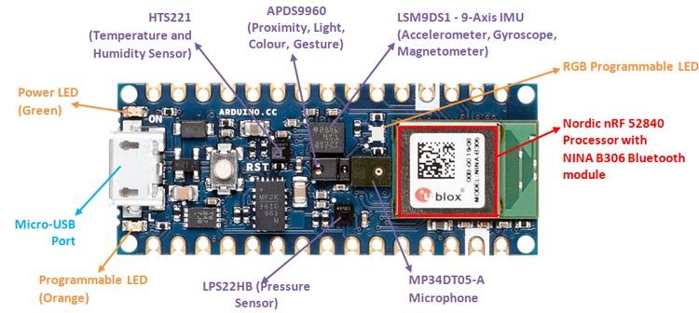

Based on the information you have learned so far, please label the sensors that act as the eyes (sight), ears (hearing), and fingers (touch).

Please answer the following question in complete sentences.

- How are sensors similar to our five senses?

