Post-Activity Quiz Answer Key
Various atmospheric gases are listed in the table below; complete all cells in the chart.
Chemical Name | Chemical Formula | VSEPR Shape (sketch) | Greenhouse Gas  Y or N
Carbon dioxide | 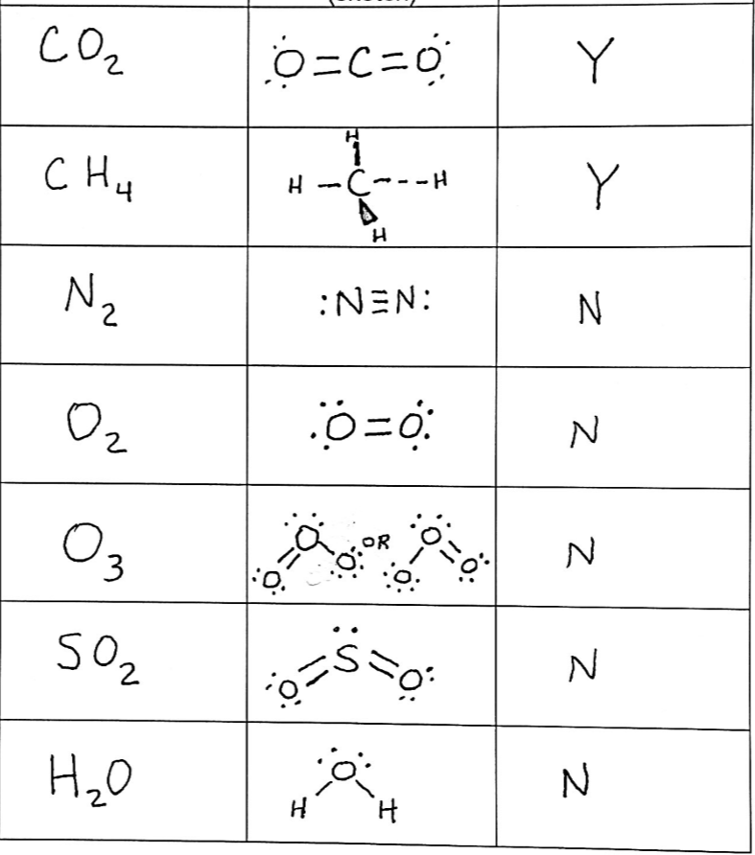
Methane
Nitrogen
Oxygen
Ozone
Sulfur dioxide
Water

