Teacher’s Slide Guide
For the Using Visual Art to Communicate Presentation
Slide 1
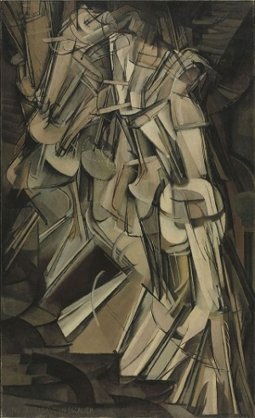
Note: The PowerPoint® file is “animated,” so each click (mouse or keyboard) brings up the next image, text or slide.
The image is Nude Descending a Stair by Marcel DuChamp. It is one of the earliest works credited with showing motion in art. The bottom rectangular shapes are meant to be the steps. The ovals in the center are the hips of a woman with each oval representing the same woman at a different time. The torso and legs are above and below each oval and the arm out to the left of each torso. This is a difficult image to see and it is intentionally chosen because of this. After students have had time to answer the questions on the slide, see how many can tell what the image is. Have students explain how it could be clearer and what they would like to see done differently.
Slide 2
This is not a famous image, but helps to illustrate some of the concepts already discussed in art. Have students describe the concepts that are being used; line, color and rhythm are common answers. Ask them if it represents something. While it does not intentionally represent anything, some students may come up with interesting possibilities that seem plausible. Also have students pay attention to how their eyes travel across the page. It results in the viewer seeing a certain flow to the image even though no real motion is happening.
Slide 3
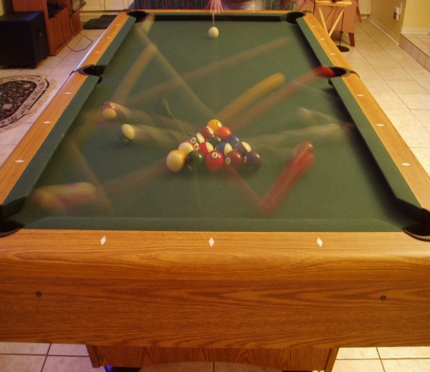
This photograph is a time lapse of the start of a pool game. The main point to make while looking at this image is that it gives us information: it is the start of the game, it is in a room, the balls were hit, the orange ball went in the hole, etc., and that some principles of art and visual design help to emphasize certain points, particularly motion.
Slide 4
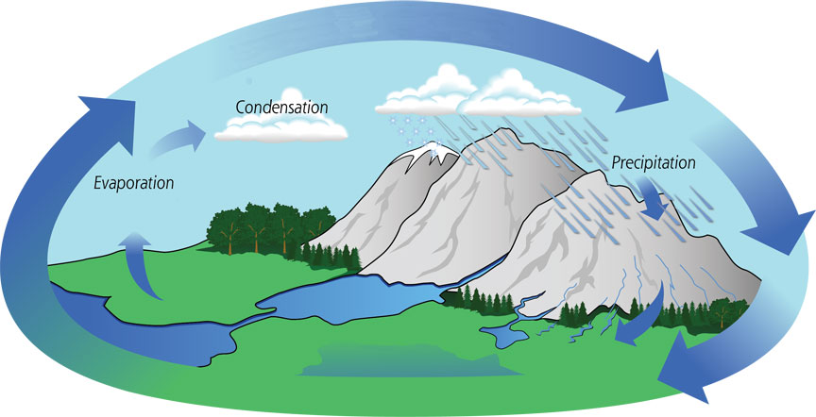

Now is the time to tie art in with the science and engineering. This image is a visual diagram of the water cycle. Point out to students how easily recognizable this image is as a scientific concept even though only three words are provided. Suggest they notice the use of different lines to illustrate evaporation and rain as well as water flow. The arrows also cause your eyes to move in a circle throughout the image and view it as a repeating cycle rather than a one-time process.

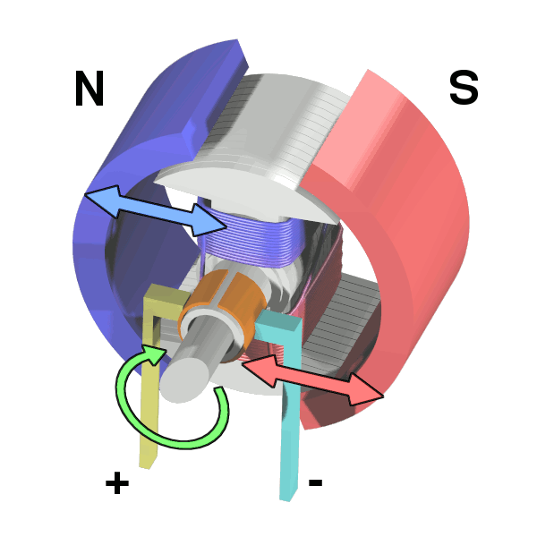
Slide 5

The last example image is a diagram of a simple electromagnetic motor. Current flows through the coil, generating a magnetic field, spins to align with the bar magnet, turns off and continues to spin. Once back in the original position, it repeats this process. This image was chosen with the idea that high school students have probably never seen a diagram of this type of motor before. However, students will probably be able to tell what is going to happen in general just by the clarity of the image design. Have students describe what they think this is and how it works. Expect many students to get closer than they realize and have them describe how they drew their conclusions. Explain to students that a well-designed diagram gives someone with little to no knowledge on your subject the ability to draw a reasonable conclusion—just like this image.
Slide 6
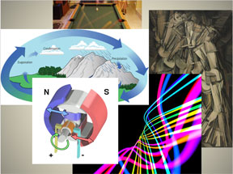

This is the concluding slide, which provides a final look at the previous five images. Have students compare their answers to the questions of each image and see if any themes emerge for each image. Also explain the importance of each image and how each might be used in illustrating scientific and engineering work. Conclude by asking: What are important visual design principles to consider when making your own diagrams and examples of science and engineering results, concepts, prototype designs and ideas?

