Interpreting the Lux Reading

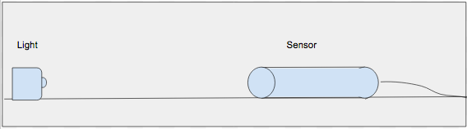

The drawing represents a light source and light meter similar to what you just used. Add to drawing to show the light from the source to the sensor. Then use the drawing to indicate what light you actually measured. Write in words what you understand was measured or what you reading represents.

