Teacher Notes for the Feel of Photons

Part One
Notes on Pre-Quiz questions:
1) Add to the drawing to show light moving from the candle to the eye.

The way the student depicts the light might indicate the misconception about vision involving beams from the eye and reflecting back from the object being viewed. A drawing of photons moving in a wave would indicate a different misconception. The representation can also reveal the sophistication of the thinking. While a simple sine wave could be used to show the light’s path for efficiency’s sake, it might tell you the student is unaware of relationships about wavelength, color and polarization.

This question and the next also serve to prime students to think about the task they will do with the light meter.

2) What, if anything, can you change in the drawing to provide a more realistic image of the light?

Answers might further indicate the depth in which each student thinks. Someone might, for instance, note the difficulty showing that only the fraction of light that fall on the pupil is seen by the recipient.

3) As you have learned in the past, the rate at which energy is used or produced is power. Power is measured in watts, which are joules per second. What, in a 100-watt light bulb is happening at 100 J/sec?

Energy is input into the lamp at a rate of 100 J/sec.

4) What, in a 5-milliwatt laser is happening at 0.005 J/sec?

The energy output rate of the laser is 0.005 J/sec.

If students are not aware that input power is usually stated for a light bulb but output power is for a laser, some instruction to that effect is needed.

5) Briefly compare and contrast engineering and science.

This final question establishes the student’s understanding of the distinction before engaging in the work. It is repeated in the Post-Quiz to let you document changes in understanding.

Discussion of the “Interpreting the Lux Reading” exercise
The questions the exercise asks might generate some confusion. Encourage students to do their best but avoid planting ideas that will lead to answers you expect. The point of the drawing is to give the student a visual representation that could lead to seeing the light meter measures something dynamic (the light which arrives at the sensor during the measurements) rather than something static (the light that was at the sensor the moment the collect button was pressed). The writing part of the exercise is to clarify that idea.

Here are possible verbal answers (roughly in order of increasing sophistication).
- Light.
- Light from the source.
- The light that was at the source when I started collection.
- Light that arrived at the source during the fraction of a second that data collection occurred.
- Suppose the reading took a hundredth of a second. The meter measured all the light that fell on the sensor in that time.
- Suppose the reading took some time t. The meter measured all the light that fell on the sensor the sensor in that time. That light came to the sensor from the truncated cone with its base at the light source and its cut-off tip at the sensor. That has to be more light than is shown in my drawing, unless the sensor is t light seconds away from the sensor. So the sensor is measuring some light that wasn’t even produced when the measurement started.

Lead a discussion about the answers. Guide students toward a more sophisticated statement than each initially offered. Get at these key points:
- The light that arrives at the sensor during collection is what gets measured.
- If it has not already come up, ask about the units of the reading. What does it mean to say some number of lux of light?

Explain the following:
In the physical sciences we tend to focus on how many joules of energy land on a surface over time, usually expressed in watts per square meter. This is called the intensity of the light. In general, the measurement of electromagnetic radiation is called radiometry.

The lux unit is more for photography and lighting design (a field of engineering). It comes from photometrics, which is the measure of how bright light appears to our eyes. The photometric equivalent of intensity is illuminance, usually measured in lumens per square meter. One lux is one lumen per square meter.

Here is a useful FAQ on the matter .

Supporting students converting the lumens to total energy
This is an intentionally vague task that is designed to give your students latitude in finding an answer. Potential problems to monitor that you students might encounter:
- The solution does not necessarily need the results from the SpectroVis. In fact you might want to hold off introducing the Spectrovis until your students see the need for the data. Methods that do not use the SpectroVIs might include
  - A chart something like the one on this page about buying light bulbs. Note that such data might be very rough. There is for example, obvious rounding involved with the claim in that table that 100 W corresponds to 1200 lm while 60 W corresponds to 800 lm.
  - The Lighting Research Center at Rensselaer Polytechnic Institute reports that a white LED produces about 25 lumen per watt (although it notes that technological advances have brought that to 35 or 40 lumens per watt since that figure was determined). Bulb wattage, however, refers to consumption, not production. Information about the efficiency would also be needed.
- The wattage of the light source is the power input and consumed by the light source. It is not the power of the output light. (Students might, however, look up estimates of efficiency as the basis of the analysis.)
- It is unreasonable to ignore precision considerations. Insure that students pay attention to the impact of the uncertainties introduced at each step. Remind them that precision can be expressed in terms of significant figures.
- Running calculations on a calculator will likely make it challenging to find and fix errors. Encourage students to work in a spreadsheet, label entries clearly and save the file often. Also encourage them to make the spreadsheet available to everyone in the group, either by emailing copies or working in a shared document like a Google Sheet. This will head off the problem of a group being unable to continue if the student with the data is absent next class.
- The lux reading is made over the duration in which the sample was taken, but the reading is given as lumens per second. That does not mean that the sample took a second.
- We are not dealing light being at a point in space at an instant in time. The focus is on the light falling on an area during a time interval. We are not dealing with joules of energy, but with the rate that energy arrives at surface of a specific area (typically a second of time and a square meter of area).

You might find a group is unable to work out a path to the answer. Given that possibility, here are two viable methods:

Method 1
1) Measure the spectroscopic curve and the lux value of the light source. Data collected for this explanation produced the curve shown in Figure 2 of the exercise. The light meter gave a reading of 1352 lux = 1352 lm/m².
2) Round the lumen-to-watt conversion factors in the “Converting from Lumens to Watts” attachment to one significant figure (summarized in Table I).

Wavelength (nm) | Lumens per watt | Wavelength (nm) | Lumens per watt
400 | 0 | 610-650 | 100 to 300
410-420 | 1 to 3 | 660 | 40
430-450 | 10 to 30 | 670-690 | 10 to 30
460 | 40 | 700-720 | 1 to 3
470-510 | 100 to 300 | 730 | 0
520-600 | 500 to 700

Table I: Conversion factors of the “Converting from lumens to Watts” attachment rounded to one significant figure.

3) Apply the interpretation that values are known within one in the last significant figure, “1 to 3” becomes “2”, giving a single conversion factor for a range of wavelengths. We can simplify further by dropping the 0 values at each end and adding those two 4 x 10¹ values into the adjacent category, ending up with only four conversion factors (Table II).

Wavelength (nm) | Lumens per watt
410-420 and 700-720 | 2
430-460 and 660-690 | 2 x 10¹
470-510 and 610-650 | 2 x 10²
520-600 | 6 x 10²

Table II: Four conversion factors that allow approximate conversion from illuminance to intensity.

4) Next estimate the portion of the 1352 lm/m² that falls into each wavelength range. That will be approximately proportional to the area under the curve that is bounded by those wavelengths. LoggerPro’s integration function makes that easy to find (see Figure 1 of this document for an example). If the area of each region is then divided by the entire area, we get the fraction of the total that can be attributed to individual wavelength ranges.
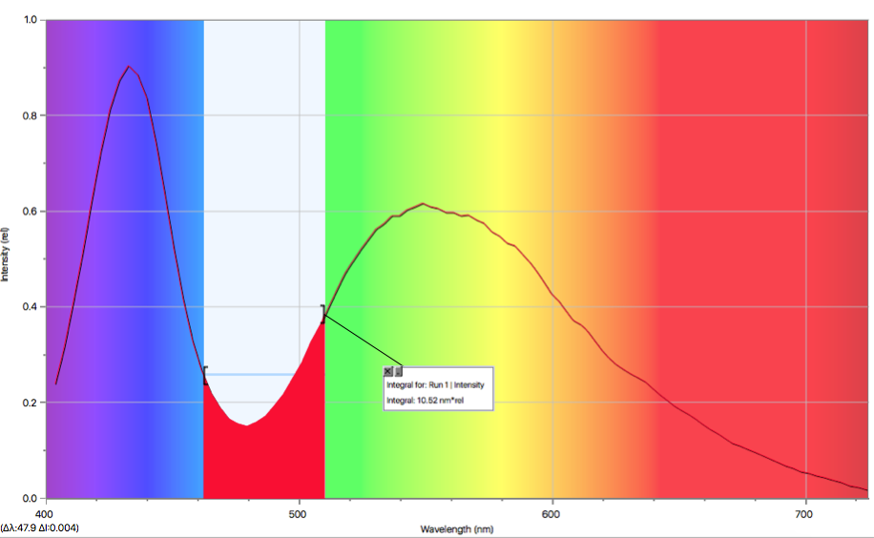

Figure 1: The red region is the portion of the light with 2 x 10² lm/W.

A clash emerges here between conversion factors being given for every 10 nm in “Converting from lumens to Watts” and the SpectroVis values being reported about every 3 nm. That is taken into account in Table III by tweaking the limits of ranges.

Here is an example of this step in the analysis.
The area under the wavelength range from 410-421 nm is 7.42 (the units are not relevant here). Divide by 115.1 (the total area under the curve):
7.42/115.1= 0.06447
This is interpreted as meaning that 6.4% of the light energy falls in that frequency range.

Multiply by the reading on the lux meter:
0.06447 x 1352 lm = 87.15 lm

That is an approximation of the number of lumens contributed to the total by the light from the 410 nm to 421 nm wavelength range. (We, of course, do not know it to four significant figures, but the rounding will happen later.)

Once that calculation is done on all ranges, each range’s conversion factor can be applied to the average wavelength of each range to find the number of watts per square meter. Those results are shown in Table III.

Wavelength range (nm) | Fraction of area under spectroscopic curve | Illuminance (lm/m²) | Lumens per watt | Intensity (W/m²)
410-421 and 690-724 | 0.079 | 107 | 2 | 54
421-461 and 660-690 | 0.26 | 346 | 2 x 10¹ | 17
461-510 and 610-660 | 0.24 | 321 | 2 x 10² | 1.6
520-610 | 0.43 | 578 | 6 x 10² | 0.96

Table III: Approximating intensity in each of the four wavelengths.

The total intensity rounds to 7 x 10¹ W/m². With all the assumptions made in the string of calculations, we should not rely in this being known to one significant figure, but might expect it to be on the correct order of magnitude. A more conservative assessment might lead us to say with confidence that it is accurate within an order of magnitude.

Method 2
This was developed by my students.

1) The blue peak and green peak are responsible for most of the intensity, so ignore the red end of the spectrum. Pick a wavelength range between the blue and green, but a bit closer to the blue since its photons are more energetic. (This group knew it would later be calculating the number of photons.) The students chose the 470 to 480 nm range.
2) They then applied the average conversion factor for that range (78.545 lumens per watt) to their entire lux reading of 5536 lumens per square meter:
5536 lumens/m² x 1 watt/78.545 lumens = 70.482 watts/m²

That is the same result as Method 1 when rounded to one significant figure.

Determining the momentum of the energy from the LED source
As with the previous task, this is somewhat open-ended. The students will have an estimate of intensity of the light, probably in units of W/m². They might try to extract the energy in joules from that value, stumbling over how much time and what area to use in finding the momentum. You may need to lead them to see that they can readily use the relationship p=E/c to find the momentum arriving per square meter per second.

Part Three
Leading the discussion of the precision of results
This might help model talking to students about this subtle matter, focusing on the photon flux calculation as an example. Suppose analysis gave the result that the photon flux is 2 x 10²⁰ photons/m-s. That might be interpreted as one of this set of conclusions: photons from the LED work light land on a 1 m² surface that is 0.100 m from light at a rate
- of more than a trillion photons per second
- of more than 10¹⁷ photons per second
- on the order of 10²⁰ photons per second
- of 2 x 10²⁰ photons per second
- of 1.96 x 10²⁰ (the sum of the values in the rightmost column of Table III)

The list of possible conclusions above is arranged from least to most precise. Barring consulting a professional statistician, where to fall on that spectrum is a judgement that should be informed by the experience of collecting and analyzing the data. Your students may be reluctant to take a stand about a conclusion, there being no clear-cut algorithm to follow for arriving at the decision in this case.

When talking with students, watch for indication of them “hedging their bets”. They might be unwilling to commit to a conclusion because of lack of comfort with the underlying logic of the calculation. If so, work with them (or give them time to work together) to remedy that.

If you find the student relying on qualifying language like “relatively certain” rather than a mathematical argument (“the rules of significant figures tell me the greatest precision is to one significant figure”), nudge him or her more toward the more quantitative reasoning.

Part Four
These answers will be compared to a second pass at the general question wen students answer “Comparing Science and Engineering Methods II” and the Post-Quiz question in {art Six of the exercise.

Part Five
As the Breakthrough Starshot Program is occasionally in the news you may find that some of your students have some knowledge of the question already. If so, encourage them to consider aspects of the project with which they are less familiar.

Here is a partial list of questions and considerations (including those in the handout). The considerations are offered to support you helping students that that get stuck doing the task.
- How small can the probe be?
  - Consideration: It needs to be able to carry enough instrumentation to make the mission worthwhile.
- What wavelength laser should be used?
  - Consideration: Students might leap to shorter wavelengths being preferred because of their greater momentum of the photons. As seen in the previous calculations in the exercise, though, the overall momentum of the laser light for a given power is not a function of wavelength.
  - Consideration: It will need to be a wavelength able to pass through the Earth’s atmosphere.
- What power can the laser reasonably have?
  - Consideration: Multiple lasers can be used for increased power.
- Can we hit it a small spacecraft with lasers from the ground?
  - Consideration: Sails around the probe can increase the target size, perhaps with little increase in mass.
  - Consideration: Is there a need to keep the sail after the initial acceleration?
  - Consideration: The laser is rotating with the Earth. How long is the laser underneath the probe? Can the probe be in geosynchronous orbit?
- Where is best site for the laser?
  - Consideration: Placing the laser at a higher elevation will reduce the thickness of overlying atmosphere.
  - Consideration: depending on the wavelength of the laser, it might pose a threat to birds and aircraft.
- What choices about the probe will make it easier to attain 20% light speed?
  - Consideration: Low mass favors higher acceleration.
  - Consideration: Using sails to provide a larger area and potentially greater power.
  - Consideration: Maximizing contact times with the laser will maximize the final velocity.
- How reflective can we make the craft (or a sail that we put around the craft)?
  - Consideration: Reflectivity depends on wavelength.

Part Six
Notes on Post-Quiz questions
1) Briefly compare and contrast engineering and science.

Comparing this answer to the writing done on the two versions of Comparing Science and Engineering Methods will indicate how the student’s thinking has progressed on understanding the difference.

2) How confident are you in your result about how many photons land per area from the light source you measured?
This answer will provide information about student attainment of elements of the following learning objectives:

Next Generation Science Standards: Science [2013]

Elements of the Science and Engineering Practices (Grades 9-12) Using Mathematics and Computational Thinking: Use mathematical representations of a phenomena or design solutions to describe and/or support claims and/or explanations.

New York State Science Learning Standards (2016) = HSN-Q.A.3
(Grades 9-12) Choose a level of accuracy appropriate to limitations on measurement when reporting quantities.
ITEEA Standards: Abilities for a Technological World
(Grades 9-12) Collect information and evaluate its quality.
ITEEA Standards: Abilities for a Technological World
(Grades 9-12) Use computers and calculators to access, retrieve, organize, process, maintain, interpret, and evaluate data and information in order to communicate.

ITEEA Standards: Design

(Grades 9-12) The design process includes defining a problem, brainstorming, researching and generating ideas, identifying criteria and specifying constraints, exploring possibilities, selecting an approach, developing a design proposal, making a model or prototype, testing and evaluating the design using specifications, refining the design, creating or making it, and communicating processes and results.

