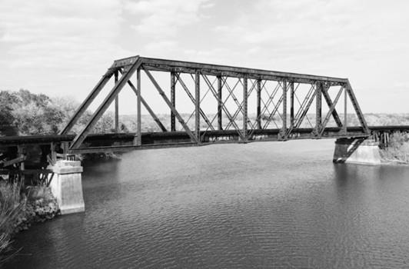
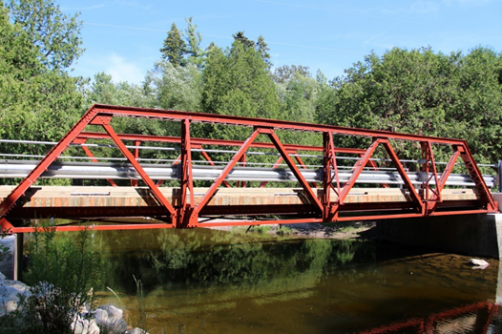
The purpose of this project is to calculate, build and test a truss bridge. Four main truss designs are going to be used: Warren, Warren with Verticals, Pratt, and Howe. Under the assumptions that only vertical loads are applied on the truss nodes, and the weight of the elements is negligible, the tensions-compressions on the bridge truss elements are calculated using Right Triangle Trigonometry, and Physics Free Body Diagrams. A Google Sheets spreadsheet or Calculation Graphic Interface is used to compute these forces on the elements.
After performed the forces analysis and tension-compression calculations, students will build the truss bridge using wood dowels, craft sticks, and carpenters glue. Finally students will test their bridges strength in class.
Project Overview
1. You will work in groups of three or four on three parts of the project:
(a). Bridge Design and Calculation.
1. You are going to be assigned a problem with a Warren, Warren w/Verticals, Pratt, or Howe, a load this bridge must support, and a budget for construction materials.
2. You will design a bridge covering a span of at least 20 inches, but no more than 36 inches, and create two drawings of your design at real scale.
3. Perform the Analysis of Forces using a Calculation Graphic Interface.
4. Determine the truss elements thicknesses and wood type for the required load.
5. Perform the analysis of costs of the chosen materials to very their hypothetical cost fits the=assigned budget.
(b). Bridge Construction.
1. Build your designed bridge using only wood dowels, craft sticks, and carpenters glue.
2. Estimate the maximum loads your bridge may resist and include in your report.
(c). Model presentation and Strength Test.
1. Presentations of electronic poster summarizing: objective, background (type of bridge used), design and construction process, calculations, and photos of model created.
2. Present your bridge and test its strength. Record a video of your bridge presentation and strength test. Submit video to teacher.
Poster Content and Model Construction/Strength Test Checklist
Poster Content | Points | ☑ | Evaluation
- Bridge Design and Calculation
(a). Tittle of Project and Students’ names | 5 | ◻
(b). Bridge Truss Design Drawing | 10 | ◻
(c).. Free body diagrams for analysis of forces on nodes | 20 | ◻
(d). System of equations from the analysis of forces | 20 | ◻
(e). Spreadsheet screenshot used for calculations | 15 | ◻
(e). Calculated tensions-compressions on truss elements | 15 | ◻
(f). Estimated maximum loads for design | 10 | ◻
(g). Construction Process Pics. | 5 | ◻

Total Points:

Model and Strength Test | Points | ☑ | Evaluation
- Bridge Model
- Bridge model with dimensions / angles matching design | 50 | ◻
- Creativity and artistic work | 10 | ◻

- Bridge Strength Test
3. Strength Test in class. Model Resisting at least 90% of estimated max load | 20 | ◻
4. Strength Test Video (Construction & Design Process included = +20 Extra Credit) | 20 | ◻

Total Points:
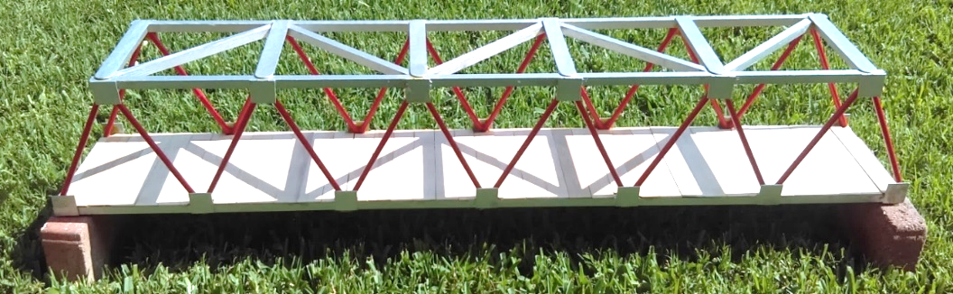

Annex 1. Bridge Trusses.

Truss. A regular structure or frame built with straight members with end point connections and forces that act only at these end points. No member is continuous through a joint.
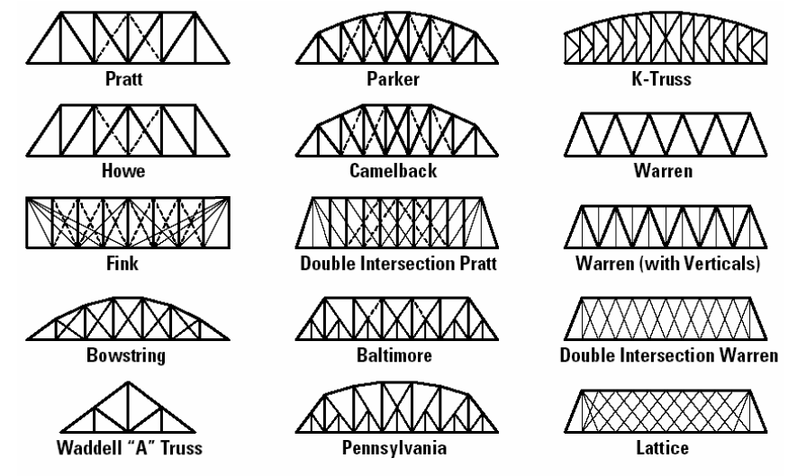
Truss Bridge. The bridge whose load-bearing superstructure is composed of a truss, a structure of connected elements usually forming triangular units. The connected elements (typically straight) may be stressed from tension, compression, or sometimes both in response to dynamic loads. The basic types of truss bridges are shown below:

Warren Truss. Design distinguished by equal-sized members and the ability of some of the diagonals to act in both tension and compression. The type is generally characterized by thick, prominent, diagonal members, although verticals could be added for increased stiffness. This design was patented by the British engineer James Warren in 1848.

Warren truss
Warren truss w/verticals

Warren truss bridges gained popularity in the USA after 1900, as American engineers began to see the structural advantages of riveted or bolted connections over those that were pinned. The design was well suited to a variety of highway bridge applications and was very popular from about 1900 to 1930.
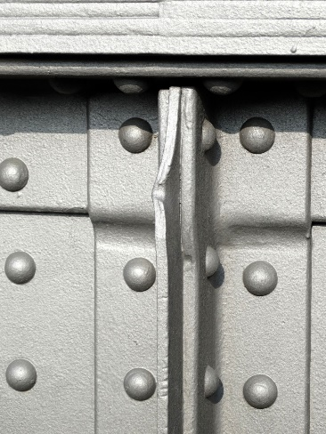
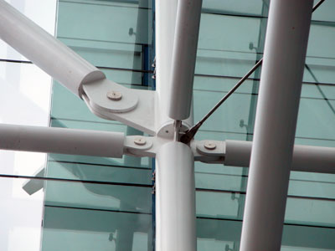

Pratt and Howe Trusses. These trusses are very similar; their trusses’ elements are arranged in right triangles. They differ in the orientation of the hypotenuse of these triangles. The analysis of forces on these trusses is very similar.
Pratt

Howe

Pratt Truss. The United States railroad expansion in the 19th century required strong, dependable bridges to carry trains over ravines and rivers. In 1844, Caleb and Thomas Pratt developed a bridge that was built initially with wood and diagonal iron rods. Later the bridge was built entirely of iron. This bridge had the advantage of low-cost construction, and could also be quickly erected by semi-skilled labor. This design became the standard American truss bridge for moderate spans.
Howe Truss. Designed by William Howe in 1840, it used mostly wood in construction and was suitable for longer spans than the Pratt truss. Therefore, it became very popular and was considered one of the best designs for railroad bridges back in the day. It utilizes similar design such as Pratt truss, but with a strong difference. Here the diagonal structural beams slope toward the bridge center, while Pratt truss utilizes diagonal beams that slope outward from the center of the bridge.

Design and Construction Tips
Truss Bridge Main Parts
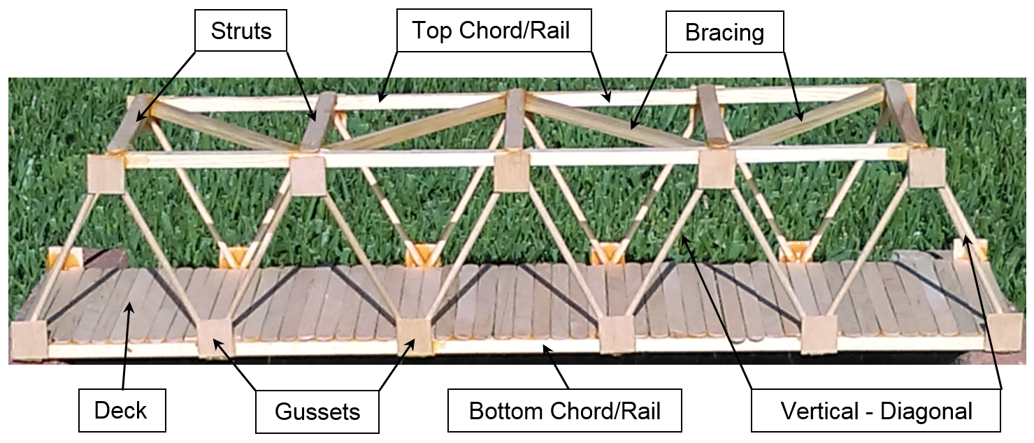

(a). Bridge Design and Calculation
- Create two precise drawings of the truss. Save time assembling two trusses simultaneously.
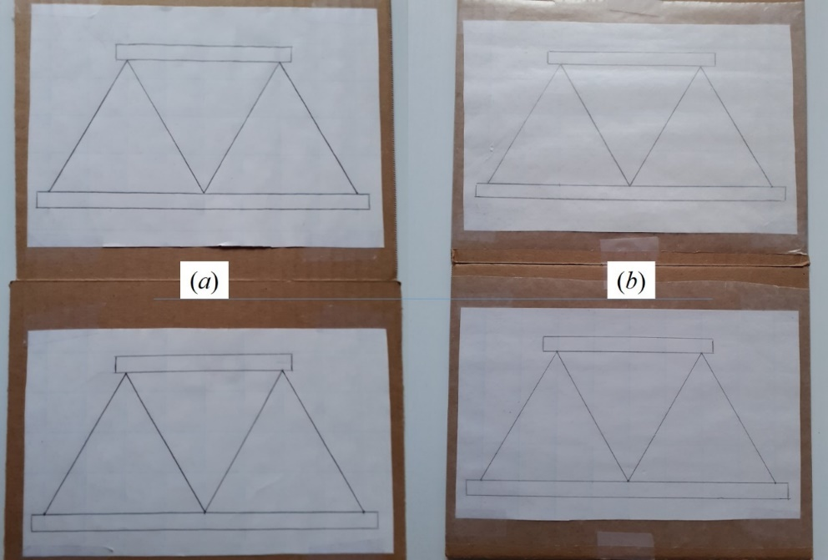

Tape the drawings to cardboards to handle and protect the bridge during construction process. Because the truss bridge is going to be constructed following the design, is necessary to protect the drawings from the glue used to assemble the truss, so they have to covered with wax paper
- Determine truss elements thicknesses and appropriate wood to make them.

Use the Calculation Graphing Interface to determine the tension compressions on the truss elements:
https://sites.google.com/gpapps.galenaparkisd.com/mramirez-math/courses-highlights/bridges/trusses-calculations
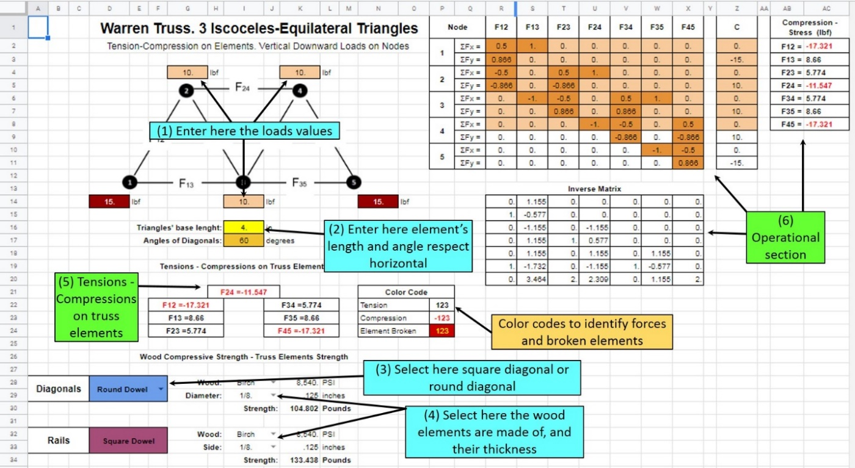

Figure 05. The graphic interface worksheet has specific cells to type values, and sections that perform the operations and display the results. Click-on the given link, Open the truss worksheet you will work and save a copy in your Google drive.

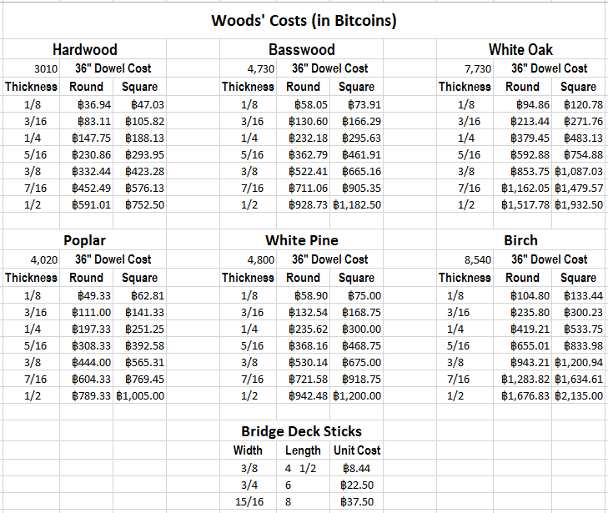
Distribute the given load equally on every node. Ex. If you have 240 lbf on a 9 triangles/10 load nodes Warren Truss, put 24 lbf on each node. Begin your calculations with the thinner elements and the weakest wood: Hardwood. Increase thickness until the simulator displays no broken elements.
These are the most common wood dowels you can find in a crafts store. The real prices range from 0.80 USD to 3.00 USD. But in this activity it was assumed they have hypothetical costs in bitcoins.

Estimate the amount and the quality of materials you are going to use

You may find for instance that ¼” diagonals-verticals work fine, but also any other thicker element, or made of a different wood may work. So you may be tempted to use thicker elements or stronger woods. But you have a restriction: a budget. The next step is select the elements that support the required load and that whose hypothetical cost fit your assigned budget
Make the cost calculations using the values on Figure 06. Use a worksheet like Google Slides or a calculator, but try to organize your analysis such that any person can understand it (Figure 07). Calculate the total lengths of Diagonals/Verticals, Rails, Braces, Struts, etc. and divide these by the standard dowel length: 36 inches, to determine the number of dowels you will need. You are possible going to have more wood that the exact needed, but remember that may be errors during the cutting so you will need to replace parts.
Craft sticks are going to be calculated by number only. To estimate how many you will need for the bridge deck, you have to take in account the craft stick width (Figure 07):

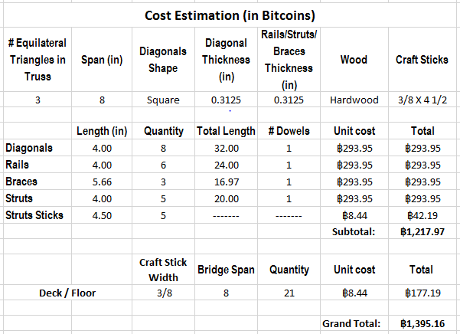
Once you have determined the number of dowels, and thickness, Begin your cost analysis with the cheapest wood: Hardwood. Multiply the number of dowels by the corresponding unit price that can be found in the table in Figure 06. You may try other woods or thicknesses, but the obtained Grand Total must fit your budget.

- It is recommended to use the craft sticks length as the width of your bridges, so you will need one per strut. Also the square truss gussets will be cut from craft sticks, one little square per truss node.
- Find the stores to get all the materials and tools.
- The real cost of the materials you will need to build your bridges is not high. Check with your teacher what materials school may provide, and purchase only the ones you really need. Check a list of generic materials in Annex 3.

Bridge Construction
Next are some steps to build your bridge models. You may find alternative or more convenient ways to work during your own iteration
- Cut truss elements: rails, diagonals/verticals, gussets and struts.
Once you have your designs on grid paper, tape them to the cardboards and protect them with wax paper. Measure the sizes of the diagonal/vertical elements you have to cut, secure the dowels with clamps to a sturdy table, and gently saw.
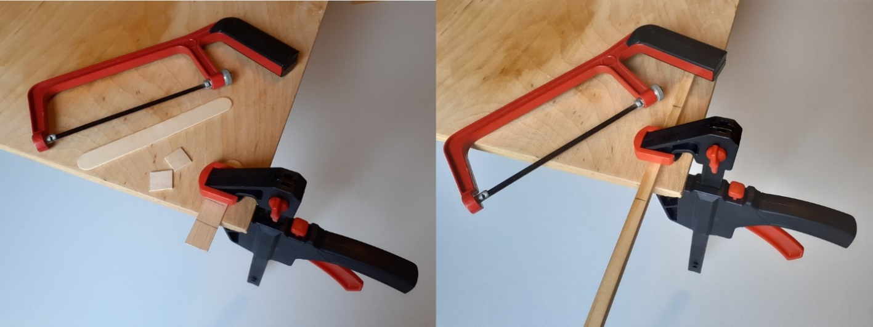

The correct cutting of the truss elements is very important and require some practice. To ease this process is recommend to use a fine teeth hacksaw, and a bar clamp to firmly hold the pieces to a table. Be patient during this process. Rushing during the cutting process may break the pieces. Gussets have to be also cut from the craft sticks in the same way. Be very careful with this little square pieces because they can break very easily.
Note: Even though by definition in a truss structure, no element is continuous through a joint, to save time, the rails are going to be continuous. So you are going to cut only four rails from the dowels. The length of these rails have to be measured on your designs.
- Glue rails and gussets using the drawings as patterns.
Once your designs are covered with wax paper, place the gussets on the truss nodes, aligning one edge to the lines representing the rails in your design:
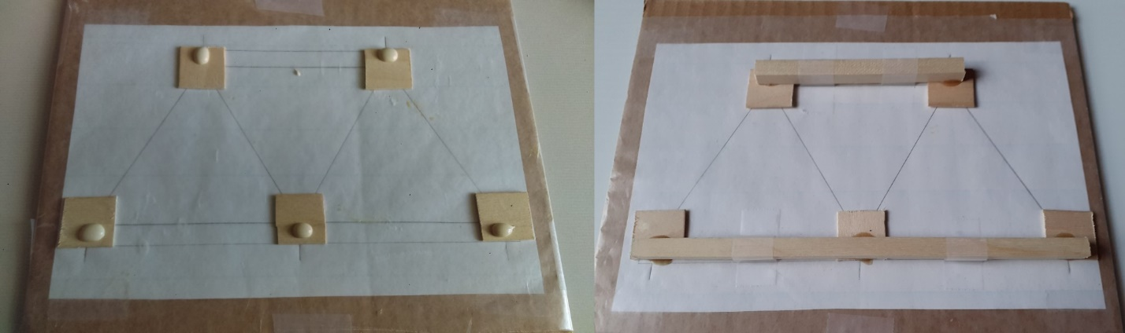

The gussets have to be placed on the drawings aligned with the rails lines. Carefully put a little glue drop near to the outer edges, and carefully place the wooden rails on. It is very important these wooden rails be aligned with the rails lines on the drawing. Carefully tape the rails to the drawing.
Put a drop of glue near to the edges, and carefully place the rails on the gussets, aligned with the rail lines. Wait about one hour before you try to place the diagonal/vertical elements.
- Cut and glue to craft-sticks the bridge struts.
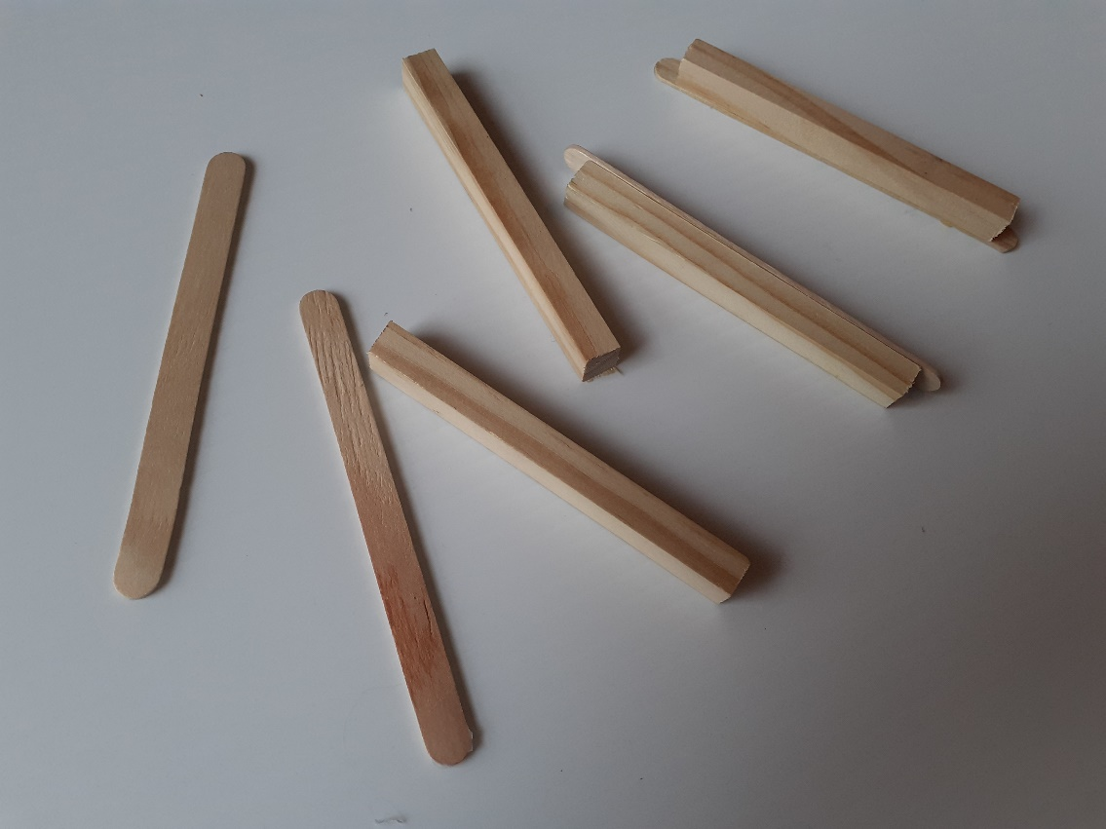
While you wait you can cut and glue the bridge struts. These are an important part in your structure because they define the bridge width (Figure 10). It is recommended, to save time and make the work simple, to use the length of the craft sticks as the bridge’s width. Measure the craft sticks length and mark about ¼ inch from every end, and cut the struts ½ inch shorter than the craft sticks. Glue the struts between the marks you drew on the craft sticks. The craft sticks glued to the struts will make easier to glue the two the trusses.

Truss Bridge struts are made from the same dowels used for the rails. To make the bridge assembling easier, struts are glued first to craft-sticks. Taking the bridge width same as the craft-sticks length, requires the struts be cut like half inch sorter, in such a way that gluing the strut centered in the craft-sticks, these elements will have an entry to fit with the rails.

- Fit and glue diagonal/vertical elements.
Diagonals must be glued to the rails and have a good contact with these. The strength of the truss bridge highly depends on this good fit rails-diagonals (Figure 11). Glue the diagonals only on the gussets, not touching the rails will make a weak bridge. The gussets here are only to help in the retention of the glue; gussets are thin and will not resist too much load.

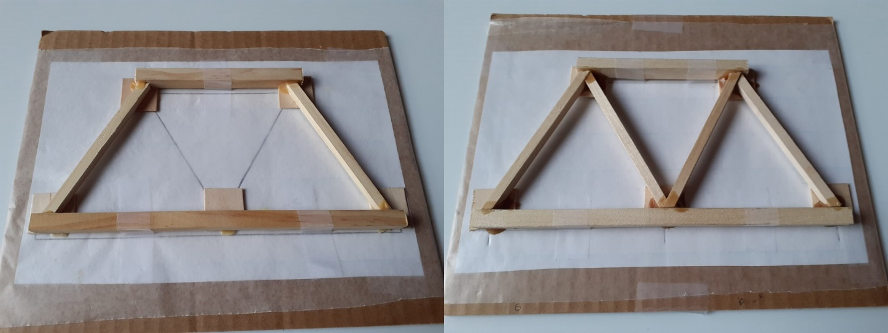

Once the rails are taped to the drawing the diagonals can be glued, following the lines in the design. Diagonals will need some sanding at the ends, to make them fit and have good contact with the rails. This will make the truss bridge strong. Glue diagonals only on the gussets without good contact with rails, will make the bridge weaker because the gussets are very thin, and will easily break under loads.
It is recommended to tape the rails to the drawings to keep them in the right position and produce some pressure with the diagonals/verticals. Important: Align the diagonals to the corresponding lines in your drawings. Diagonals will require some sanding at the ends, in order they fit and make good contact with the rails and other diagonals.
- Assemble the bridge by gluing the trusses with the struts
After 24 hours carpenter’s glue has firmly bonded the trusses, it is time then to assemble the bridge gluing trusses and struts. First, carefully remove the trusses from the drawings (if wax paper is ripped off, cover again with new wax paper), then take one of the drawings and tape the bridge’s bottom struts on the bottom nodes, perpendicular and aligned to the bottom rail (Figure 12.a)
Drop carpenter’s glue at the ends of the struts and place the trusses in position, use a drafting triangle to be sure the trusses are perfectly vertical and use something heavy, like textbooks, to keep the trusses vertical. Once the two trusses are in vertical position, glue the top struts to the trusses and verify trusses are still vertical. Use more heavy objects as supports to keep second truss and the whole structure still. Wait at least one hour before you remove the supports.

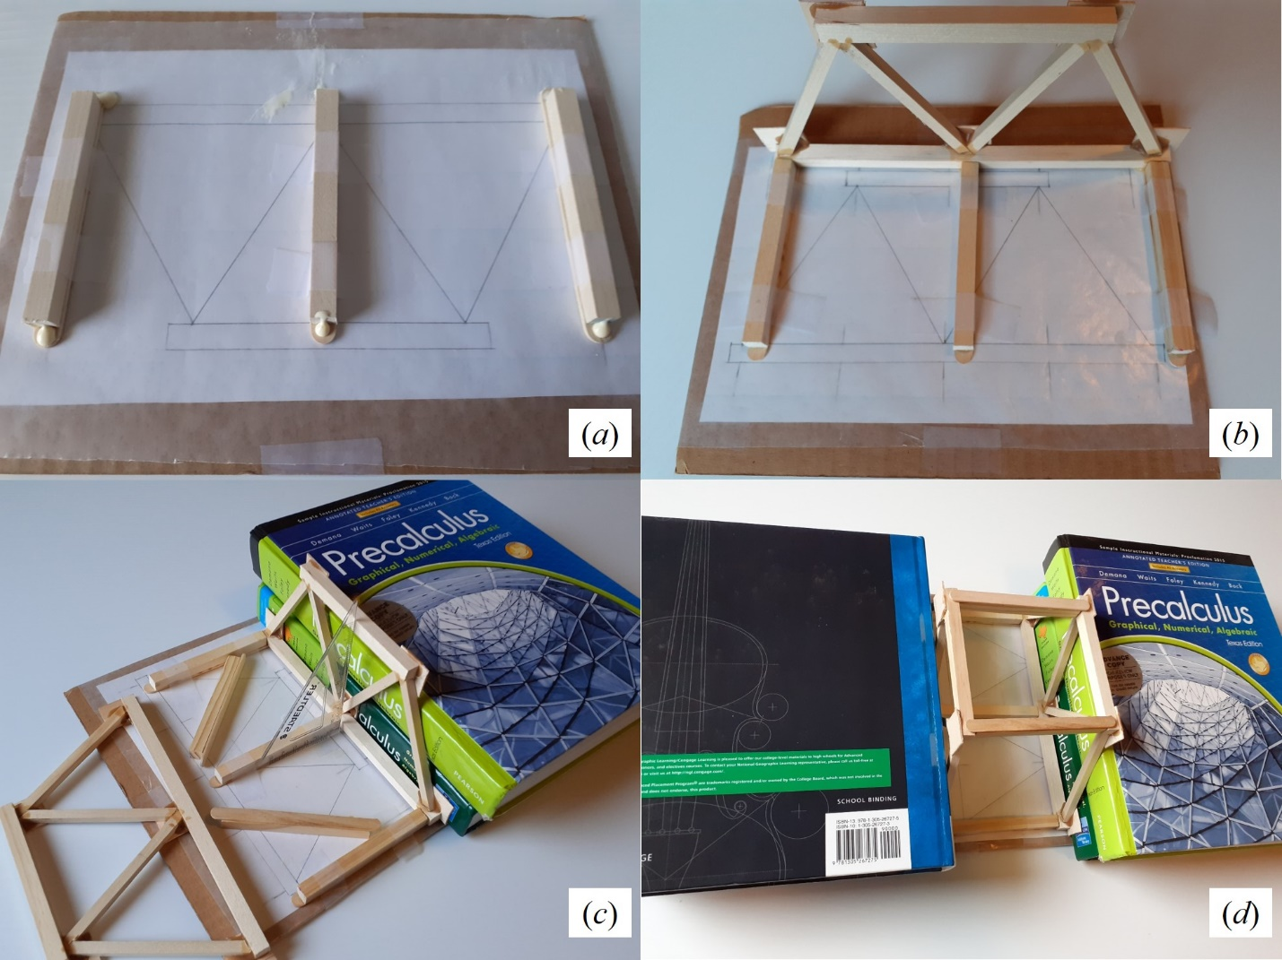

- Begin the presentation poster
While the glue dries, you may begin to structure the presentation poster. Using Google Slides or MS-PowerPoint, a single slide has to be created containing:
1. Tittle of Project and Students’ names
2. Outline of the project. Brief description of all work done
3. Bridge Truss Design Drawing, with a brief description/history of the truss used
4. Example of a Free Body Diagram for the analysis of forces on a truss node.
5. System of equations resulting from the analysis of forces (Can be a snapshot of the matrix in the Graphic Interface)
6. Screenshot of the specified load applied on the truss (Can be a snapshot from the Graphic Interface)
7. Calculated tensions-compressions on truss elements (Snapshot from same worksheet)
8. Pictures of the bridge model. Some pictures of the construction process.
9. Poster neatness, creativity, and artistic touch

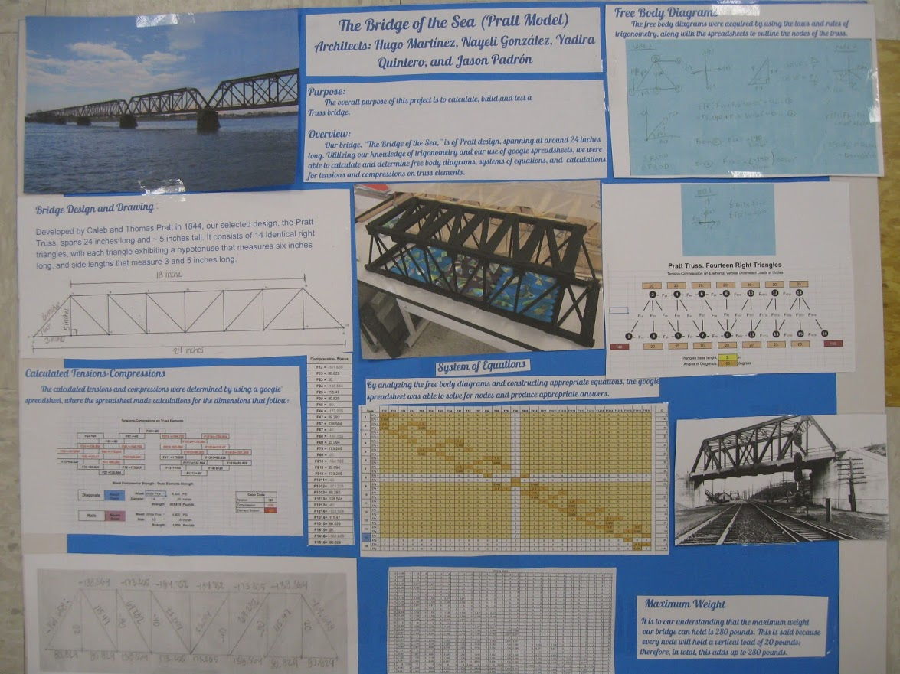

A research-style poster will be necessary to support the presentation of the model and the explanation of the work done. Poster could be a hardcopy or in electronic format. Students can google “research poster format” and find the many templates universities made public.
- Reinforce the bridge with braces (Optional)
Depending how much students want to reinforce their bridges, you can insert braces diagonally between the struts. Bracing is recommended but not mandatory. These reinforcement will help to keep the trusses straight under lateral loads. You will have to sand the ends of these braces to insert them between the struts.
- Bridge’s deck and decoration
The deck is made simply gluing craft sticks on the bridge bottom rails. The decoration of your bridge is optional and will give you extra points. For this last step your imagination and creativity are the limits.

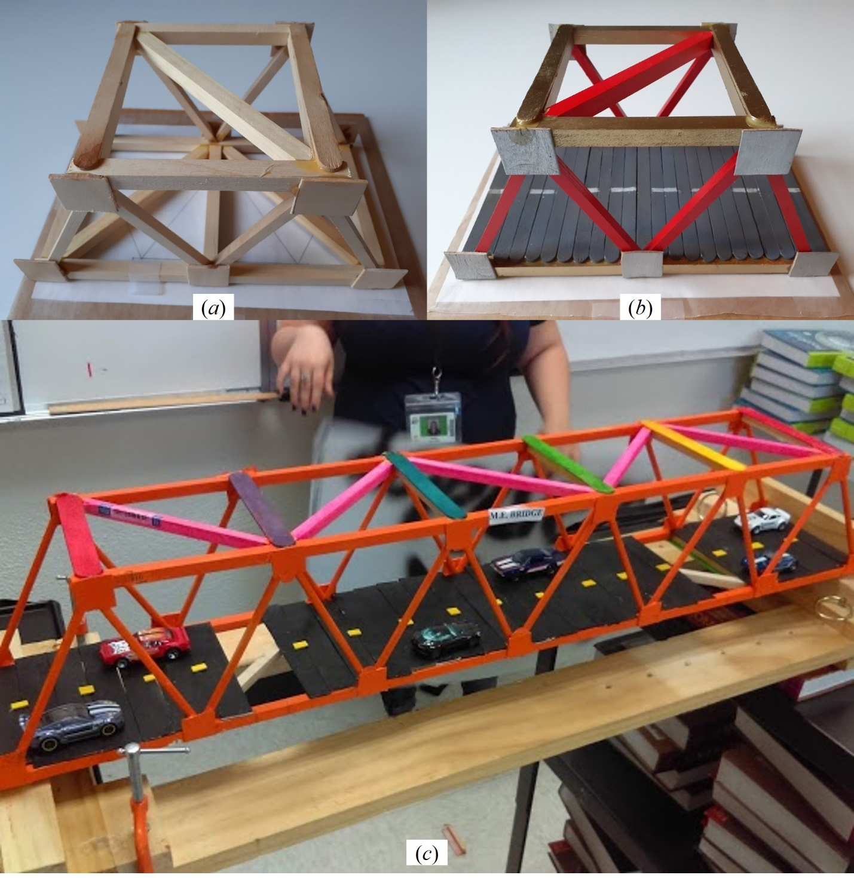

Bracing reinforce a truss bridge to resists transversal loads. Braces are placed at the top and bottom of the truss bridge, diagonally between the struts (a). To fully finish the bridge, the deck or floor has to be collocated. This can be done gluing craft-sticks on the bottom rails (b). Creativity and art in the bridge decoration will give extra points to students in the activity’s final grade (c).

Materials
The truss bridge model in this activity has to be built using only wood dowels, craft-sticks, and carpenter’s glue. Some extra tools and materials like the hacksaw, sandpaper, waxed paper, masking tape, wood, rulers, squares, drafting protractors, clamps, and paint for finishing, will be also used. All these materials can be found at places like Home Depot, Lowes, Walmart, and crafts stores like Michaels’, Joann’s, and Hobby Lobby.
The dowels thickness, kind of wood, and quantity will depend on the truss assigned, its size, required strength, and assigned budget. Next is a generic list of materials, with approximate costs (In USD):
For a bridge’s with a span of 20-28 inches:
- 1/4 in x 36 in square dowel ($1.00)
- 1/8 or 1/4 in x 36 in round ($0.90). Optional for truss elements. Trusses can be made also with the ¼ square dowel; There are available also bags of round dowels of different diameters, 12 inches long ($3.00)
- 5/16 in x 4 ½ in craft sticks ($3.00 bag w/100)
- 3/4 in x 6 in jumbo craft sticks ($6.00 box w/300)
For a bridge’s with a span of 29-36 inches:
- 5/16 in x 36 in square dowel ($1.20)
- 1/4 in x 36 in round dowel ($0.50) Optional for truss elements. Trusses can be made also with square dowel
- 5/16 in x 4 ½ in craft sticks
- 15/16 in x 8 in extra or super jumbo craft sticks ($3.00 bag w/30)
Students will select the thickness dowels, use square or round dowels, depending on their designs. Every bridge will require for it construction also:
- Carpenters glue (Recommended; Titebond II Premium wood glue, $4.00 8 oz)
- Junior Hacksaw. ($9.00)
- Sandpaper 100 and 220 ($3.00 3M General purpose packet)
- Wax paper ($3.00 /roll)
- 1 in x1 in Grid Easel paper 2.5 ft x 2.08 ft, (Usually available at school)
- Meter stick or Yard stick (Usually available at school)
- Spring clamps or bar clamps ($ 12.00 - $20.00)
- Drafting triangles, 30 cm – 12 in ruler, and protractor. (Usually available at school)
- 0.96” Masking tape ($ 3.00)
- Two 40 x 12 (approximately) cardboard sheets.

Ask your teacher which of these materials your school may provide. Also, some materials can be shared. For instance, a team may purchase the wax paper and other team the sandpaper package. The whole wax paper roll or the sand paper package is not going to be used by one team, so teams can interchange the surplus. Same will happen with the glue or masking tape. Even material like craft sticks usually may come in bags or boxes with 300 or more.
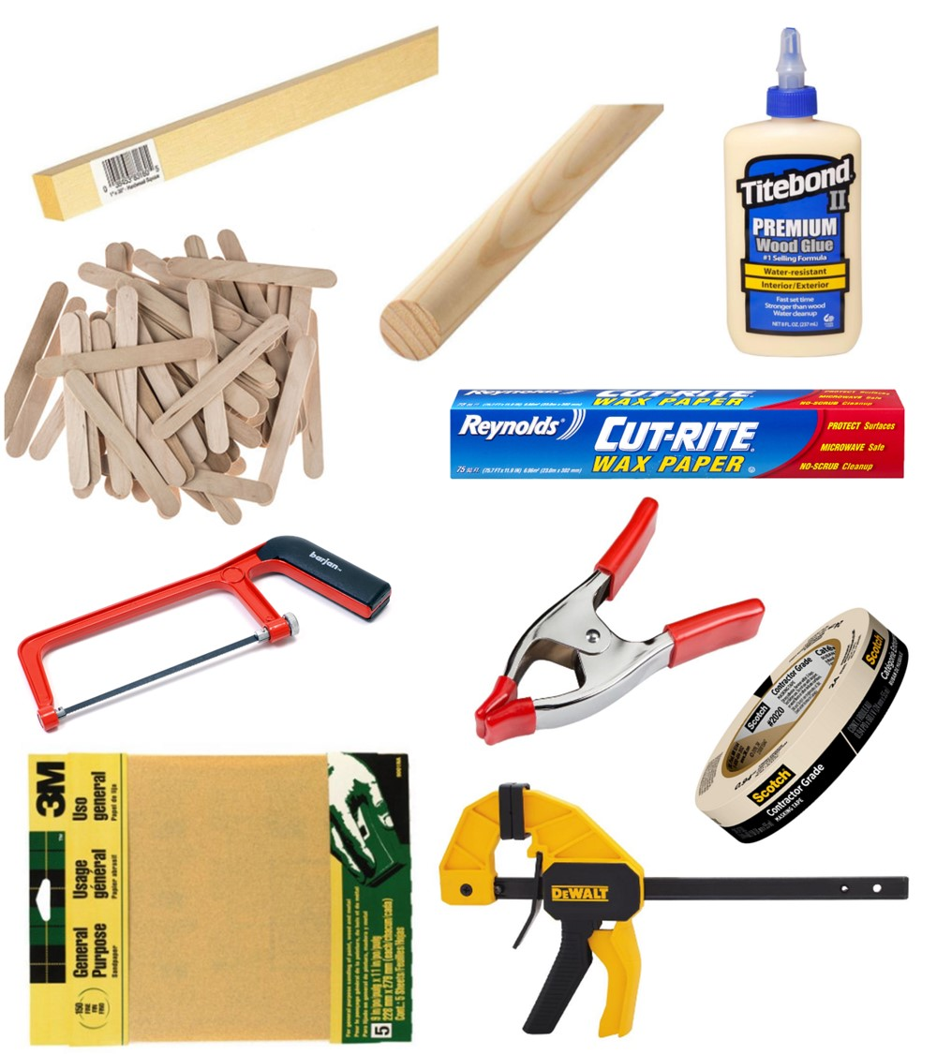

Estimation of Maximum Loads for Wood Elements
The strength of a wooden truss bridge will depend on the strength of the wood used, the glue’s strength, and on the bridge good construction. Be aware of the wood the dowels are made from. There is a big difference between Balsa Wood and Hardwood, and between Hardwood and Birch
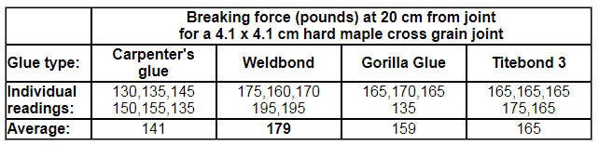
Wood glues differs in strength, and a glued joint strength also depends on joint type and the strength of the wood fibers. It is not simple to determine a glue’s strength. Different kind of tests can be found on the internet. Test performed on a cross grain joint made with a strong wood as hard maple, gives the next breaking forces:

Sometimes manufacturers give specific information about their products strengths. It can be found in the internet. that the strength for Titebond III is 4,000 psi, and for Titebond II is 3,750 psi. All this number depends on the type of test performed.
Research on the internet for information about the strength of different kind of woods. For the woods commonly used in the dowels you can find at stores:

Wood | Modulus of Rupture (psi) | Crushing Strength (psi)
Hardwood | 5,480 | 3,010
Poplar | 10,100 | 4,020
Basswood | 8,700 | 4,730
White Pine | 8,600 | 4,800
White Oak | 14,830 | 7,730
Birch | 16,900 | 8,540
Do not take the above numbers as absolute values, but as an average for that kind of wood. These values change for the different wood sub-species, and factors as water content. For a specific kind of wood you may look in on the internet for its exact values (R.10)-(R.14).
Wood has several kinds of strength. For a rough, general estimate of strength, refer to the specific gravity or density of the wood. When you need more detailed information, there are additional choices.
Engineers measure the compressive or crushing strength by loading a block of wood parallel to the grain until it breaks, and the bending strength by loading a block perpendicular to the grain.
Both are measured in pounds per square inch (psi). Stiffness is determined by applying a load to a beam until it deflects a certain amount, and it’s measured in millions of pounds per square inch (Mpsi). To find hardness, engineers drive a metal ball halfway into the wood’s surface. The force used is recorded in pounds (lbf). In each case, the higher the number, the stronger the wood. The table at the end of this annex shows values for common woods. (See Reference 17).How can we calculate the strength of a dowel using the above values?
Because the elements of a truss bridge are only under tension or compression forces along them, the number to consider is the Compressive or Crushing Strength. Knowing this number per square inch the crushing strength for a dowel of a cross section area a can be calculated using a simple proportion.
Example 1. ¼ inch square poplar dowel:  Poplar Compressive Strength: 5,540 PSI (Pounds force -lbf - per square inch)  ¼ inch poplar dowel cross area:  a = (0.25)² = 0.0625 in² | Example 2. 1/8 inch round white pine dowel:  White Pine Compressive Strength: 4,800 PSI (Pounds force -lbf - per square inch)  1/8 inch poplar dowel cross area:  a =  (1/16)² = 0.01227 in²
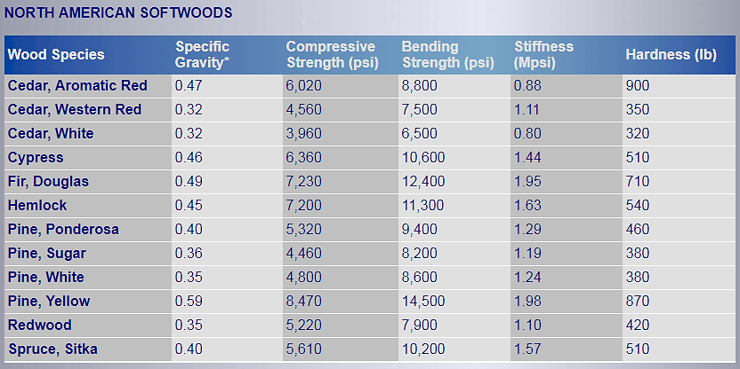
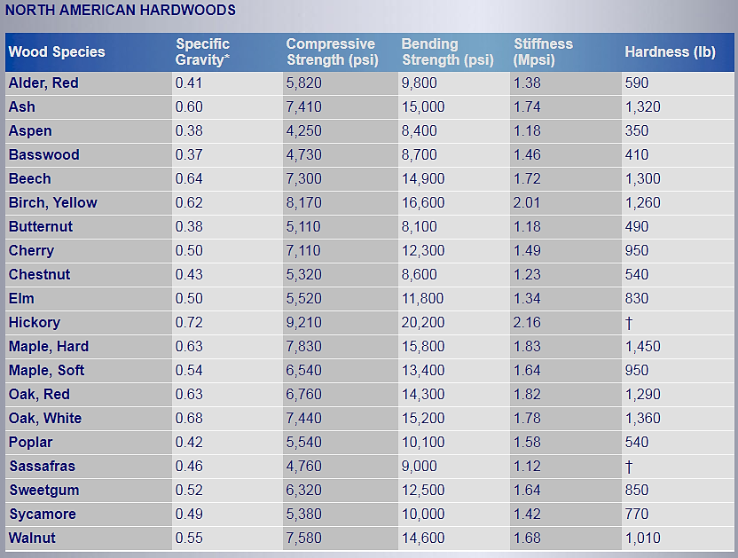

References.
- Benson, Harris: University Physics. Revised Edition. Chapter 2 Vectors. John Wiley & Sons. 1996
- Learn Civil Engineering. Structure Engineer Section Review / AM Section. Mechanics of Materials-Tension and Compression.
http://www.learncivilengineering.com/wp-content/themes/thesis/images/structural-engineering/PE-reviewStructure-Mechanics-of-Materials-Tension-and-compression.pdf
- Mr Wayne Classroom. Free Body Diagrams. The Basics. http://www.mrwaynesclass.com/freebodies/reading/index01.html
- NCDOT North Carolina Department of Transportation. Historic Bridges.
https://www.ncdot.gov/projects/ncbridges/historic/types/?p=17
- Arbabi, F. Structural Analysis and Behavior. McGraw-Hill Inc. 1991
- Wikipedia. Truss Bridges. https://en.wikipedia.org/wiki/Truss_bridge
- Wikipedia. Truss. https://en.wikipedia.org/wiki/Truss
- Pinsdaddy. Steels Pin Connections.
http://www.pinsdaddy.com/steel-pin-connections_PDE*7M5xqrsuQ099UuT1wYt2ME6U6BxL5UlfXt969ao/
- pxhere. Steel Rivet Connections. https://pxhere.com/en/photo/908147
- University of North Carolina at Charlotte. Learning Activity #3. Analyze and Evaluate a Truss.
https://webpages.uncc.edu/~jdbowen/1202/learning_activities_manual/Learning_Activity_3.pdf
- University of North Carolina at Charlotte. Learning Activity #1. Build a Model of a Truss Bridge. https://webpages.uncc.edu/~jdbowen/1202/learning_activities_manual/Learning_Activity_1.pdf
- University of North Carolina at Charlotte. Learning Activity #5. Design and Build a Model Truss Bridge.
https://webpages.uncc.edu/~jdbowen/1202/learning_activities_manual/Learning_Activity_5.pdf
(13). THE HISTORICAL MARKER DATABASE. The Pratt Through-Truss Bridge. Patuxent Branch Trail. https://www.hmdb.org/marker.asp?marker=20498
(14). The Wood Database: Poplar. http://www.wood-database.com/poplar/
(15). Woodgears.ca: Glue Strength Testing. https://woodgears.ca/joint_strength/glue.html

(16). The Wood Whisperer: Differences Between Titebond Glues. August 4, 2010.

(17). Workshop Companion: The Nature of Wood. 3. Wood Strength.

http://workshopcompanion.com/KnowHow/Design/Nature_of_Wood/3_Wood_Strength/3_Wood_Strength.htm

(14). Wood Strengths. https://www.woodworkweb.com/woodwork-topics/wood/146-wood-strengths.html

Annex 6. Rubric to Evaluate Presentation
 | Non-Professional | Quite professional | Professional
Body Language | - Reading notes or slides  - Sight not on audience  - Lacks confidence during the whole presentation  - No natural movements or gestures (fidgeting or nervous) | - Read notes or slides sometimes  - Some eye contact with audience  - Some movement and gestures  - Some confidence and poise (but still something nervous) | - Eye contact with audience,  - Little or any reading of slides or notes  - Natural movements and gestures  - Looks confident during the whole presentation
Voice | - Speaks too softly to be understood  - Speaks to quickly or slowly  - Frequently uses of word or sounds like: Ok, so…, you know…,uh, umm, I mean …  - Not using the proper technical language or formal English | - Speaks clearly most of the time  - Sometimes speaking to quickly or slowly  - Speaks loudly enough for most of the audience  - Occasionally uses words or sounds like: Ok, so…, you know…,uh, umm, I mean…  - Use proper technical language or formal English during most of the presentation | - Speaks clearly during the whole presentation  - Speaks at uniform volume, and at a normal pace, not too quickly or slowly  - Speaks loudly enough for everyone to hear  - Rarely or don’t’ use words or sounds like: Ok, so…, you know…,uh, umm, I mean …  - Use proper technical language or formal English during the whole presentation
Overall Presentation | - No main idea present, wrong, or incomplete  - Ideas presented in the wrong sequence  - Missing important steps in the development  - Missing, incorrect, or incomplete introduction and/or conclusion,  - Bad presentation time management  - Did not answer properly the asked questions | - Main idea present, but not proficiently explained  - Ideas presented in the right order, but not proficiently connected or missing important points  - Introduction and conclusion, present, but they are not effective  - Presentation done in the allotted time, but time not proficiently distributed on topics or ideas  - Answer properly and in context most of questions | - Main idea in a clear and effective way  - Ideas presented in the right order, emphasizing main points, and in context  - Effective introduction and conclusion  - Presentation done in the allotted time, and time proficiently distributed on topics or ideas  - Answer properly and in context questions. Enriching answer with relevant information or examples
Students Look | - Not wearing clothes appropriate for the occasion | - Students wearing semi-formal clothes | - Wearing clothes appropriate for the occasion. (Professional Job Interview)

Annex 7. Rubric to Evaluate Poster
 |  | Below Standard | Met Standard | Above Standard
a. | Project Title, Students’ Names | - Incomplete or missing students’ names, project name, or date | - Students names, project name, and date displayed | - Students names, project name, date displayed  - Attention Catching Format
b. | Project Description | - Missing or incomplete outline of the objective of the project  - Missing or incomplete outline of procedures and resources used  - Missing or incomplete outline of results obtained | - Correct description of the objective of the project  - Correct outline of the procedures and resources used  - Correct summary of obtained results | - Correct description of the objective of the project  - Correct outline of the procedures and resources used  - Correct summary of obtained results  - Eye catching slide format, Figures/Pictures to help understanding
c. | Truss Bridge Design | - Incorrect or missing truss design picture  - Picture included but too small or low definition picture  - Missing, incorrect or incomplete Truss dimensions on picture  - Missing or incorrect Truss Dimensions’ units  - Picture colors difficult to see | - Correct truss design picture Included  - Picture dimensions proportional to poster size and with good definition  - Correct and complete truss dimensions on design  - Correct Truss Dimensions’ units on design.  - Picture colors giving good contrast | - Correct truss design picture Included  - Picture with size proportional to poster size and with good definition  - Correct and complete truss dimensions on design  - Correct Truss Dimensions’ units on design  - 3-D view of design  - Eye catching format to design
d. | Analysis of Forces Description/ Free Body Diagram Example | - Analysis description missing or incorrect  - Text case too small or difficult to read  - Body Diagram Example missing or incorrect  - Body diagram example picture too small or low definition  - Picture colors difficult to see | - Correct analysis of forces description  - Font size easy to read  - Correct Body Diagram Example for one node  - Body diagram example picture dimensions proportional to poster size and with good definition  - Picture colors giving good contrast to picture | - Correct analysis of forces description  - Font size easy to read  - Correct Body Diagram Examples for different nodes  - Body diagrams picture size proportional to poster size and with good definition  - Picture colors giving good contrast to picture  - Eye catching format to design
e. | System of Equations resulting from Analysis of Forces | - Missing or incorrect system of equations or matrix  - System of equations picture included but too small or low definition picture  - Picture colors difficult to see | - Correct system of equations or matrix included  - System of equations picture included with dimensions proportional to poster size and good definition picture  - Picture colors giving good contrast | - Correct system of equations or matrix included  - System of equations picture included with dimensions proportional to poster size and good definition picture  - Picture colors giving good contrast to picture  - Eye catching format  - Brief explanation of method used to solve this system

f. | Load Distribution on Truss Nodes | - Missing or incorrect diagram with loads on truss nodes  - Picture included but too small or low definition picture  - Picture colors difficult to see | - Correct diagram with loads on truss nodes  - Picture dimensions proportional to poster size and good definition picture  - Picture colors giving good contrast | - Correct diagram with loads on truss nodes  - Picture dimensions proportional to poster size  - Picture colors giving good contrast to picture  - Brief comment of why all nodes were loaded  - Eye catching format
g. | Calculated Tensions-Compressions on Truss Elements | - Missing or incorrect picture with tensions-compressions on truss elements  - Picture included but too small or low definition picture  - Picture colors difficult to see | - Correct picture with tensions- compressions on truss elements  - Picture dimensions proportional to poster size and good definition picture  - Picture colors giving good contrast | - Correct picture with tensions- compressions on truss elements  - Picture dimensions proportional to poster size and good definition picture  - Picture giving good contrast to picture  - Elements with the highest tensions-compressions highlighted  - Eye catching format
h. | Pictures of Bridge Model. | - Missing Model’s Picture  - Picture included but too small or low definition picture  - Picture colors difficult to see | - Model’s Picture included  - Picture dimensions proportional to poster size and good definition picture  - Picture colors giving good contrast | - Model’s Picture included  - Picture dimensions proportional to poster size and good definition picture  - Picture colors giving good contrast  - Pictures with design and construction process  - Process steps
i. | Poster Neatness, Creativity, and Artistic Touch | - Poster not formatted  - Difficult to read fonts used  - Information dispersed on poster. Not Layout flow (for easy reading)  - Font color difficult to read | - Poster professionally formatted  - Most of the text used presentation in readable Font (Size > 24, appropriate color)  - Poster with good layout flow (Information organized to easily read project’s steps sequentially) | - Poster professionally formatted  - Most of the text used presentation in readable Font (Size > 24, appropriate color)  - Poster with good layout flow (Information organized to easily read project’s steps sequentially)  - Poster professionally formatted. Eye catching design

