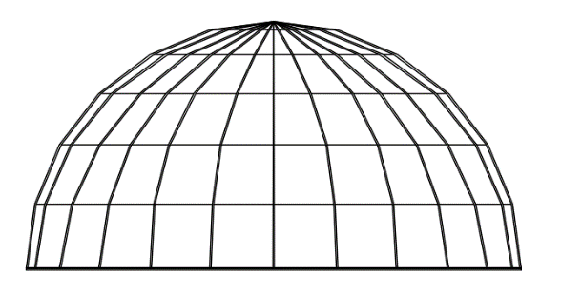**Activity Pre-Quiz Answer Key**

**The problem:** A 25-m diameter semispherical segmented dome is going to be constructed (see *Figure 1*). Six equal-length segments will be used to create the revolving line (see *Figure 2*). *Table 1* shows the relative positions of the revolving line vertices. Assuming the dome is a solid of revolution, **find the dome’s volume.** Show your work and give the result with three decimal places.

**Figure 1**

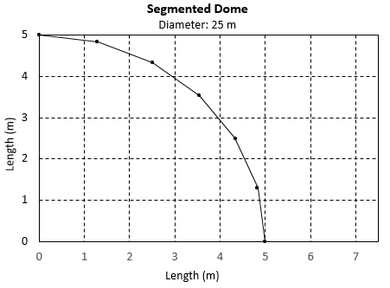

|  |  |
| --- | --- |
| ***x* (*m*)** | ***y* (*m*)** |
| 0.00000 | 5.00000 |
| 1.29410 | 4.82963 |
| 2.50000 | 4.33013 |
| 3.53553 | 3.53553 |
| 4.33013 | 2.50000 |
| 4.82963 | 1.29410 |

**Table 1**

**Figure 2**

Answer:

The same solid is obtained revolving around the *x*-axis or *y*-axis. The volume obtained revolving the segmented line around the y-axis can be computed the using the following formula:

Because no algebraic expression exists for the segmented line, a numerical integration must be performed. The trapezoidal rule for non-uniform partitions is appropriate for this problem:

Then, the volume can be computed using the following expression:

Taking *R*(*yi*) = *xi*, the *x*-values in Table 1:

V  ½  [(52 + 4.829632)(1.2941 – 0) + (4.829632 + 4.330132)(2.5 – 1.2941) +

(4.330132 + 3.535532)(3.53553 – 2.5) + (3.535532 + 2.52)(4.33013 – 3.53553) +

(2.52 + 1.29412)(4.82963 – 4.33013)]

V  258.843 *m*3



Note: Volume of half-sphere of radius 5 *m*: