**Practice Problems Answer Key**

1. A part of the function *f* (*x*) = 4 – 0.25(*x* – 4)2 is approximated by a straight segment on the interval [0, 2]. Is there a point between 0 and 2 for which a line tangent to the function is parallel to the segment?

*The slope of the segment joining points* (0, 0) and (2, 3) is:



*The slope of a tangent line of a function is obtained through the derivative of the function:*



*Because the tangent line and the segment have to be parallel for an x-value between* 0 *and* 2*, the two above expressions must be equal*:



*Tangent line* at *x* = 1 *is parallel to the segment joining points* (0, 0) *and* (2, 3)

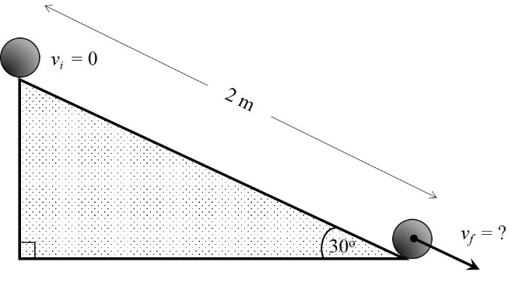2. A solid homogenous sphere of 4 kg mass and radius 0.1 m rolls down a 2-meter-long incline. The angle of the incline to the horizontal is 30o. The initial velocity of the sphere is zero at the top of the incline. Calculate:

A. The static friction coefficient for this system

B. The friction force between the incline and the sphere

C. The final velocity of the sphere at the end of the incline

1. Using lesson formula (7):
2. Using lesson formula (4):

1. Using lesson formula (18) and considering the height on the incline *h* = *f* (*x*):

*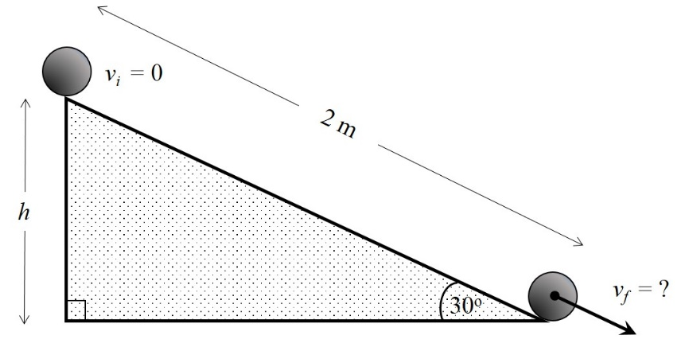Initial height of sphere*:

*f* (*xi*) = *hi* = 2sin(30o) = 2* ½ = 1 *m*

*Final height of sphere*:

*f* (*xf*) = *hf*= 0

*Sphere’s initial velocity*:

*v*0 = 0

