**Annex 1: Truss Analysis. The Method of Joints**

*Warren Truss Analysis. Loads on Truss Nodes*

In this section it will be analyzed a simple Warren truss created with five **equilateral** triangles, using the *Method of Joints* (5). The analysis for isosceles triangles will be similar. The analysis for a structure with more triangular elements will be also similar.

60o

4 in

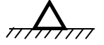

2

4

6

3

5

1

7

In this analysis it is considered that:

(a). Vertical downward forces are applied on truss nodes. Weight of truss elements negligible

(b). The bridge is supported at bottom nodes 1 and 7 only.

(c). Only tension and compression forces are considered acting along the structure’s segments.

(d). Elements are considered rigid. Structure’s segments do not bend.

(e). Once determined a tension or compression force at one end of the segment, the complementary force at the other end will be equal but in opposite direction.

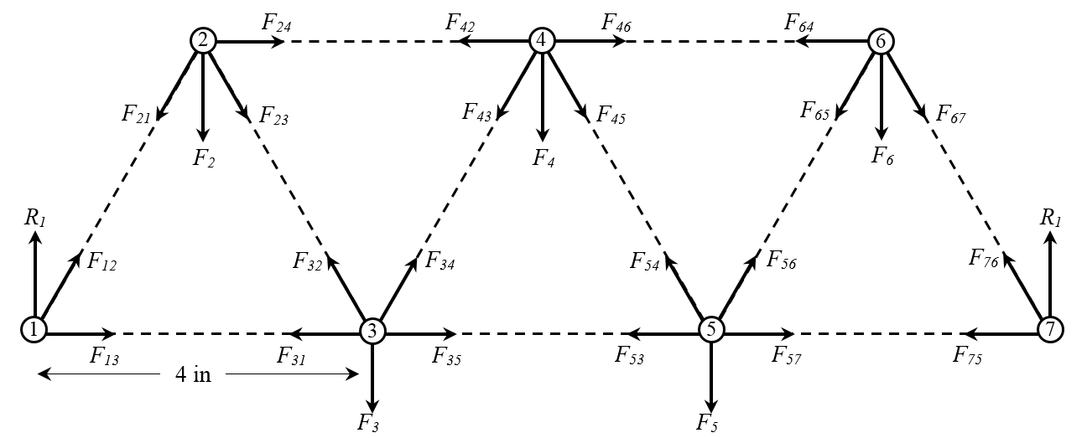

The forces on every node are illustrated above. The vertical forces acting on the upper nodes are denoted by *Fn*, *n* being the node’s number. Forces along the segments are denoted by *Fnm*, where *nm* denotes the force points from node *n* to node *m*. The reactions on the bridge supports are denoted by *Rn*. The solutions of the equilibrium conditions will specify the force magnitude and its action on the node as compression or tension.

The first that have to be calculated are the reactions on the supports. For this, it is necessary to use the moments around the nodes 1 and 2 produced by the vertical forces *F*2, *F*3, *F*4, *F*5, and *F*6., and the also vertical reactions *R*1 and *R*2. Considering the bridge elements dimensions specified in Figure.08, -equilateral triangles of side 4 in-, the equations for the moment’s equilibrium are:

Moment around Node 1: $M_{1}={-F}_{2}∙2-F_{3}∙4-F_{4}∙6-F_{5}∙8-F_{6}∙10+R_{7}∙12=0$

(3)

Moment around Node 7: $M_{7}=R_{1}∙12-F_{2}∙10-F_{3}∙8-F_{4}∙6-F_{5}∙4-F_{6}∙2=0$

The negative sign indicates the downward direction of the forces. To simplify calculations a little, assume that the three applied vertical forces are equal to 4 pounds: $F_{2}=F_{3}=F_{4}=F_{5}=F_{6}=4 {lb}_{f}$. With this assumption:

$$M_{1}=-4∙2-4∙4-4∙6-4∙8-4∙10+R_{7}∙12=0$$

$$M_{7}=R_{1}∙12-4∙10-4∙8-4∙6-4∙4-4∙2=0$$

Solving these equations for *R*1 and *R*7:

*R*1 = 10 *lbf R*7 = 10 *lbf*

(4)

With these additional values (4), it is possible now to set up the equilibrium conditions (1) for every node. This will produce a system of equations whose solutions will the tension-compression forces on the elements. But according to the diagram in Figure.08, there will be 14 equations (2 per-node) with 22 variables, and this will not produce any solution. But according to the definitions of tension and compression forces, the magnitude of these forces must be the same at the ends of every element, i.e. *Fmn* = *Fnm* . This assumption gives a new forces diagram below:

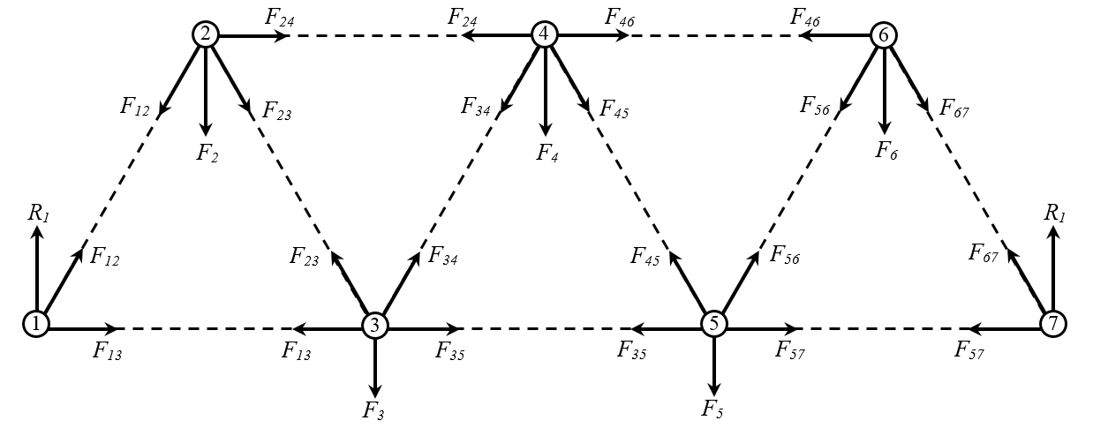

*R7*

There are now 14 equations to determine the values of 11 variables. This over-determination will not be a problem. It is also important to notice that the assumption *F*2 = *F*3= *F*4 = *F*5= *F*6, simplifies substantially the computations. Because of the symmetry of the structure, the values for the forces on nodes 1, 2, and 3, will be the same for the forces on nodes 5, 6 and 7. So in this case, it will not be necessary solve all the nodes.

In this analysis, all forces magnitudes are positive, and the direction of the force projection on the axes will be specified in the equation, i.e. If the projection is on the positive part of the axis (right or upward), this projection is added; If the projection is on the negative part of the axis (left or downward), this projection is subtracted. The equilibrium equations for the nodes will be obtained from the corresponding free body diagrams:

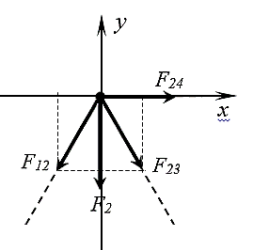

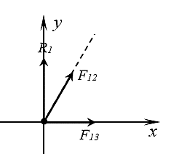



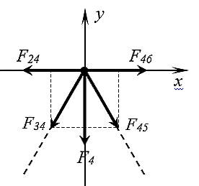

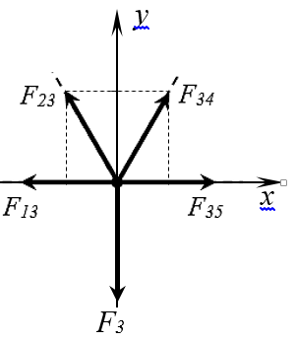



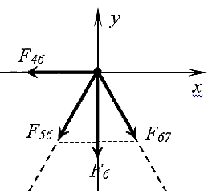

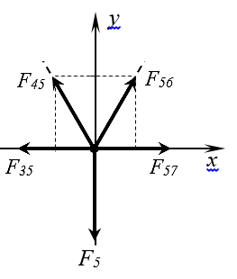





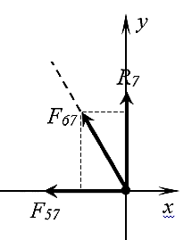

The above obtained equilibrium conditions, plus the system resulting after substituting the values of the known forces - reactions, and sin 60o, cos 60o approached by 0.866, 0.5 respectively, are summarized in the next table:

|  |  |  |
| --- | --- | --- |
| **Table 1. Warren Truss. Equilibrium Conditions for 7 Nodes – 11 Elements** | | |
| **Node** | ***Fy* = 0**  ***Fx* = 0** | |
| 1 | *R*1 + *F12* sin60o = 0  *F12* cos60o + *F13* = 0 | 10 + 0.866 *F12* = 0  0.5 *F12* + *F13* = 0 |
| 2 | *– F2 – F12* sin60o  *F23* sin60o = 0  *–F12* cos60o + *F23* cos60o + *F24* = 0 | *–*4 *–* 0.866 *F12*  0.866 *F23* = 0  *–*0.5 *F12* + 0.5 *F23* + *F24* = 0 |
| 3 | *– F3 + F23* sin60o + *F34* sin60o = 0  *–F13 – F23* cos60o + *F34* cos60o + *F35* = 0 | *–*4 + 0.866 *F23* + 0.866 *F34* = 0  *–F13 –* 0.5 *F23* + 0.5 *F34* + *F35* = 0 |
| 4 | *– F4 – F34* sin60o  *F45* sin60o = 0  *–F24 – F34* cos60o + *F45* cos60o + *F46* = 0 | *–*4 *–* 0.866 *F34*  0.866 *F45* = 0  *–F24 –* 0.5 *F34* + 0.5 *F45* + *F46* = 0 |
| 5 | *– F5 + F45* sin60o + *F56* sin60o = 0  *–F35 – F45* cos60o + *F56* cos60o + *F57* = 0 | *–*4 + 0.866 *F45* + 0.866 *F56* = 0  *–F35 –* 0.5 *F45* + 0.5 *F56* + *F57* = 0 |
| 6 | *– F6 – F56* sin60o  *F67* sin60o = 0  *F46 – F56* cos60o + *F67* cos60o = 0 | *–*4 *–* 0.866 *F56*  0.866 *F67* = 0  *F46 – 0.5 F56* + 0.5 *F67* = 0 |
| 7 | *R*7 + *F67* sin60o = 0  – *F57* – *F67* cos60o = 0 | 10 + 0.866 *F67* = 0  – *F57* – 0.5 *F67* = 0 |

The standard way solve the above equations is by substitution. Solving first the Node 1 equations, the solutions obtained are used to solve Node 2 equations. The solutions obtained in Node 2 are next used to solve Node 3 equations, and so on until finish solving the last node equations.

Node 1:

(Compression Force)



(Tension Force)



Node 2:

(Tension Force)



(Compression Force)



Node 3.

(Compression Force)



(Tension Force)

Node 4.

(Tension Force)



(Compression Force)

Because of the symmetry and conditions assumed in this case, the solutions obtained until this point can be used to determine the forces on the remaining elements (Fig.10).

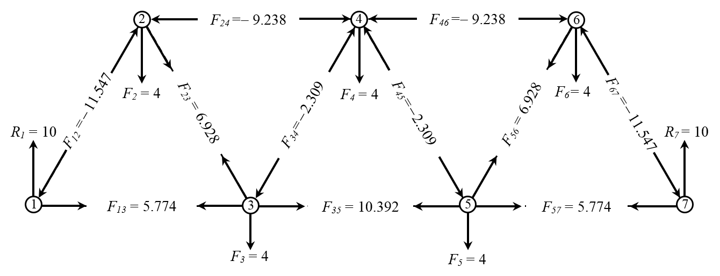

But the solutions of the remaining equations have to verify these values:

Node 5.

(Compression Force)



(Tension Force)



Node 6.

(Tension Force)

At this point all the stresses-compressions on the structure’s elements have been determined. It can be seen that the above calculations confirms the results from the symmetry assumption above. The remaining equations can be used for additional verification:



(True)

Node 7.

(True)



(True)

The above procedure has to be repeated every time the load forces *Fi* are modified. This is not very efficient when the forces may be changed several times or the number of elements is increased. An alternative and more efficient approach that uses math software and technology, is to write the system of equations in Table.1 as a matrix. Then through the inverse of this matrix the stresses-compressions can be determined. The system of equations in Table 1, can be summarized in the next coefficients’ matrix:

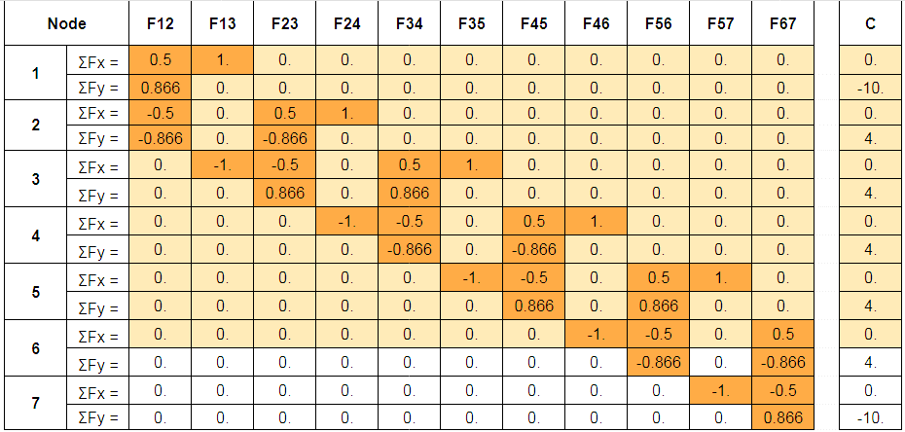

As it was previously annotated, this is a system of 14 equations (2-per-node) with 11 variables (the stress-compression on every element). Given that the inverse matrix exists only for the square matrices, it is recommendable to solve the equilibrium equations at nodes 1 through 5, and complete the system with one of the equations at node 6. The system in matrix form is then:



(5)

System (5) can be denoted as: $A∙\vec{F}=\vec{c}$, where ***A*** is the coefficients matrix, $\vec{F}$ is a vector whose components are the forces on the truss elements, and $\vec{c}$ a vector whose components are the forces-reactions on the structure. It is well known in basic Algebra, that the solution of a *n*x*n* (square) matrix system of equations:, can be obtained using the inverse matrix: $\vec{F}=A^{-1}∙\vec{c}$, Because this is a big matrix, it will be necessary to use a math software and technology to find its inverse.

When a TI-Nspire CX is the available resource, and your system is no bigger than the above one, follow the next procedure:

(a). Open a *Calculator* document

(b). Select Menu → Matrix & Vector → 1:Create → 1:Matrix, and create the extended matrix of your system (coefficients + forces- reactions values *c*), in this case create a matrix of 11 rows by 12 columns.

(c). Type your numbers in the matrix format shown. Be very careful in your typing. When finished, store your matrix in the calculator’s memory: press *ctrl* + *var* + m, then press *enter.*

(d). Type rref(m) and press enter. Check the last column of the displayed matrix for the system solutions

For larger systems than (5), and really for systems of any size, it is convenient to use a computer spreadsheet like MS-Excel or Google Sheets. The use of a computer makes much more efficient the typing and data review, but requires a couple more of steps to reach the solutions. The procedure in MS-Excel and Google Sheets are practically identical:

(a). Open a new spreadsheet.

(b). Label the rows and columns of your matrices to make easier your work. Type the matrix of coefficients (Fig.11. Table 1) obtained from the analysis of all the structure nodes. Identify the equations that will be solved, in this case the first eleven, corresponding to nodes 1 to 6 (Fig.12)

(c). Select the cells in the spreadsheet where the inverse is going to be placed. These must be same rows and column identified in the above point (b). Select the command bar and type: =minverse(b2:l12) (range where coefficients are), and press enter (shift+ctrl+enter in MS-Excel). The inverse matrix will appear in the selected region below.

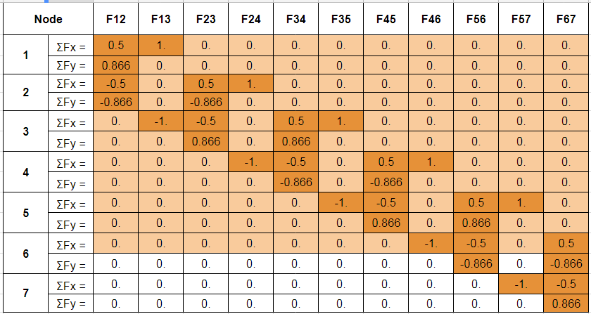

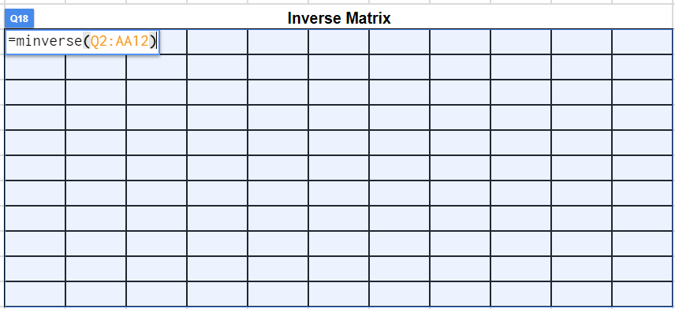

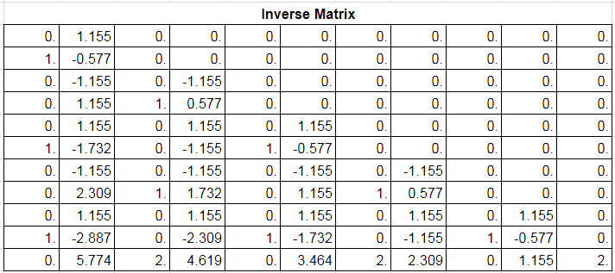

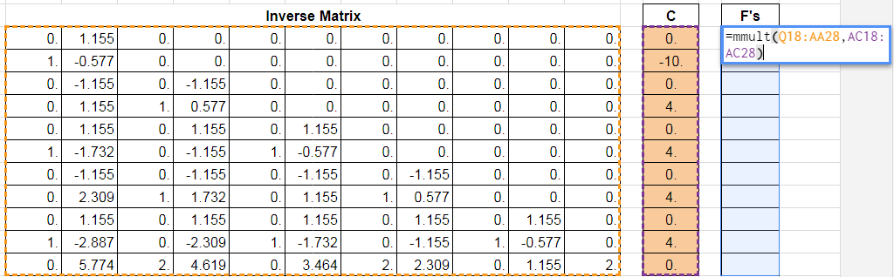

(d). Type next to the inverse matrix the vector with the values of the loads-reactions on the structure. Select the cells where the solutions are going to be placed (same size as the loads-reactions vector), and type: =mmult(b18:l28,n18:n28) (ranges where matrices are), and press enter to calculate the solutions or stress-tensions on truss elements displayed on the worksheet.

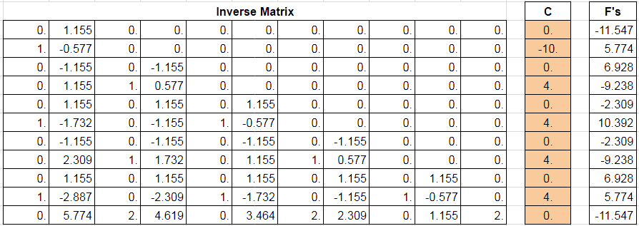

The advantage to use a computer spread sheet like MS-Excel or Google Sheets in these analysis, is the simple way to recalculate the resulting forces when the loads on the truss nodes are changed. It is only necessary to change entries in the loads reactions vector.

*Pratt Truss - Howe Truss Analysis. Loads on Nodes*

These trusses are very similar. Their trusses’ elements are arranged in right triangles, but these differ in the orientation of the hypotenuses of these triangles

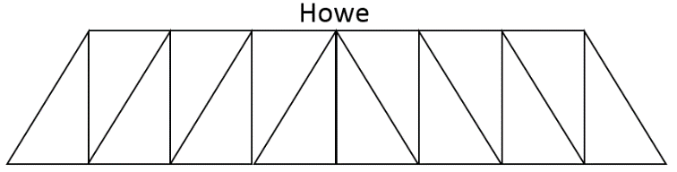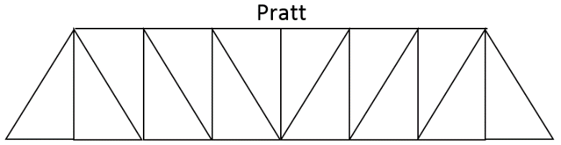

The analysis of forces on these trusses is very similar, so only the Howe truss will be explained here

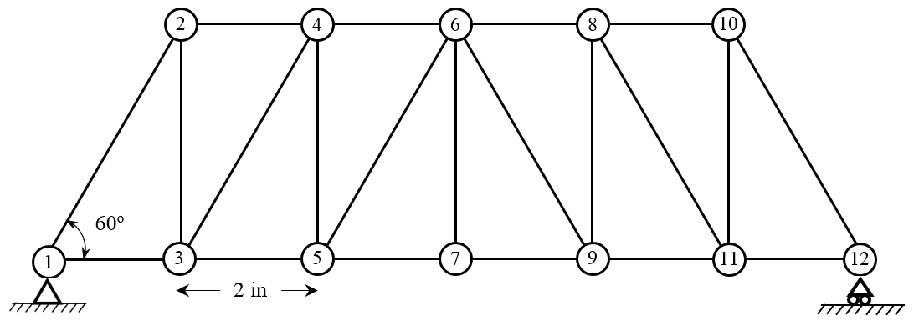

Here will be analyzed using again the Method of Joints (5), a ten triangular elements Howe truss, whose diagonals make 60o with the horizontal. The assumptions are going to be same as in the Warren truss analysis:

(a). Vertical downward forces are applied on truss nodes. Weight of truss elements negligible

(b). The bridge is supported at bottom nodes 1 and 12 only.

(c). Only tension and compression forces are considered acting along the structure’s segments.

(d). Elements are considered rigid. Structure’s segments do not bend.

(e). Once determined a tension or compression force at one end of the segment, the complementary force at the other end will be equal but in opposite direction.

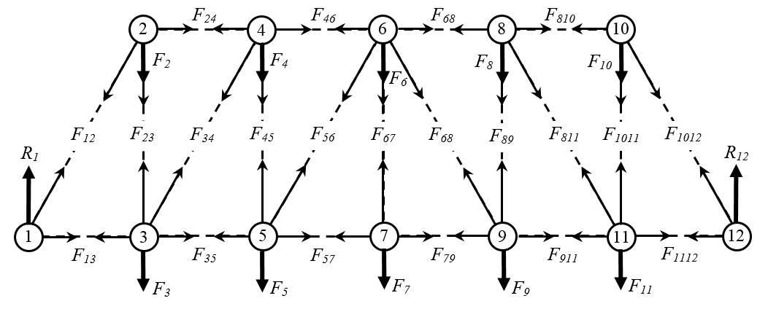

The analysis of forces on this truss nodes will be similar to the one performed for the Warren truss. Then, only some of the nodes will be explicitly solved. Also in the case of equal loads on the nodes, the problem will be symmetric, i.e. tensions compression on nodes 8 – 12 will be equal to those on nodes 1 – 5.

The analysis of forces on nodes 1 & 12 is the same as in Warren truss; analysis on node 2 is similar to Warrens truss node 2, but with one element vertical. In Fig.17 it can be seen that the analysis of forces on nodes 3 and 5 is identical. Analyzing then nodes 4, 5, 6 and 7:

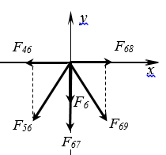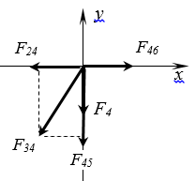

*Fy =* 0

*Fx =* 0

*– F4 – F45 * *F34* sin60o = 0

*– F24* – *F34*cos60o + *F46* = 0

**Node 4.**

**Node 6.**

*Fy =* 0

*Fx =* 0

*– F6 – F67 * *F56* sin60o – *F69*sin60o = 0

*– F46 – F56* cos60o  + *F69* cos60o  + *F68* = 0

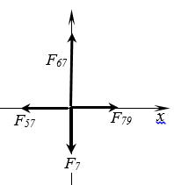

**Node 7.**

**Node 5.**

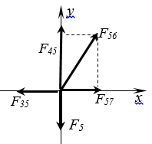

*Fy =* 0

*Fx =* 0

*– F7 + F67* = 0

*– F57* + *F79* = 0

*Fy =* 0

*Fx =* 0

*– F5 + F45*  *F56* sin60o = 0

*– F35* + *F56* cos60o + *F57* = 0

It is possible again to write in a matrix array the equations resulting from the analysis of forces on all the nodes. For this 12 nodes-21 elements structure, again using MS-Excel or Google Sheets, and the values for sin 60o and cos 60o, the matrix array is shown in Figure 19:

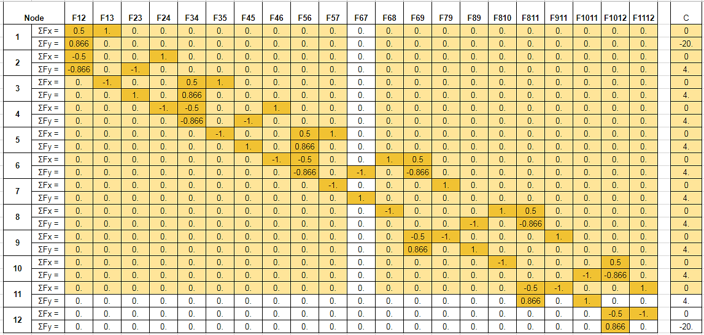

Same as in the Warren truss case, there are more equations than variables, but only 21 of the 24 equations have to be used.to find the values of the tension-compression on the truss elements. The computational procedure is similar to the one described in Warrens case.

For the particular case of an equal load of 4 pounds on every node, the calculated tensions and compressions on the elements are shown below:

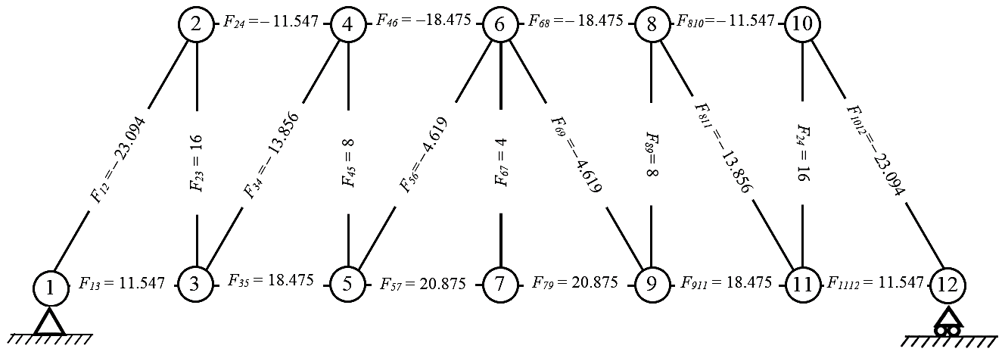

**NOTE:** There are available calculation worksheets to help you verify your solutions for the Warren Truss, for the Pratt or the Howe trusses, for different numbers of elements. Click on the link: <https://sites.google.com/gpapps.galenaparkisd.com/mramirez-math/courses-highlights/bridges/trusses-calculations>

