Mars Thermos Worksheet
Today, you will conduct an experiment to demonstrate the movement of atoms and molecules through temperature measurements and engineer a design that can slow down that movement.

Take a few minutes and, in your own words, write the definitions of these words and phrases:
HEAT_____________________________________________________________________________

TEMPERATURE____________________________________________________________________

EQUILIBRIUM______________________________________________________________________

THERMAL ENERGY TRANSFER_______________________________________________________

Before you begin setting up the experiment, can you predict how the temperature will change in each cup? Using the vocabulary from above, write a hypothesis for what you think will happen in the experiment.
__________________________________________________________________________________ __________________________________________________________________________________ __________________________________________________________________________________
__________________________________________________________________________________
__________________________________________________________________________________
__________________________________________________________________________________
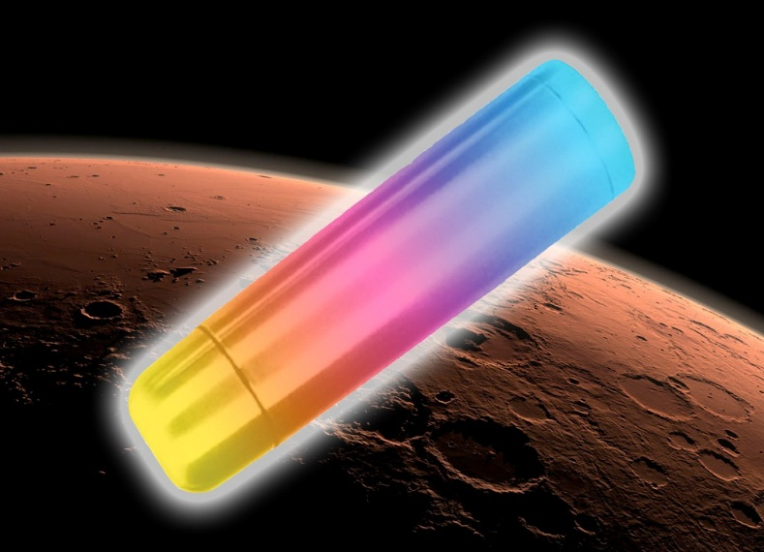

- Record the temperature of the room: _________°F.
- Decide how much water you should use in your cup. Our group has decided to use ______ml of water because ________________________________________________________________.
- Decide how often you will record the temperature for each cup of water.
- Using a graduated cylinder, measure ice water (with no ice) and pour it into one small cup. Repeat for hot water (from the tap or from your teacher).
- Perform the control experiment (no insulation). Record your data in the “Control” column in the table below.
- Collect necessary materials, create a Mars Thermos for each cup, and perform the experiment, noting the data in the data table below. Your goal is to limit the temperature change of the water to no more than 5°F in 10 minutes. Note the materials you are using for each cup here:
__________________________________________________________________________________ __________________________________________________________________________________ __________________________________________________________________________________
__________________________________________________________________________________
__________________________________________________________________________________
__________________________________________________________________________________

- Improve your design by trying another combination of materials and repeat the experiment. Record your results using the table for Trial 2. Note changes here:
__________________________________________________________________________________ __________________________________________________________________________________
__________________________________________________________________________________
- If time allows, repeat the experiment a third time with a different amount of water. Does the amount of water affect the temperature loss? ____________
- What can you conclude from your experiment?
__________________________________________________________________________________ __________________________________________________________________________________ __________________________________________________________________________________
__________________________________________________________________________________ Mars Thermos Data Table
Time  Min:sec | Cold Water Cup (°F) |  |  | Hot Water Cup (°F)
Time  Min:sec | Control | Trial 1 | Trial 2 | Control | Trial 1 | Trial 2
0:00

Graph the results from your experiment, using the data from either Trial 1 or Trial 2. Time is the independent variable in this experiment. You, as the experimenter, decide when to take temperature readings. The independent variable is plotted on the x-axis. The temperature of water is the dependent variable in this experiment. The temperature of water depends on the time it was measured. The dependent variable is plotted on the y-axis. Label the y-axis below and plot your data using dots. Connect your dots to make a line. Draw two lines in two different colors to distinguish the data from each cup.

Mars Thermos Graph

y
Temperature (°F)
0 |  |  |  |  | Time (sec) |  |  |  |  | x

