Rube Goldberg Rubric

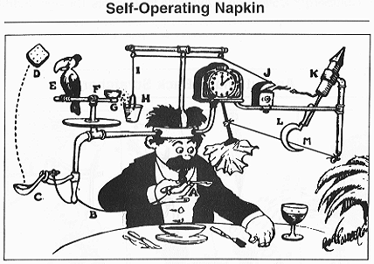

 | Points | Total
The device uses all 6 simple machines. | 10 pts each
Each team member made two steps. | 20 pts
All the steps in the device works together. | 20 pts

