Name: _____________________________________________________________________________ Date: ____________________________ Class: _____________________
Photosynthesis and Cellular Respiration Activity Worksheet Answer Key
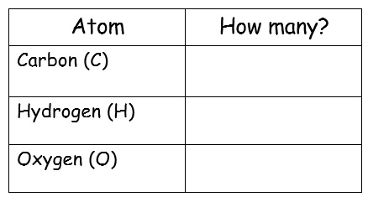
Initial Mass: Student-weighed mass
Final Mass: Student-weighed mass _______________
Initial Mass: Student-weighed mass
Final Mass: Student-weighed mass
ATP
Molecules used to power life activities

Cellular respiration takes place in
________________________________________________________
Photosynthesis takes place in
________________________________________________________
Table 3 Final Atom Count
Table 4 Final Atom Count
Table 2 Initial Atom Count
Table 1 Initial Atom Count
glucose + oxygen
H₂O
carbon dioxide + water
O₂
C₆H₁₂O₆
CO₂

Light energy

Chloroplasts (in plants)
6
1
12
2
8
3

1
6
Mitochondria (in plants and
animals)
12
2
3
8

Photosynthesis and Cellular Respiration Activity Worksheet Answer Key
ATP
Molecules used to power life activities

Cellular respiration takes place in
________________________________________________________
Photosynthesis takes place in
________________________________________________________
Table 3 Final Atom Count
Table 4 Final Atom Count
Table 2 Initial Atom Count
Table 1 Initial Atom Count
glucose + oxygen
carbon dioxide + water
C₆H₁₂O₆
6 O₂
6 H₂O
6 CO₂

Light energy

6
Chloroplasts (in plants)
6
12
12
18
18

6
6
Mitochondria (in plants and
animals)
12
12
18
18
Initial Mass: Student-weighed mass (should equal or be close to final mass)
Final Mass: Student-weighed mass (should equal or be close to initial mass)
Initial Mass: Student-weighed mass (should equal or be close to final mass)
Final Mass: Student-weighed mass (should equal or be close to initial mass)

