Name: _____________________________________________________________________________ Date: ____________________________ Class: _____________________
Photosynthesis and Cellular Respiration Activity Worksheet
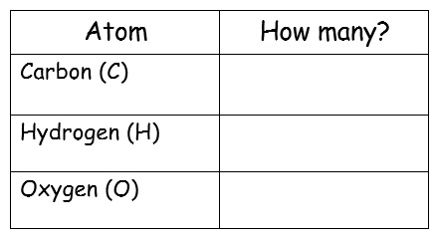
Initial Mass______________
Final Mass _______________
Initial Mass______________
Final Mass _______________
ATP
Molecules used to power life activities

Cellular respiration takes place in
________________________________________________________
Photosynthesis takes place in
________________________________________________________
Table 3 Final Atom Count
Table 4 Final Atom Count
Table 2 Initial Atom Count
Table 1 Initial Atom Count
glucose + oxygen
H₂O
carbon dioxide + water
O₂
C₆H₁₂O₆
CO₂

Photosynthesis and Cellular Respiration Activity Worksheet
__H₂O
__CO₂
Initial Mass______________
Final Mass _______________
Initial Mass______________
Final Mass _______________
ATP
Molecules used to power life activities

Cellular respiration takes place in
________________________________________________________
Photosynthesis takes place in
________________________________________________________
Table 3 Final Atom Count
Table 4 Final Atom Count
Table 2 Initial Atom Count
Table 1 Initial Atom Count
glucose + oxygen
carbon dioxide + water
__O₂
__C₆H₁₂O₆

