Reference: CAD Model to G-Code
Step 1: CAD Solid Model to Stereolithography File
Background
Each software has its own way of converting a stereolithography file (a set of coordinate data points) to a solid model. Each type of software uses chords (in a circle, a straight line segment whose endpoints both lie on the circle edge) to divide up the object. The concern when dividing up the object is with curved edges/surfaces. Since circles and arcs, by definition, are made up of an infinite number of points, CAD software is unable to produce them because they lack the processing power. A solution the software employs is to create a polygon with a lot sides to represent an arc or circle. (See the figures below.)
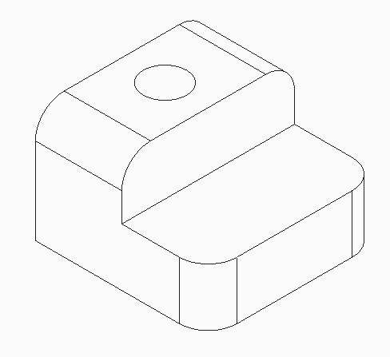
Left image: a zoomed-in view of edge of the hole in the above CAD model
Right image: the colors denote the polygonal edges of the hole in the CAD model

Chord Length
The higher the chord number, the more polygonal the object will look; the lower the chord number, the rounder the model will look. (Note: zero as a chord number is not an option because there needs to be distance between points.)
Figure 3: Chord Length = Smallest Spacing Possible Allowed by Software
Figure 1: Original Object Figure 2: Chord Length = 1
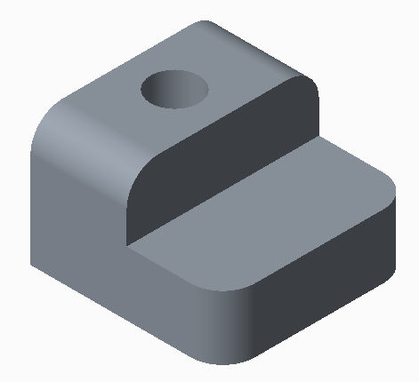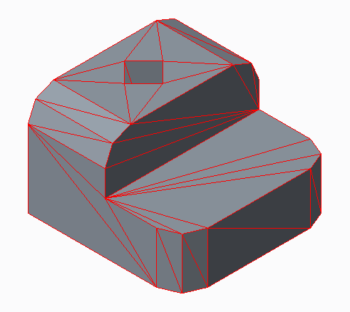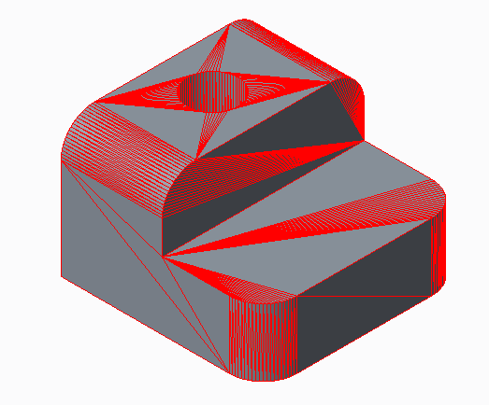

The red lines on the object represent the coordinate points that form the geometry. Figure 2: an object with a high chord length from the original object (Figure 1) has a hole that has turned into a square. Figure 3: with a low chord, length the hole (although not truly a circle) has points close enough together to appear as a circle.
Advantages and Disadvantages to Chord Length
Disadvantages
High Chord Length
- High chord length results in poor resolution. The features on the part will not be as detailed.
- Curved or circular features will be more polygonal than circular.
- The surface finish maybe coarser, depending on the geometry.
- It is difficult to assemble mating pieces, because it is hard to match the geometry between pieces. The dividing of coordinate points is calculated by the software and the user does not have control on how the polygonal shape is rendered.
Low Chord Length
- Results in longer print time.
- Machine motors may not be able to traverse a such a small distance between coordinate points, which may result in a failed print.
Advantages
High Chord Length
- Results in a shorter print time.
- Machine motors will have little strain moving between coordinate points.
Low Chord Length
- Provides a better resolution.
- Offers better print quality..
- Curved and circular features will be created as round as possible, making pieces easier to assemble.

Step 2: CAD Model and G-Code from Slicing Software
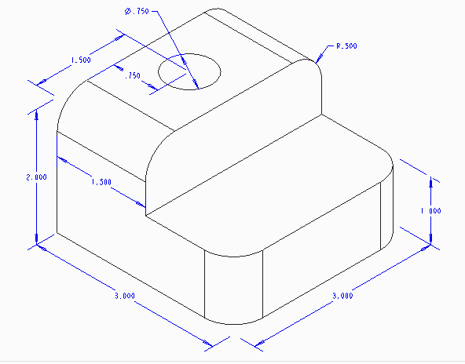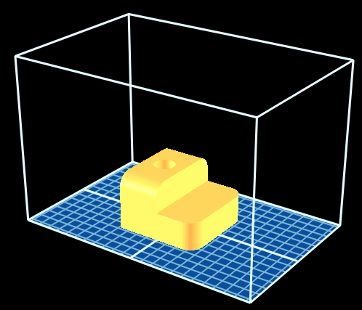
Model Slicing Software on Build Plate

G-code will vary slightly based on the machine being used. The settings below are produced by replicator G-code slicing software that is designed to be imported on a Makerbot Thing-O-Matic printer with the following settings:
Settings
Chord Height: Set to the lowest chord level possible.
Layer Height: 0.3 mm
Shells (Wall Thickness): 2
Note: shells represent the number of passes the extruder head will make in outlining the part. The size of the extruder head nozzle will determine how thick the walls of the object will be. The user should also consider if the model will be finished (sanded) or if holes will be tapped for threads. In this case, the walls of the object should be thicker.
Infill %: 20%
Note: the user can determine how much solid material will be on the inside of the shells. This percentage should be modified if the model needs to support more load upon testing. An infill of 20% will allow the print to construct a latticework that takes up 1/5 of the inside of the model.
Scale: Full
Full Code: See the attached Notepad file: Reference CAD Model to G-Code Full Code.

