G-Code Coding Assignment
Directions: Write a G-code program in ncviewer.com for the following:
- L-Block
- U-Block
- Bracket
- Tool Rest
Be sure to also include the following code:
- Machine setup: use the Machine Setup and Shutdown Code from the G-code tutorial.
- Homing position: adjust the homing position based on the part. Be sure the home position is above and away from the part by a minimum of 30 mm.
- Tool path: consider the direction of the tool path. Limit the number of times that the tool traces over the same line. (Hint: move the tool off the part and reposition using G00 to avoid tracing any lines). Mark any traced lines with a comment within the code.
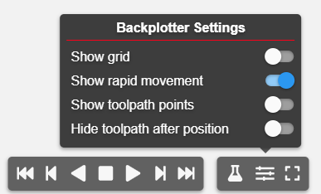
You may consider turning the grid off as parts will be larger than the given grid. Go to Backplotter Settings > Show Grid

Part 1: L-Block
References: Origin and coordinate points.
Part: metric

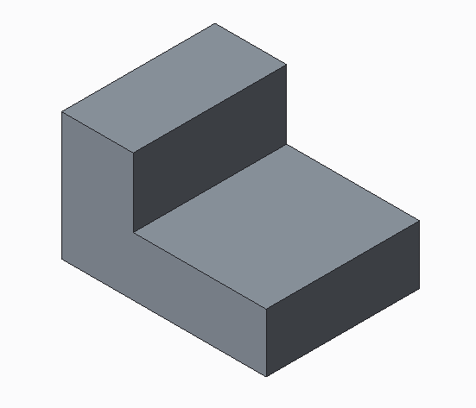

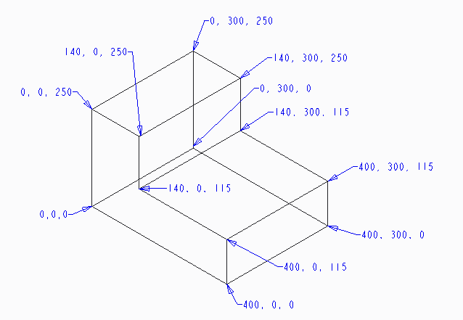

Part 2: U-Block
References: Dimensions of the part.
Step 1: Determine the origin point.
Step 2: Convert dimensions into coordinate points.
Step 3: Write the program.
Part: metric

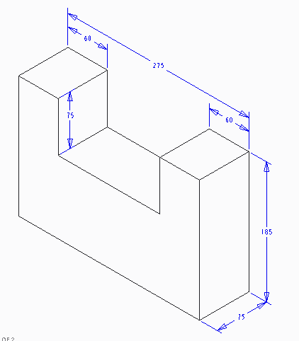

Part 3: Bracket
References: Dimensions of the part.
Step 1: Determine the origin point.
Step 2: Convert dimensions into coordinate points.
Step 3: Write the program
NOTE: To create arcs, adjust code to G18 (z- and x-axis). Use the I,J,K method in G-Codes Basics Tutorial.
Part: metric
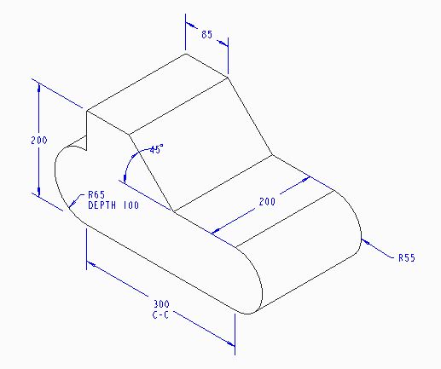

Part 4: Tool Rest
References: Dimensions of the part.
Step 1: Determine the origin Point
Step 2: Convert dimensions into coordinate points.
Step 3: Write the program.
Part: inches
