Linear Approximation Entrance Ticket

The data in the table below shows how the height of a plant changed over time.
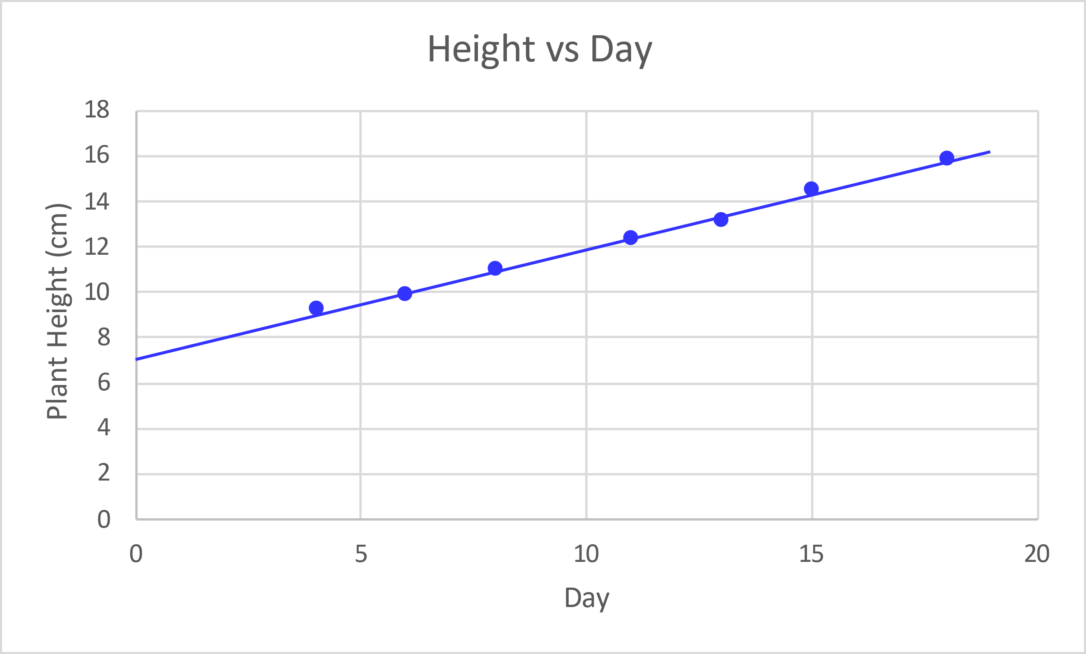
Day | Height (cm)
4 | 9.2
6 | 9.9
8 | 11
11 | 12.3
13 | 13.1
15 | 14.5
18 | 15.8

Find the equation of a line that you think best follows the data. Show your work or include a justification of the values for your equation.

Use your equation to determine how tall the plant will be after 25 days? Show work.

