Linear Approximation Entrance Ticket Answer Key

Exact student answers will vary. An example solution is provided.

The data in the table below shows how the height of a plant changed over time.
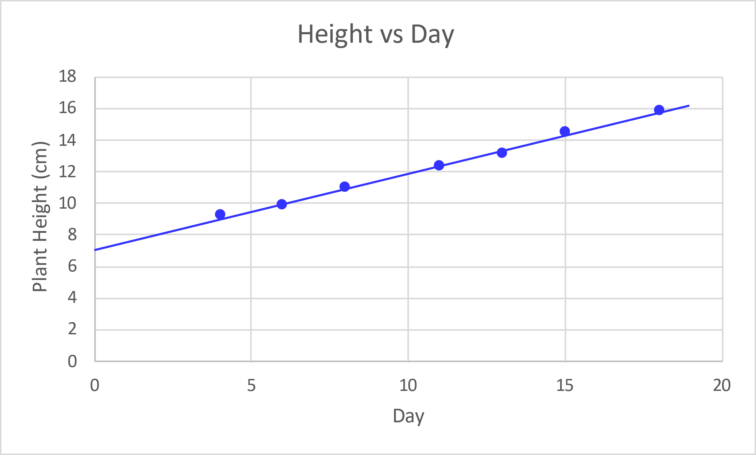
Day | Height (cm)
4 | 9.2
6 | 9.9
8 | 11
11 | 12.3
13 | 13.1
15 | 14.5
18 | 15.8

Find the equation of a line that you think best follows the data. Show your work or include a justification of the values for your equation.
Students should plot the data and draw a line of best fit. Check that students label the axes.

Select two points to find the slope: (0,7) and (11,12.3).
Slope = $\frac{y_{2}-y_{1}}{x_{2}-x_{1}}=\frac{12.3-7}{11-0}=0.48 {cm}/{day}$
The point (0,7) gives the y-intercept.
Slope-intercept form equation: $y=0.48x+7$
Where y is the height of the plant (cm) and x is day.

Use your equation to determine how tall the plant will be after 25 days? Show work.

Let $x=25 days$
$$y=0.48 \left(25\right)+7=19 cm$$

