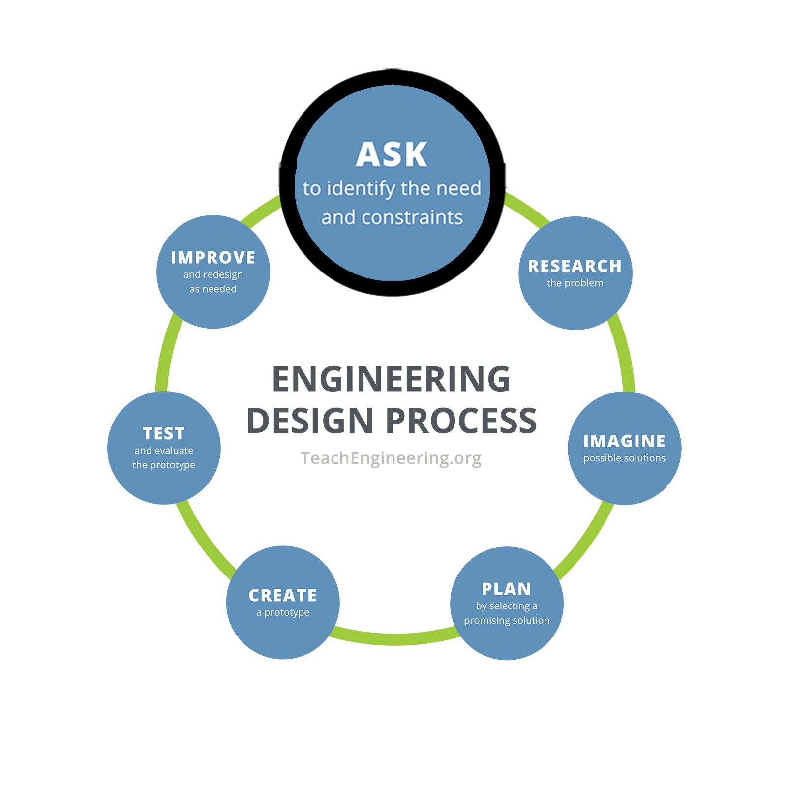
Student Worksheet

Engineering Design Process Step 1: Ask
What is the problem to solve? What do we want to design? Who is it for? What do we want to accomplish? What are the project requirements? What are the limitations? What is our goal?

On your own, jot down a quick answer to the following question.

What problems can be solved by teaching a machine how to do something that humans are also good at?

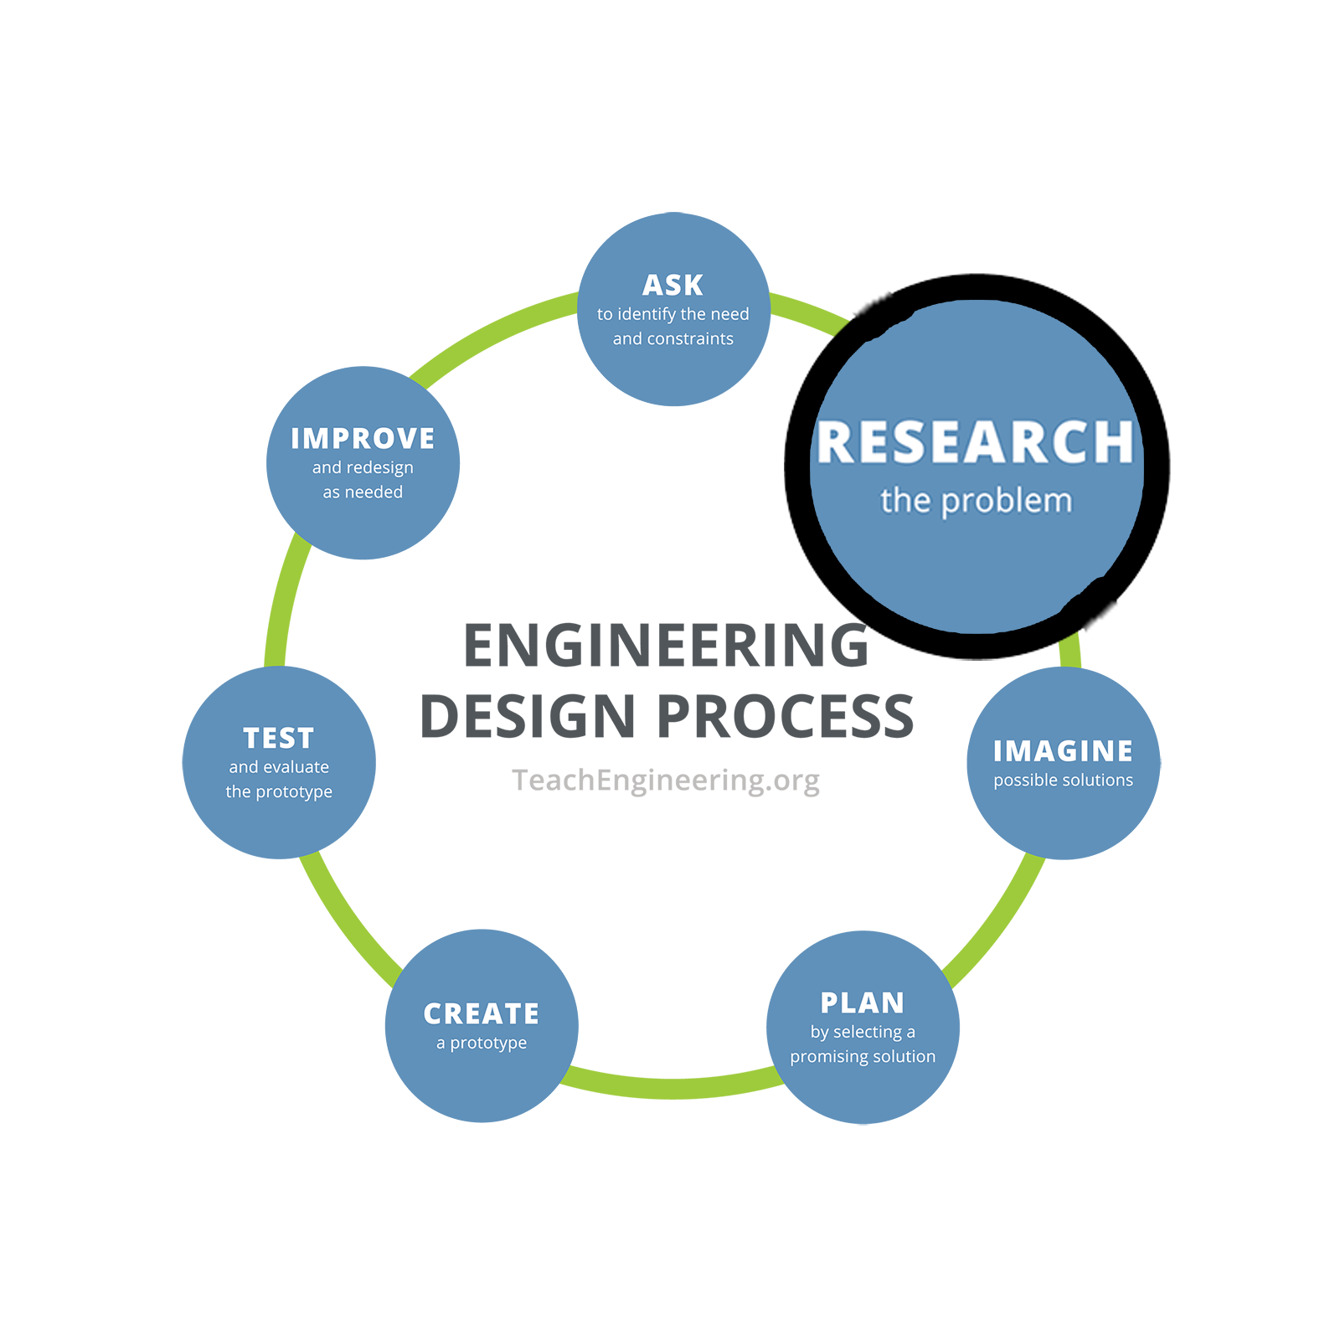
Share your answer with people around you and the group or class.

Engineering Design Process Step 2: Research
What products or solutions already exist? What technologies might be adaptable to your needs?

Brainstorm a few answers to the following questions, on your own or with a small group.

What are some systems that exist right now that allow computers to learn from humans or the world around them in order to solve problems? What information do these systems use to learn from? What problems do these systems solve?

Computer system | Information for learning | Problem being solved

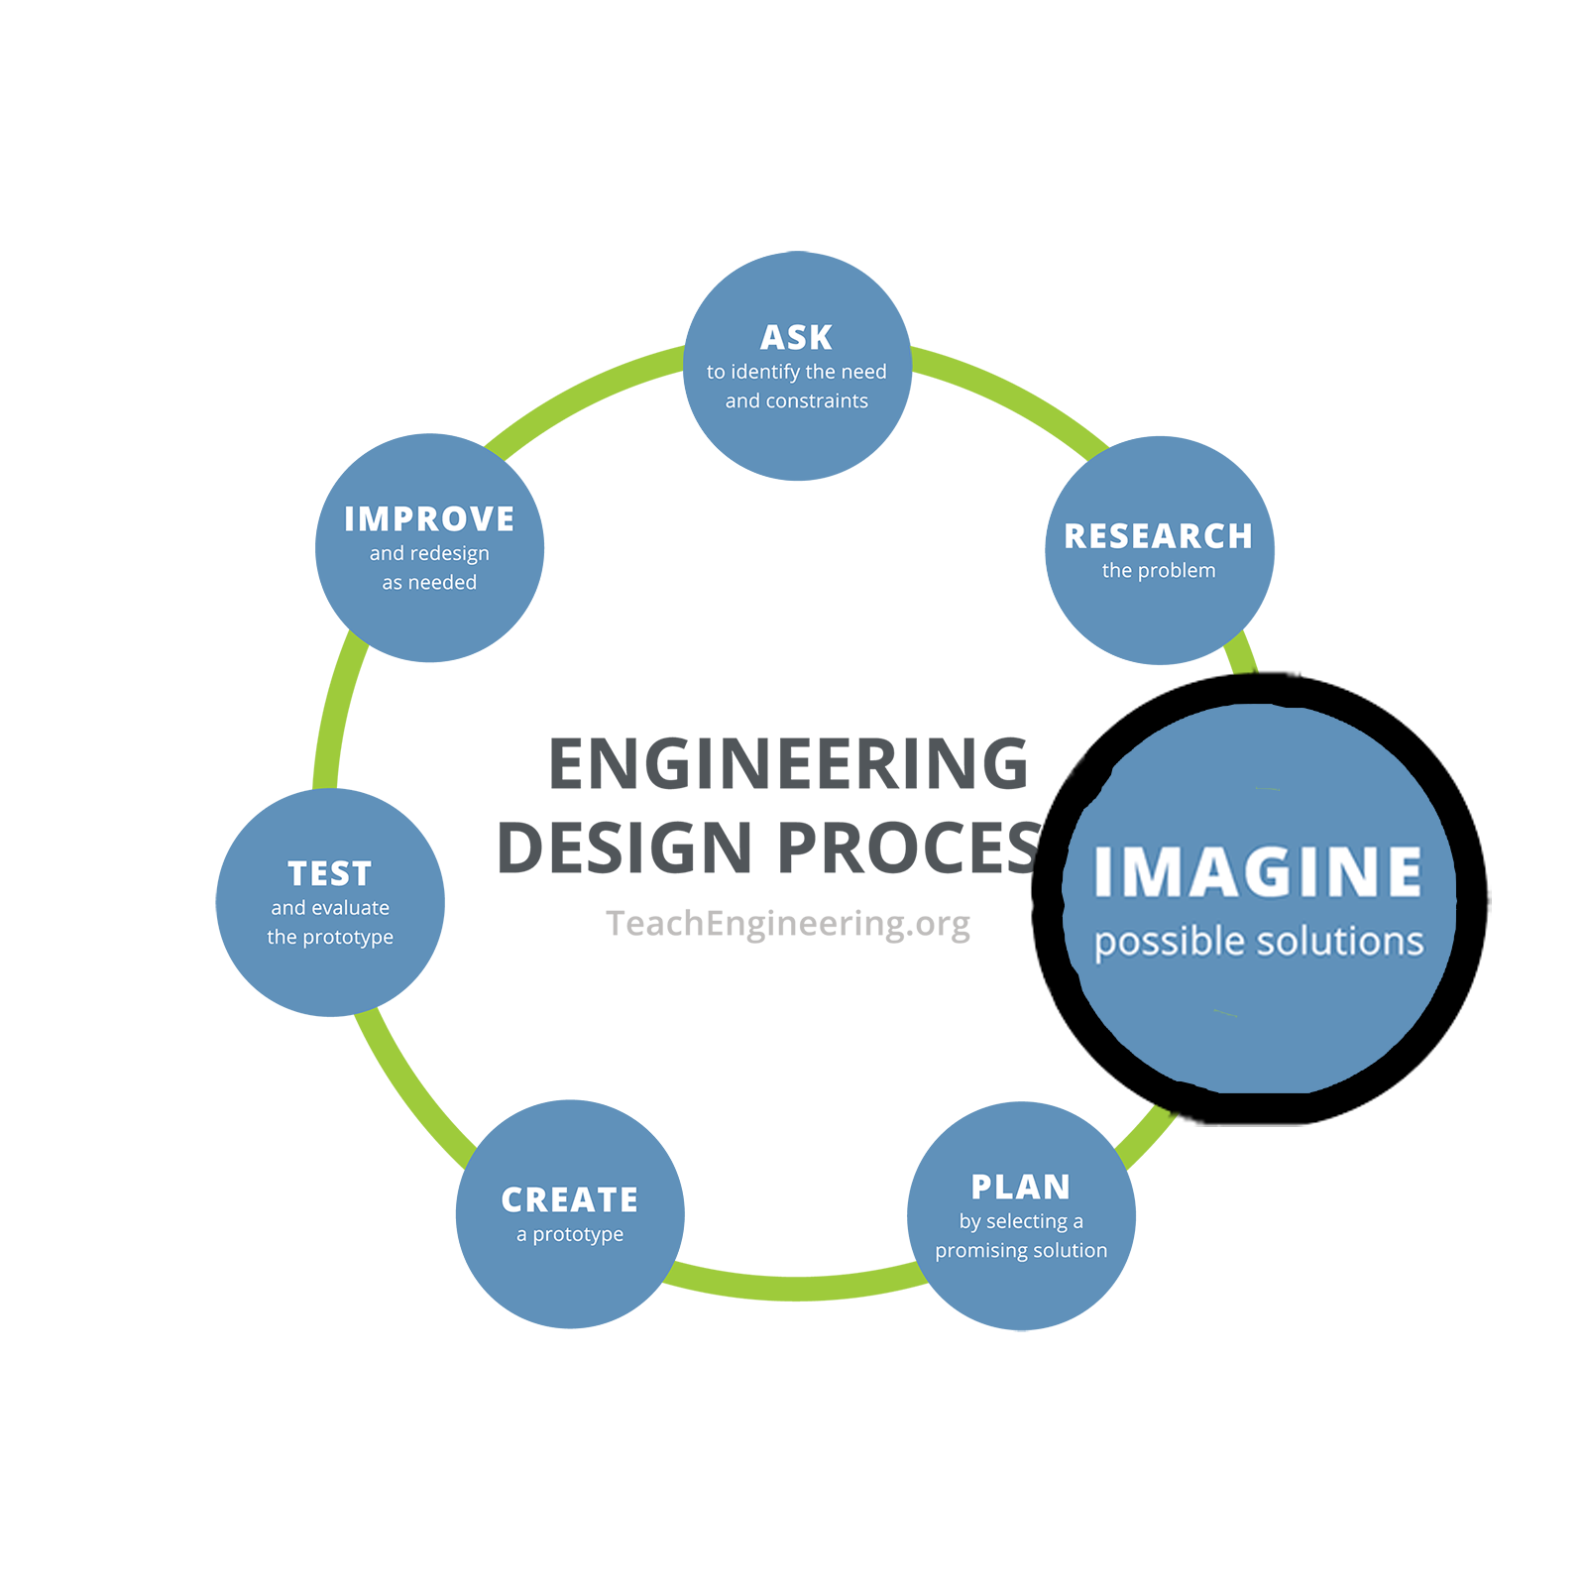
Engineering Design Process Step 3: Imagine
This is the time to encourage wild ideas and defer judgment! Build on the ideas of others! Stay focused on topic, and have one conversation at a time! Remember: Good design is all about teamwork.

Your group is going to work together to help someone improve their ability to hit a target by flicking a ball. A designated learner will respond to feedback from the team and try repeated flicks, with the goal of getting closer to the target on average. Brainstorm with your group about what data the group should collect and what kinds of feedback the learner should receive to improve their ability to hit the target. Write lots of ideas in the boxes below. It’s fine to add ideas that aren’t going to work; even the ideas that don’t work can improve the process.

Data to collect | What feedback to share and how to share it

Each time your group does Steps 4-7, it will be called an “iteration” of the process. Only one person needs to write details about each iteration. Which iteration are you the notetaker for? (1, 2, 3)

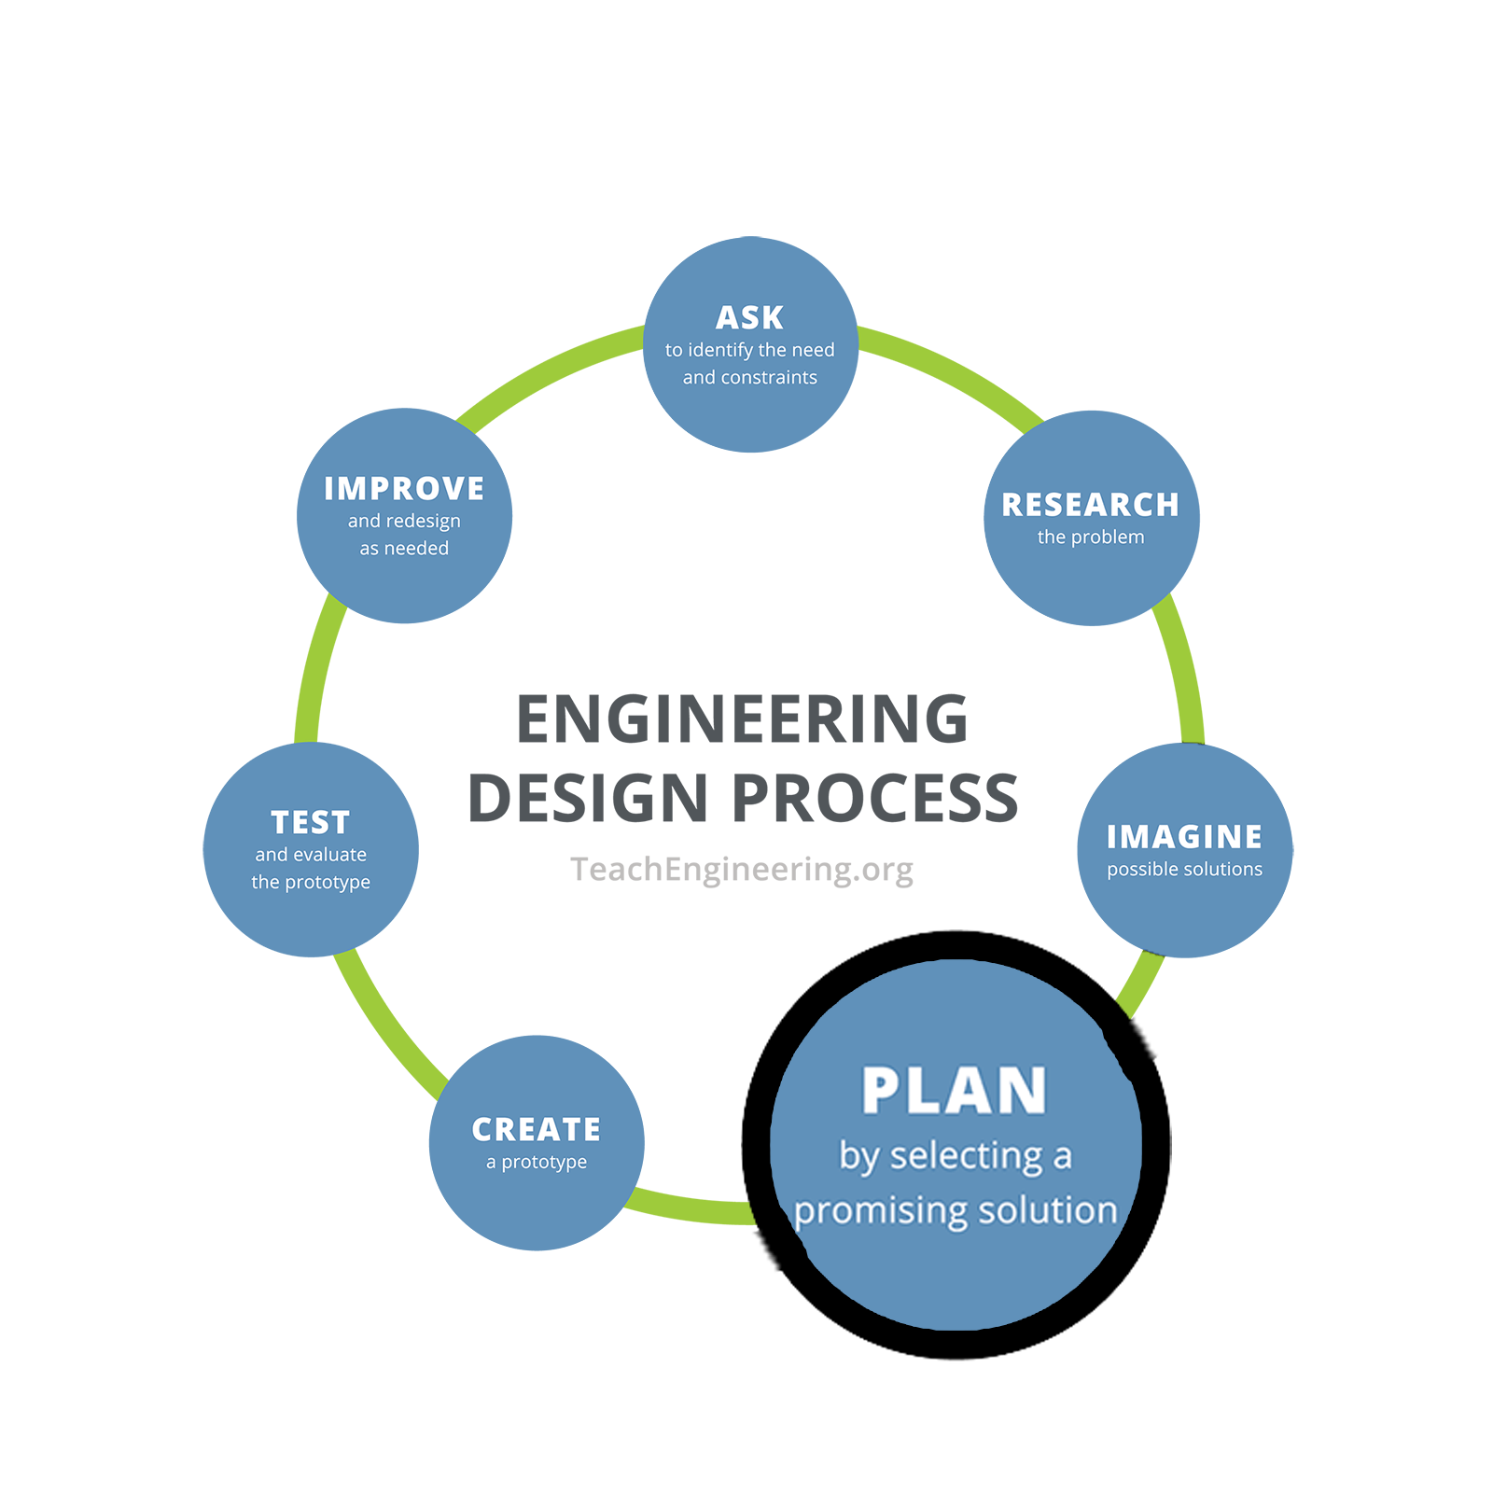
Engineering Design Process Step 4: Plan
Revisit the needs, constraints, and research from the earlier steps, compare your best ideas, select one solution, and make a plan to move forward with it.

Plan with your group and, as a group, decide on what data you will collect about each flick of the ball. Remember that only one person in the group writes notes for each iteration. Write down who in your group will collect the data, and how. Write down how your group will give the learner feedback to help improve the next flick.

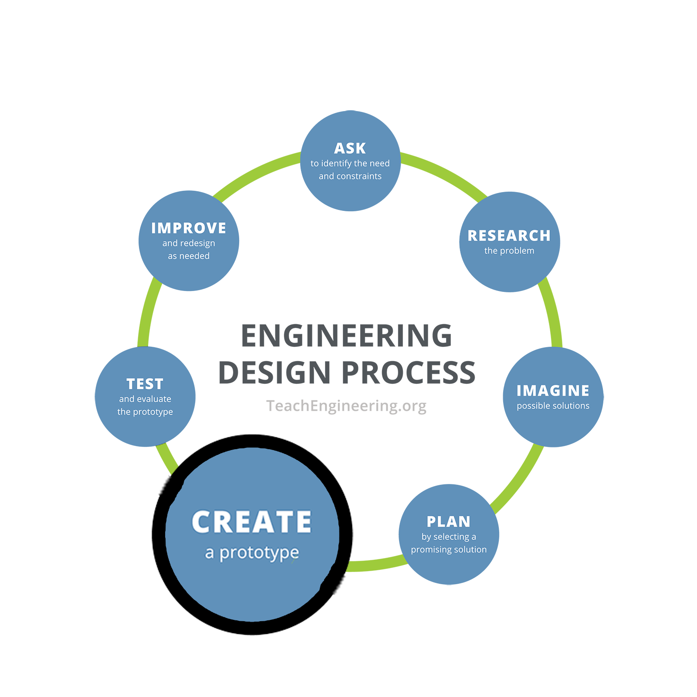
Engineering Design Process Step 5: Create
Building a prototype makes your ideas real! These early versions of the design solution help your team verify whether the design meets the original challenge objectives. Push yourself for creativity, imagination, and excellence in design.

Designate one person in your team to be the learner. Create a process to analyze your design “prototype” system by tracking your data in the table below. You can decide on whatever columns you want to add to this table.

(Create your own column headers in the space below)
Flick #
1
2
3
4
5
6
7
8
9
10

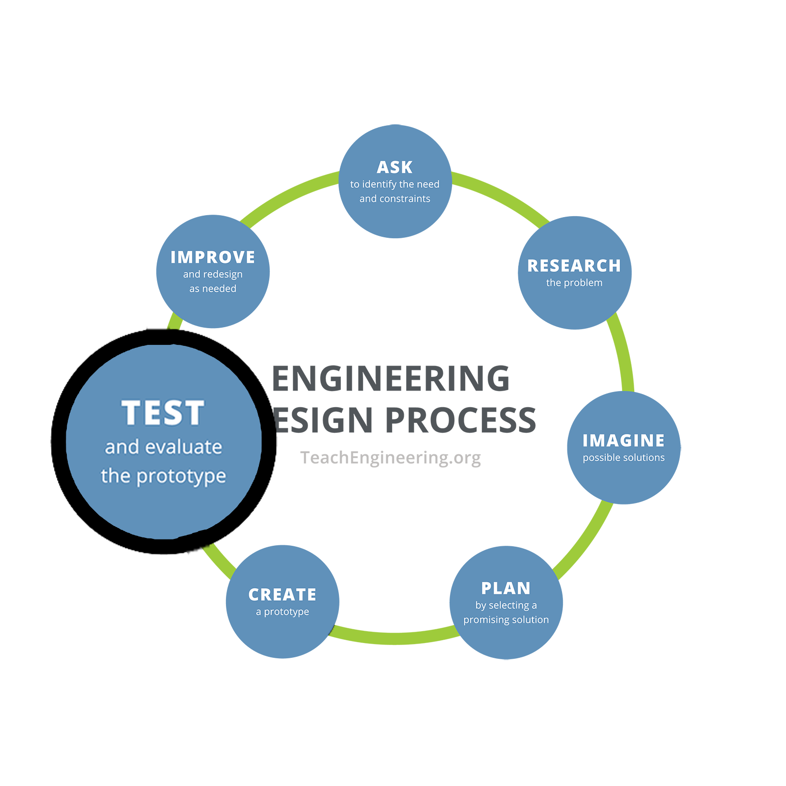
Engineering Design Process Step 6: Test and Evaluate
Does it work? Does it solve the need? Communicate the results and get feedback. Analyze and talk about what works, what doesn't, and what could be improved.

Based on testing your system for training, evaluate with the following questions. Did the learner improve? What about your system for training worked well? What could be better?

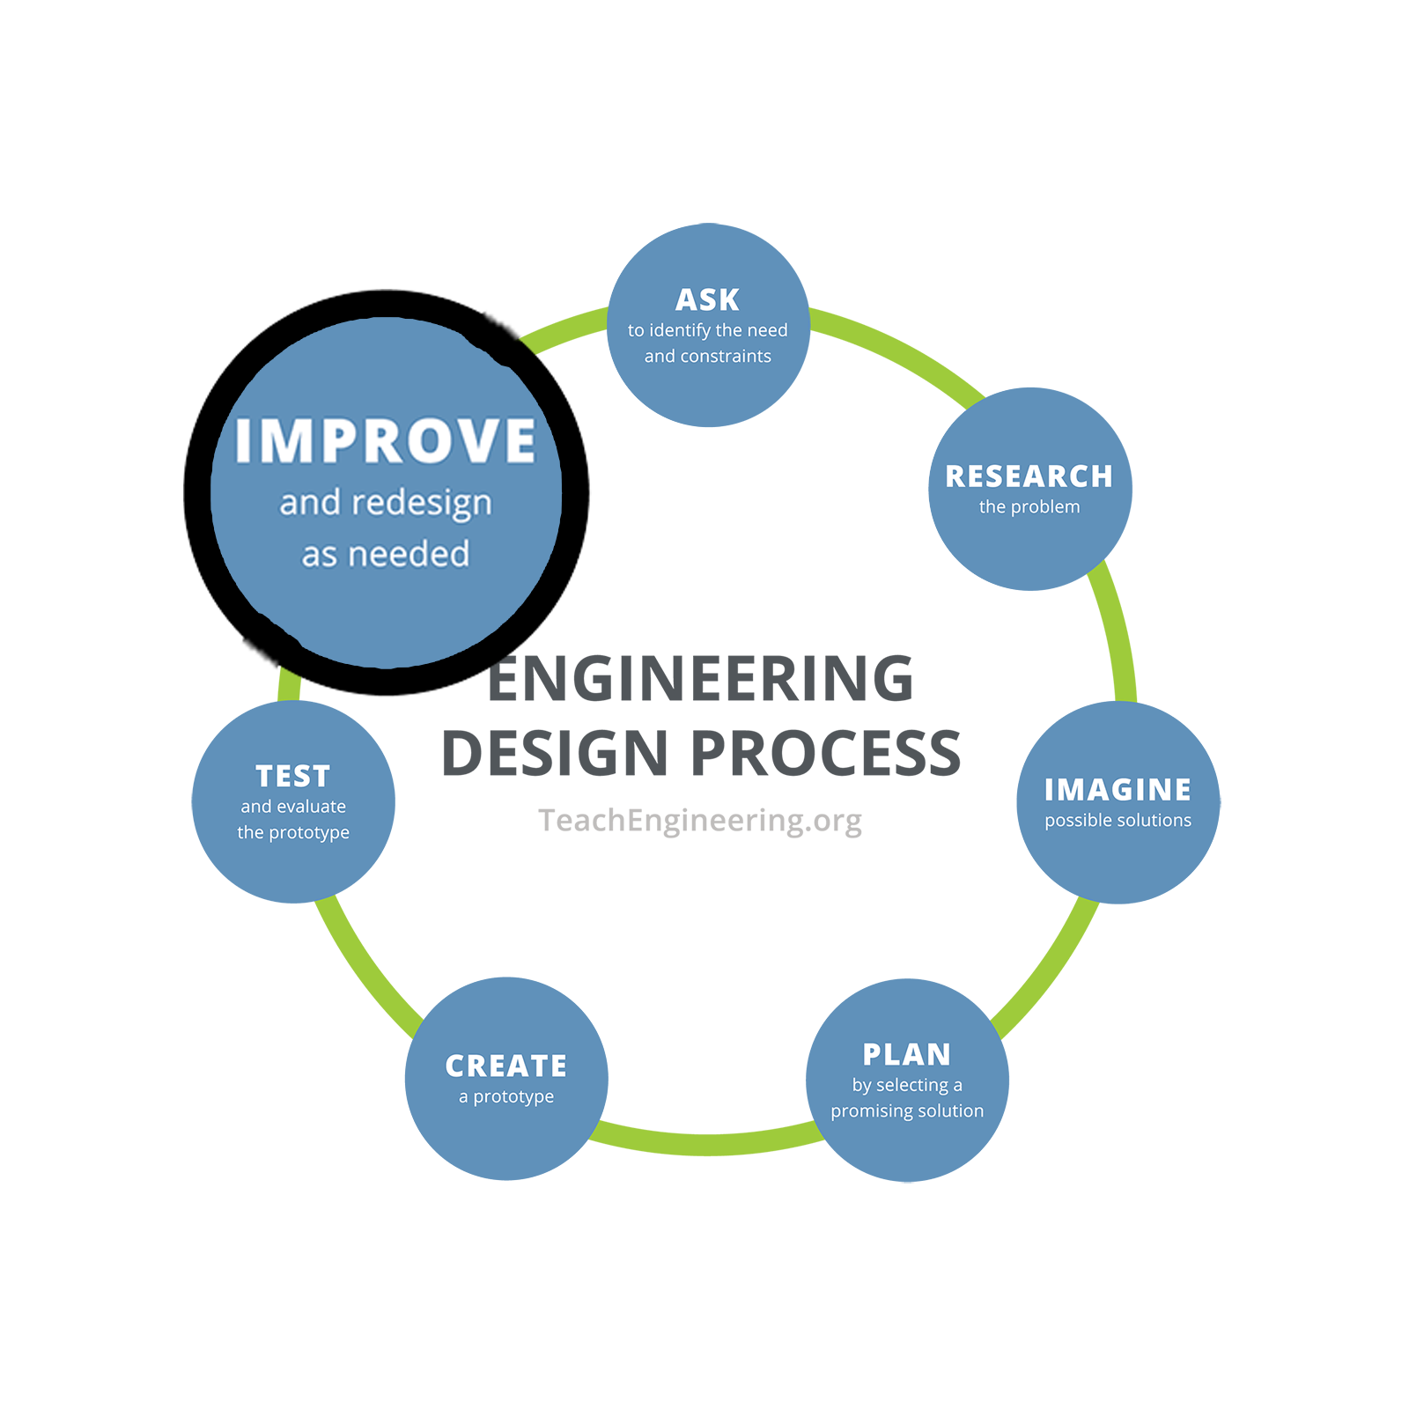
Engineering Design Process Step 7: Improve
Discuss how you could improve your solution. Make revisions. Draw new designs. Iterate your design to make your product the best it can be.

How could your system improve on its goal of helping the learner to improve? Your teacher is going to give you an altered way for the learner to flick the ball next time: Does your system work if learners are blindfolded, or facing backward?

Iterate!
Your teacher is now going to ask you to go through several steps of the design process quickly, to improve your system and test it with some new variations. With each iteration, your teacher will ask your learner (who should be a different person in your group than in the first iteration) to launch the ball a little differently, but you will still gather data and provide feedback to the learner. Consider 1-2 ways taken from what the group wrote for Step 7 that you could improve your system; could you change which data you are gathering, or provide feedback in a more specific way?

Iteration 2: What did your teacher ask you to do differently this time?

Go back to Steps 4-7. A different person in the group will be the notetaker for Iteration 2.

Iteration 3: What did your teacher ask you to do differently this time?

