Introduction to Digital Evolution Handout Answers
Note to teacher: The questions in this handout and the suggested answers (in red, below) are meant to guide discussion, not be an assessment. It is recommended that students answer the questions to the best of their abilities as they complete each section of the activity, while leaving space to modify and add to their answers during class discussion.
1.1 Questions to address about artificial life and evolution of digital organisms
- Compare and contrast the digital organisms in the Avida environment to biological organisms in the natural world. In what ways are digital organisms similar to computer viruses?
Example answer: Digital organisms in Avida have an instruction set similar to the genetic information that biological organisms have in their DNA. Like biological organisms, the instructions set codes for “traits” of an organism as well as replication instructions for reproduction. The genetic information can also be changed by random mutation. Digital organisms are similar to computer viruses because they are short, self-replicating computer programs.
- What do biologists mean when they use the word “evolution”? Can we observe evolution? Can we experiment with evolution? Explain your answer and give examples from the article or prior knowledge.
Example answer: Evolution refers to change in a population over time (many generations). Modern biologists are specifically referring to change in gene frequencies over generations (whereas Darwin focused on changes in frequencies of traits in a population). We can observe evolution in biological organisms, especially organisms that replicate quickly such as bacteria and many simple plants and animals. The development of antibiotic resistance and the evolution of viruses are important examples. We can experiment with evolution using biological organisms, but we can also use software models such as Avida. The article gives many examples of evolutionary questions that Avida has addressed such as the study of the origin of complex features, the origin of sexual reproduction, and the future course of evolution.
- What makes Avida a useful tool for biologists? What are the strengths and limitations of such an approach?
Example answer: Avida has been summarized as “an instance of evolution in a modeled environment.” Avida is less complex than biological systems and can be manipulated in ways that biological organisms cannot. All of the requirements for evolution by natural selection are present: variation (random mutation), inheritance (replication), selection (differential fitness), and time (many generations). Because digital organisms replicate much faster than biological organisms, data for many generations can be gathered quickly. In addition, the software makes it much easier to track changes in the “genetic” code of digital organisms than in biological ones. The same mechanisms are at work in Avida and in biological organisms, but the actual organisms and the environment are very different.
1.3 Questions to address while examining organisms
- How is the instruction set for an organism in Avida-ED similar to a bacterial genome?
It is a circular set of instructions for replication and for the traits of the organism similar to the circular DNA of bacteria.
- At which point of the genome did the program begin reading the instructions? How could you tell? Does the program always proceed through the instructions the same way?
The program began reading at the “r” command. It is at the three o’clock position on the circular genome. You could tell because the circle was outlined (as it runs through the code each letter is highlighted with this outline). The program always proceeds in the same direction (clockwise) through the genome.
- If you wanted to determine the function of each letter (command) of the code, where could you find that information? At which position of the genome are the instructions for replication?
The boxes in the lower right corner of the organism viewer tell what each letter stands for. You can tell that the instructions for replication of the ancestor organism are in the one o’clock to two o’clock region of the genome because when the cursor reaches those letters it keeps reading them over and over and starts copying each letter of the genome into a new organism.
- How is the organism’s instruction set copied? How did the copy compare to the original using the default setting (0% per site mutation rate)?
As each letter is circled in blue, it is copied to a new organism that is attached to the original organism. At the 0% per site mutation rate the new organism was identical to the original.
- After you changed the per site mutation rate to 10%, how did the copied genome compare to the original instructions? What would happen if a mutation occurred in the replication instructions?
The copied genome was not identical to the original. Some letters were substituted for different letters. If a mutation occurred in the replication instructions, the new organism would not be capable of reproducing.
- How did your new organism (replicated with the 10% mutation rate) compare to your neighbors’ organisms? How do you account for any differences?
They were not the same. Everyone will see differences between the original and the new organism, but the location and exact substitutions will differ. Even the number of substitutions can differ (at 10%, a one in 10 chance of an error exists as each letter is copied. The exact number of differences will range from one or two errors to more than 10 since it is completely random).
1.4 Questions to address while growing organisms
- What do we mean when we say that we are “growing” Avida organisms? How is this similar to the growth of bacteria? How is it different than the growth of plants or animals?
The digital organisms are replicating. It is the population that is “growing.” Usually when we say that a plant or animal is growing we are referring to it increasing in size. The growth of digital organism is more similar to bacteria that do not increase very much in size, but reproduce quickly to form a colony of individuals.
- Nine different resources are available in the default setting of Avida-ED. Why might you want to change these in future experiments?
You may want to test what effects the availability of resources has on the population.
- What are the default mutation rate and world size? What are the maximum and minimum values for mutation rate and world size in Avida-ED? Why might you want to change these in future experiments?
The defaults depend on the version. They are either 2.0% or 3.0% mutation rate and 60x60 or 30x30 cells. You may want to test the effect of different mutation rates and world sizes in future experiments.
- What types of data can you collect in Avida-ED?
You can collect data about individuals (the functions they can perform, their fitness, metabolic rate, and gestation time can be seen in the organism box of the lab bench. You can also save individuals and examine their instruction sets in the organism viewer). You can also collect data about the entire population in the population statistics box on the lab bench (that is, population size, the number of organisms performing each function, and the average fitness, gestation, and age). The population data can be graphed in the analysis viewer.
- What do biologists mean when they use the word “fitness” in reference to populations? What does the fitness depend on and why?
Fitness is related to how successful an organism is in its environment. Biologists define fitness in terms of reproductive success, because it is the number of viable offspring that really determine how an organism’s traits will be represented in the future generations. Fitness depends on the survivorship of the organism in order to reproduce.
- Based on what you observed in the population statistics and the organism information boxes during the run, what do you think accounts for the increasing fitness of the population and specifically the organism you froze (saved)?
The ability to perform functions increases an organism’s fitness. When a mutation occurs that allows an organism to perform a function, it is rewarded with more energy to replicate itself. Mutations can also decrease the gestation time, which allows the organism to replicate more efficiently and thus increases its fitness.
- In Avida-ED, fitness is defined as the metabolic rate divided by gestation. Metabolic rate refers to how fast an organism can execute instructions (letters of its genome) while gestation refers to the number of instructions it takes for an organism to reproduce. How does this compare to fitness in biological populations?
Biologists define fitness in terms of reproductive success It refers to the contribution that the organism has made to the gene pool. If an organism survives for a very long time but never passes on its genes, its genes will not be represented in the population in the future. Therefore, reproductive success is the most important factor in fitness.
The calculation in Avida is very similar to the concept of biological fitness since the only things that influence the reproduction of the organism are how much energy it can utilize (metabolic rate) and how efficiently it replicates (gestation time). Fitness of the digital organisms is maximized by increasing the metabolic rate (that is, by performing functions that are rewarded) and by decreasing the gestation time.
1.5 Questions to address while viewing an evolved organism
- How is the arrangement of the evolved organism’s instructions different than the default organism’s instructions (refer to Figure 4)? Are any sections conserved (stayed the same from the ancestor)? Compare your evolved organism with your neighbors’. How similar are they?
There will be many differences in the order of the commands (letters) between the evolved organism and the ancestor organism. Students may notice that the instructions in the replication information (the one o’clock to two o’clock position of the genome) are more highly conserved that in other regions. The evolved organisms are each unique due to the random nature of the mutations.
- Organisms in Avida-ED reproduce asexually, similarly to bacteria. What caused the changes in the genome of the evolved organism from the ancestral organism?
Random errors during replication over many generations account for the differences between the evolved organism and the ancestor organism.
- Occasionally you will freeze an organism in Avida-ED only later to find out that it cannot make copies of itself. Based on what you know about the nature of random mutation, how can you explain the fact that some organisms would be incapable of reproduction? What implications does this have for the future genetic information of the population?
If a mutation occurs in the replication instructions, the offspring would not be able to reproduce. Those mutations cannot be passed and will thus not affect future generations (although they will keep popping up because of new mutations in the replication instructions).
- In Avida-ED, an organism inherits its parent’s fitness. Knowing this, how certain are you of the fitness value of the particular individual you saved? What could cause an individual to have a fitness value different than its parent?
Since fitness depends on reproductive success there is no way to calculate absolute fitness until an organism actually replicates (in which case you would not be able to watch it in real time in Avida-ED). The software therefore assigns the fitness value of the parent to the offspring. It will often be a close approximation, but if a mutation has occurred in the replication instructions then the organism has a fitness value of zero (and it will not reproduce to pass on that particular mutation).
2.1 Questions to consider while competing two organisms
- What is the metabolic rate of the default organism (@ancestor) and what functions can it perform? What is the metabolic rate of your saved organism and what functions can it perform?
The default metabolic rate of the ancestor is 0.2526 and it cannot perform any functions. Evolved organisms will have a higher metabolic rate and may be able to perform one or more functions.
- The metabolic rate is an indication of how fast an organism is able to execute the instructions of its genome. How do the functions that an organism performs influence its metabolic rate? How does this relate to the resources available in the environment (look back at the default environmental settings if necessary)?
In the default settings, all of the functions are rewarded, thus any organism’s metabolic rate increases with each function that it performs.
- After 10–20 updates, how did the descendants of the saved organism compare to the descendants of the default organism in terms of fitness, functions performed, and population size (number of individuals)?
There were more descendants of the saved organism and they had a higher fitness than the ancestor (which may not have replicated at all yet). Note: Sometimes the ancestor does not replicate at all because the evolved organism’s metabolic rate is so much higher that a colony quickly forms and overwrites the ancestor organism.
- After a few hundred updates, how did the descendants of the saved organism compare to the descendants of the default organism in terms of fitness, functions performed and population size (number of individuals)?
There were more descendants of the saved organism and they had a higher fitness value. Typically after a few hundred updates, the ancestor population is “extinct” because the descendants of the evolved organism outcompeted the ancestor’s offspring for space on the grid.
- Given that the default organism starts with a certain metabolic rate (even though it cannot perform any functions) and that resources in the environment are unlimited (cannot be depleted), the competition between organisms is not for resources in the environment. What are the organisms competing for? Relate this to the petri dish grid and the world size settings. How does this compare to competition between biological organisms?
The organisms are competing for space on the grid. The faster they replicate, the more descendants they leave behind (the new organisms begin to overwrite the older ones). Some biological organisms probably compete for space as well, but in the natural world they also compete for many other resources.
- Did you observe extinction of one of the populations? Why or why not?
The ancestor population went extinct because they were not able to compete (for space on the grid) with the descendants of the evolved organism that could perform functions.
- Explain how selection can account for the differences observed in the populations descending from the two different ancestors.
We would say that the ability to perform functions (the descendants of the evolved organism) was “selected for” since they had the advantage of increased metabolism. Selection refers to the competitive advantage that one type has over another, which leads to its increased reproductive success. In nature we call this “natural selection,” which refers to the increase in proportion of adaptive traits over many generations due to the reproductive success of those traits.
2.2 Data Analysis: Use your data tables and graph to answer the following questions.
- Compare the shapes of the population growth curves (thin lines) for the three different experiments. Did the populations reach their maximum world sizes in approximately the same number of updates for each experiment? Why or why not? What accounts for the similarities in the overall shape of the growth curves for each experiment?
Below are sample graphs. The red lines are the ancestor population with all rewards on (from section 1.4), the blue lines are the evolved organism populations with no rewards on (from section 2.2) and the green lines are the evolved organism populations with limited rewards on (from section 2.2). The populations all reached the maximum world size eventually, although not always in the same number of updates. Therefore, the growth curves all look similar in terms of their shape.

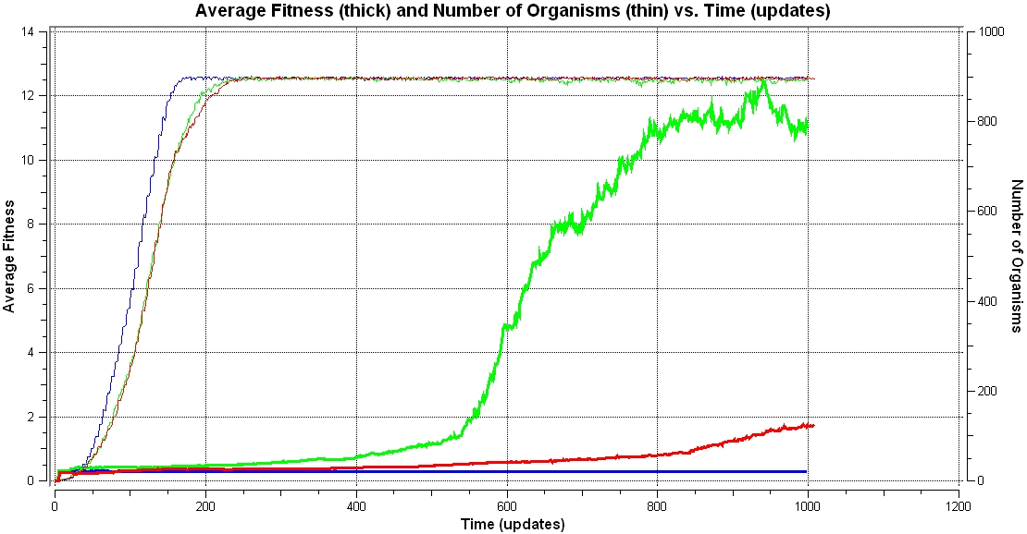

Example A

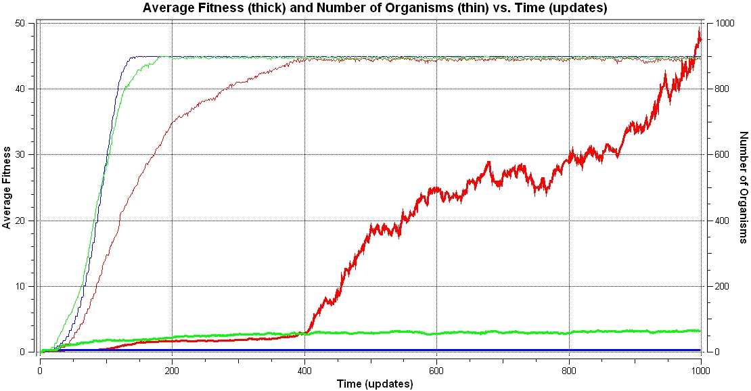

Example B

- Compare the shapes of the average fitness lines on the graph. Which one shows the sharpest increase? Would this pattern be the same for every trial?
Results vary with different runs depending on which functions evolved because the increases in fitness are due to the appearance of new functions that are rewarded.
- Explain why the graph of average fitness for the “no resources” experiment looks the way that it does.
The trial with no rewards on will always show a flat line because fitness cannot increase much at all (only the gestation time may get slightly lower) if none of the functions are rewarded.
- Compare the graph of average fitness for the “no resources” experiment to the data you collected in the table. Which functions evolved in the population during the experiment? Did the functions that evolved have an impact on fitness? Why or why not?
Functions appear due to random mutation, but since they are not rewarded, they do not increase an organism’s fitness and thus are not acted on by selection (they do not increase in frequency).
- Compare your graph for average fitness in the “limited resources” experiment to your data table. Can the data you collected account for the change in the shape of the line over time (updates)?
Students should compare their graph to the data tables they made in section 2.2. The changes in average fitness on the graphs for their runs with no rewards and limited rewards can be directly correlated to their data tables by noting when (how many updates) a new function appeared and how quickly it increased in frequency in the population.
- Did any functions increase in a population for a time only to decrease or disappear later? Explain how this could occur.
This is common in the run with no rewards because there is no advantage for performing a particular function. A function may appear (by random mutation) and increase in frequency as that organism reproduces, only later to decrease or disappear. This is because later random mutations “knock out” the function and there is no disadvantage for not having it. Functions that are rewarded also occasionally appear, but because the number of organisms performing the function is low it may be lost when other organisms around it overwrite it.
- What do the differences in the shapes of the graphs of average fitness for the three different experiments suggest about the role of the environment in evolution?
The environment does not cause certain traits to appear, but the environment determines whether a trait will be selected for (increase in frequency in the population over generations) or against (decrease in frequency in the population over generations). A trait that is advantageous in one environment could have no advantage (or even be harmful) in another environment.
- Did any new functions appear in the population with limited rewards? What caused these functions to appear? Did they increase or decrease in frequency in the population over time? Why?
The appearance of new functions depends on the random mutations that occurred in the individuals. Generally students will see new functions appear in this trial, but occasionally (especially if they start with an organism that can perform many different functions) since only certain functions are rewarded, none of those will happen to appear within the 1,000 updates (as in example B, above).

