Peer Evaluation—Potential Projects to Fund Analysis
You are a member of the grant approval team from the Glaucoma Research Foundation. Your job is to evaluate potential projects with the intent of providing funding for one project team to develop its ideas beyond the prototype stage. As you watch the presentations, complete the table below. Use your critical evaluation skills since you are familiar with the design and prototyping process. Then, make your final recommendation.
Team Name | Pressure Sensor Description
E X A M P L E  Bellow Beginnings | 1. Does the prototype contain all the necessary components to act as a wireless device? __Yes__. How do you know?  The prototype has an antenna to receive and transmit messages to the reader. The prototype has a pressure gauge to transmit information about pressure to the reader. The pressure gauge acts as a RFID tag.  2. If this prototype were further developed, would it successfully measure intraocular pressure? __Yes__.  How do you know?  The prototype has a bellow that sits on top of a resonator. The bellow moves up and down when pressure is applied. The energy from this movement causes vibrations in the resonator. The resonator is connected to the antenna, so the message from the bellow transmits to the antenna and then to the reader.  3. As defined by the given scale, would this prototype fit in an eye? __No__. How do you know? The scale is 1:0.06. If the volume of the design is 22.5 cubic centimeters, then the volume of the actual size would be 0.0023 cubic centimeters. The volume available in the eye is 0.0014 cubic centimeters. So, it will NOT fit as it is designed.
1. Does the prototype contain all the necessary components to act as a wireless device? _______ How do you know?

2. If this prototype were developed further, would it successfully measure intraocular pressure? ________
How do you know?

3. As defined by the given scale, would this prototype fit in an eye? _______ How do you know?

1. Does the prototype contain all the necessary components to act as a wireless device? _______ How do you know?

2. If this prototype were developed further, would it successfully measure intraocular pressure? ________
How do you know?

3. As defined by the given scale, would this prototype fit in an eye? _______ How do you know?

1. Does the prototype contain all the necessary components to act as a wireless device? _______ How do you know?

2. If this prototype were developed further, would it successfully measure intraocular pressure? ________
How do you know?

3. As defined by the given scale, would this prototype fit in an eye? _______ How do you know?

1. Does the prototype contain all the necessary components to act as a wireless device? _______ How do you know?

2. If this prototype were developed further, would it successfully measure intraocular pressure? ________
How do you know?

3. As defined by the given scale, would this prototype fit in an eye? _______ How do you know?

1. Does the prototype contain all the necessary components to act as a wireless device? _______ How do you know?

2. If this prototype were developed further, would it successfully measure intraocular pressure? ________
How do you know?

3. As defined by the given scale, would this prototype fit in an eye? _______ How do you know?

Final Recommendation
Based on the presentations, which team would you fund (give money to) in order to develop its prototype into a real device?
Provide at least three specific reasons for your choice. Correlate your reasons with the design requirements and constraints (refer to Figure 1).
Team name: __________________________________________________________
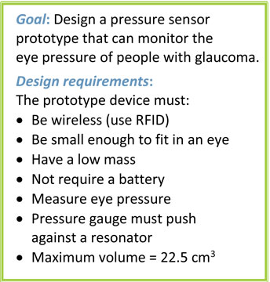
Reason 1:

Reason 2:

Reason 3:

Figure 1. Design requirements and constraints.

Additional reasons:

