For Teacher Reference: Large Versions of Figures 4-7
Figure 4. An example 3D print of an RFID reader prototype.

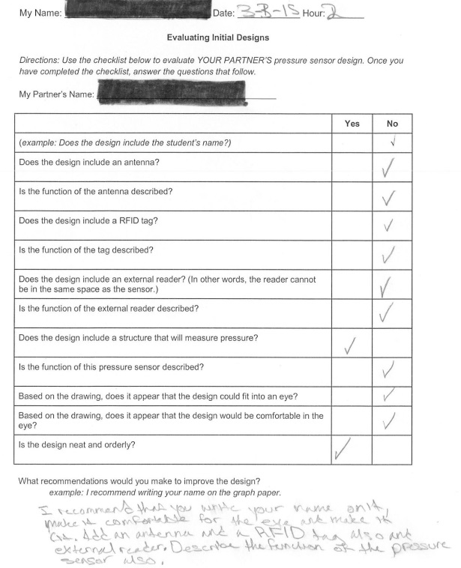
Figure 5. Example completed student peer-evaluation document for the initial design.

Figure 6. Example student initial intraocular pressure device design, including top and side views identifying structures and functions.
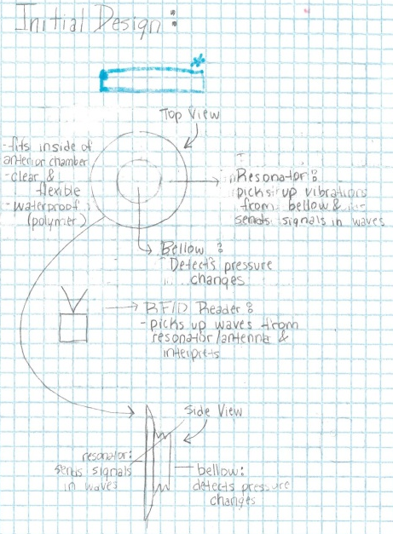

Figure 7. Three examples of student-created 3D-printed intraocular pressure sensor prototype devices with their design sketches.
