Components of RFID Technology
Example: Animal microchip implants

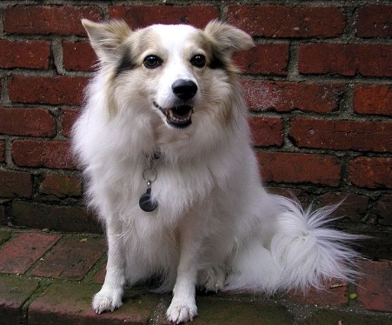

RFID reader
RFID microchip tag

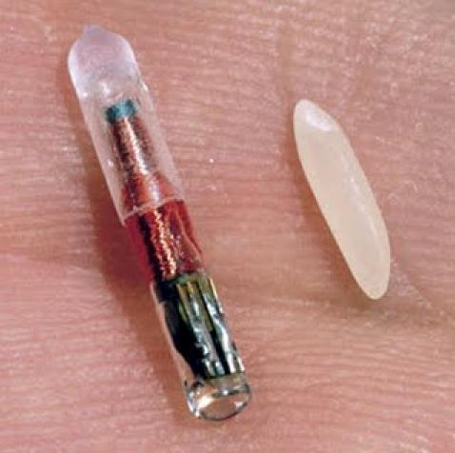
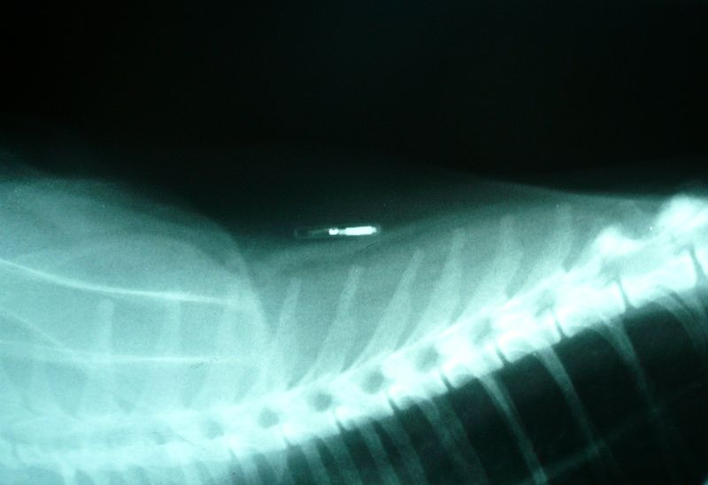
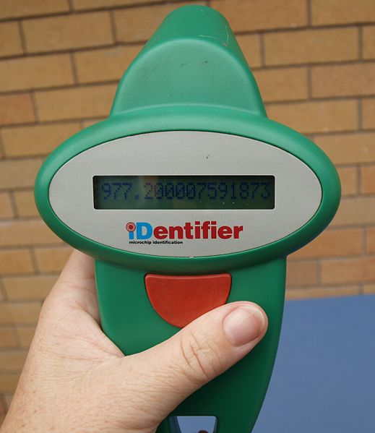

Image sources
Dog: 2013 Neal Ziring, Wikimedia Commons http://commons.wikimedia.org/wiki/File:White_cute_dog.jpg
Animal control dog catcher cartoon character: City of Gatesville, TX http://www.ci.gatesville.tx.us/index.asp?Type=B_BASIC&SEC=%7B58DA565A-2CB9-4331-A932-2BF4DFCC114F%7D
Veterinarian with dog: Connecticut State Board of Veterinary Medicine http://www.ct.gov/dph/cwp/view.asp?a=3143&q=388948
RFID reader/scanner: 2010 Oscar111, Wikimedia Commons http://upload.wikimedia.org/wikipedia/commons/thumb/2/2c/Rfid-scanner.jpg/519px-Rfid-scanner.jpg
X-ray showing microchip near a cat’s spine: 2007 Joelmills, Wikimedia Commons http://commons.wikimedia.org/wiki/File:Feline_identifying_microchip.JPG
Microchip/RFID tag and rice grain (for size comparison): 2009 Light Warrior, Wikimedia Commons http://commons.wikimedia.org/wiki/File:Microchip_rfid_rice.jpg

