Checking Your Understanding Answer Key
Section 1: RFID Technology
- RFID stands for:
  - regular-frequency identification
  - radio-frequency identification
  - radio-frequency identification device
  - repetitive frequencies in devices
- Define the purpose of RFID technology.
Answers may vary. Example answer: RFID technology enables signals to wirelessly transfer information from one object, often a tag, to another object, often a reader or scanner.

- What are the advantages of RFID technology?
Answers may vary. Example answer: RFID technology is a method of wireless data transfer that can transfer information from an internal source to an external source. For example, information about the pressure in an eye can be transferred to an external reader. RFID technology enables us to create devices that are small enough to fit in an eye.

- Would you recommend this form of technology in the development of a pressure sensor intended for implantation in a human eye? Why or why not?
Answers may vary. Example answer: I would recommend that this form of technology be used to create a pressure sensor. The pressure sensor can be small enough to fit in the eye, but can still transmit information about pressure within the eye.

Section 2: Electromagnetic Waves and Sensor Structures
- Radio waves are:
  - sound waves
  - microwaves
  - infrared waves
  - electromagnetic waves
- Define electromagnetic waves and provide an example.
Answers may vary. Example answer: An electromagnetic wave is a wave that can travel through space and matter. Radio waves are one example of electromagnetic waves.

- How are electromagnetic waves detected? Provide at least one example.
Answers may vary. Example answer: Electromagnetic waves can only be detected by using a device that is able to detect them. For example, an antenna on a radio can detect radio waves, which are electromagnetic waves.

- Looking at the radio below, fill in
the missing information.
The antenna receives radio waves, which are electro- magnetic waves. The antenna converts the energy from these waves into electrical power.
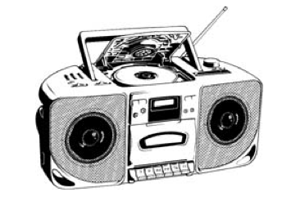

The speakers vibrate, which causes sound waves to form. These waves can be heard.

The dial tunes a radio to a specific frequency.
Each radio station has a specific frequency
so that we can hear different music.

- Which structure within a pressure sensor would best receive and transmit frequency signals?
- the antenna
- the RFID reader
- the resonator
- the RFID tag
- Which structure would best interpret and analyze the information within the tag of a pressure sensor?
  - the antenna
  - the RFID reader
  - the resonator
  - the RFID tag
- Which structure within the pressure sensor would best store information about pressure in the eyes?
  - the antenna
  - the RFID reader
  - the resonator
  - the RFID tag

