Highlighting the Neuron Lesson –
Lesson Review Activity: Neuron Naming – Answers

Directions
Label the image of the Neuron on the following page with the terms/words listed below.
Use a line to point to the location on the image where the word(s) should be placed.
Hint: one of these terms is the title.
- axon terminal
- transfers messages from dendrites
- dendrites
- The Neuron – Structures and Function
- cell body
- gap where messages travel from one neuron to the next
- axon
- receive messages
- synapse
- messages leave neuron
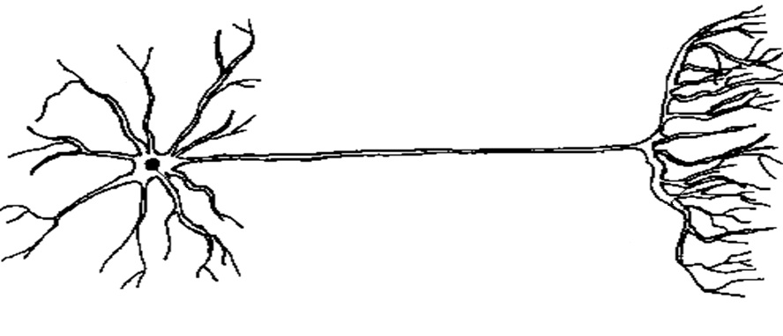
Image Source: <htt://biomed.brown.edu/Courses/BI108/BI108_2001_Groups/Nerve_Regeneration/Introduction/Introduction.htm>

Title: ______________________________________________________________________________
Highlighting the Neuron Lesson – Lesson Review Activity: Neuron Naming – Answers 2

Name: Date:

The Neuron – Structures and Function
transfers messages from dendrites
dendrites
axon
cell body
receive messages
axon terminals
messages leave neuron
synapse
gap where messages travel from one neuron to the next

