Scaling a Figure Worksheet
Learning Goal: How does a figure or shape change when we enlarge or reduce it?
Introduction
Below is floor plan for the interior design of a bedroom. Let’s look at what happens to the items in the design when we enlarge or reduce them.
Instructions
- Measure and record the size and length of each part of the bedroom
for the original, enlarged and reduced designs.
- Calculate the perimeter and area for each design.
- Answer the questions below.

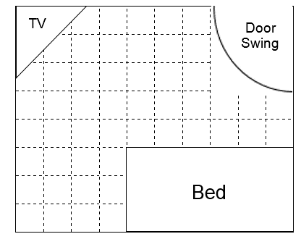
Enlarged
Original

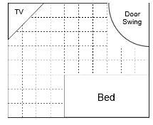
Reduced

Data Collection
- Record your measurements and calculations for the bedroom in the table below.
Bedroom | Length | Width | Perimeter | Area | Angles
Original
Enlarged
Reduced

- Record your measurements and calculations for the door swing (quarter circle) below.
Door Swing | Radius | Circumference | Area | Angle
Original
Enlarged
Reduced

- Record your measurements and calculations for the TV in the table below.
TV | Length | Width | Perimeter | Area | Angles
Original
Enlarged
Reduced

Questions
Answer the following questions based on your measurements and calculations.
- By how much was the design enlarged? How do you know? How did that change the perimeter? The area? The angles? Explain.

- By how much was the design reduced? How do you know? How did that change the perimeter? The area? The angles? Explain.

- If we were to draw a new design at quadruple (four) times the size, how would the perimeter change? How would the area change? The angles? Explain

- Which characteristics of a figure change when the original is scaled? How can you predict their new size? Which characteristics stay the same? Explain.

