Practice Sample Data Worksheet Answer Key
Using the data provided in the Practice Sample Data Spreadsheet, answer the following questions using formulas provided by Google Sheets. Once completed, represent the data graphically using the GeoGebra graphical app.
1. Calculate the mean temperature of each of the four samples.
(Answers rounded to the nearest thousandth)
Sample 1 | Sample 2 | Sample 3 | Sample 4
21.649 °C | 21.712 °C | 21.646 °C | 21.202 °C

2. Calculate the standard deviation of each of the four samples.
(Answers rounded to the nearest ten thousandth)
Sample 1 | Sample 2 | Sample 3 | Sample 4
0.0848 | 0.0705 | 0.0766 | 0.1200

3. Calculate the standard deviation for each hour recorded on the sensor.
(See the Practice Sample Data Spreadsheet tab 2: Sample Data Standard Deviation.)
Then calculate the mean of these standard deviations.
Mean standard deviation at each hour = 0.2363
4. What does this standard deviation mean in the context of this data?
Answers may vary. The mean of the standard deviations at each hour helps explain the variability between sensors. When normalized, 95% of the data falls within a 0.9452 °C range of each other.
Using graphing software (GeoGebra, Google Sheets, Excel), produce the following graphs.
5. Construct a box plot for each of the samples. See below
6. Construct a time plot for each of the samples. See below
7. Calculate the mean between each sample at each hour and construct a time plot. See below
8. Construct a time plot comparing the standard deviations at each hour and the time. See below

Box plots for problem 5; sample 1 is on top, sample 4 is on bottom.
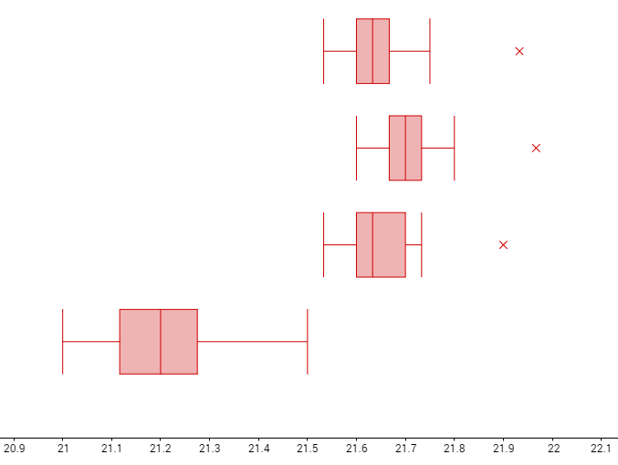

Time plots for problem 6
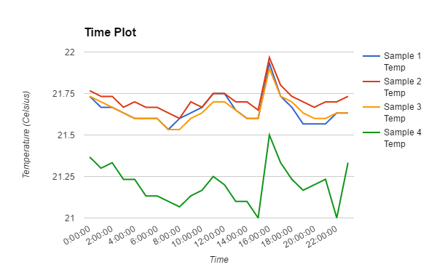

Time plot for problem 7
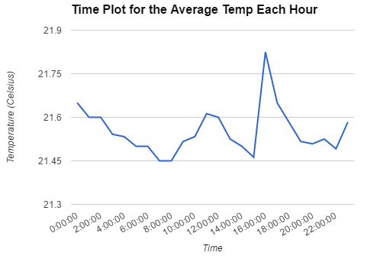

Time plot for problem 8
