Speed & Momentum Crash Quiz Answer Key
- Fill in the flow chart diagram below with the steps of the engineering design process.
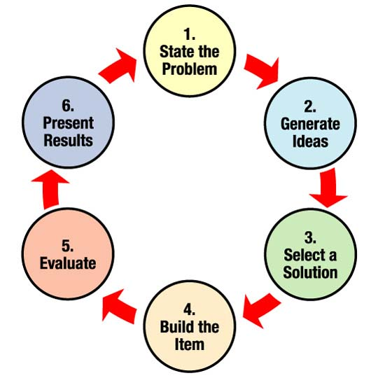

- Build the item
- Present results
- Evaluate & analyze/improve
- Generate ideas
- Select a solution
- State the problem

- Describe momentum.
Definition: For an object moving in a line, momentum is the mass of the object multiplied by its velocity; thus, a slowly moving, very massive body and a rapidly moving, light body can have the same momentum.

- Describe the relationship between mass and momentum.
Momentum depends upon the variables mass and velocity. Momentum is directly proportional to an object's mass or velocity.

- Explain the importance of using the steps of the engineering design process to solve real-world problems related to momentum and collisions.
The steps of the engineering design process are basic steps that provide guidance in solving problems and finding solutions. The process usually involves accomplishing a task or creating a product, process or structure. In the field of car design, following the steps are important because car accidents are inevitable, therefore safety features that are created and tested (two steps of the engineering design process) are necessary to ensure passenger and driver safety as much as possible. Because we have different vehicles for different purposes (trucks, cars, semis, golf carts, boats, trains, etc.) and different roads (speed limits, conditions, accident scenarios), it is important to test safety features in all possible scenarios in order trust that vehicle features can be counted on to prevent or limit injury if accidents occur.

