Speed & Momentum Crash Quiz
- Fill in the flow chart diagram below with the steps of the engineering design process.
Choose from the options provided below the diagram.
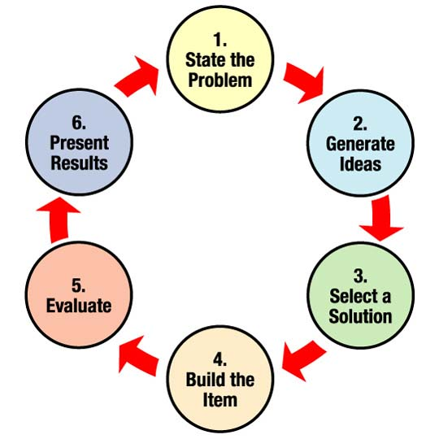
4.
3.
1.
2.
5.
6.

- Build the item
- Present results
- Evaluate & analyze/improve
- Generate ideas
- Select a solution
- State the problem

- Describe momentum.

- Describe the relationship between mass and momentum.

- Explain the importance of using the steps of the engineering design process to solve real-world problems related to momentum and collisions.

