Angular Velocity Experiment Worksheet
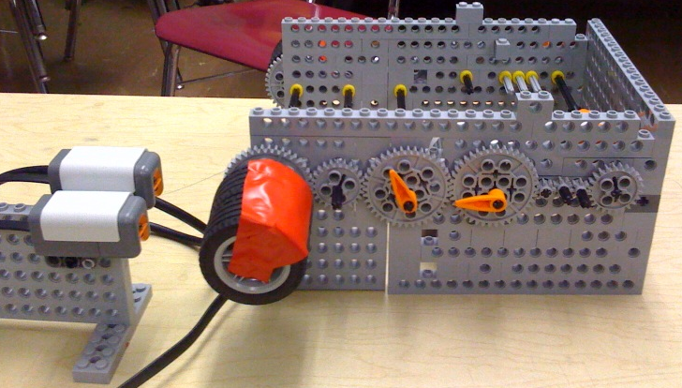

Figure 1. Example data logging experimental setup.

Vocabulary/Definitions
Word | Definition
data logging | Using a computer to collect and record data over an extended period of time through the use of a sensor.
length | The measure of how long something is from one end to another.
period | The length of time to complete one cycle.
gear | A rotating machine with cut teeth.
gear train | A set of gears that is able to transfer rotational motion.
circumference | The distance around a circle.
degree | The unit of measure for a given angle.
radian | The unit of measure for a given angle equal to 57.296 degrees. The measure of a circle is equal to 2π radians = 360°.
velocity | The distance traveled per unit time.
angular velocity | The change in rotation traveled per unit time.
optimal | Best suited for the situation. The best choice, arrangement, result or decision obtainable that meets specific requirements.

Hypothesis

Materials
- LEGO MINDSTORMS Education NXT base set
- 2 LEGO MINDSTORMS NXT intelligent bricks
- calculator
- ruler
- 2 pieces electrical tape (not black)
To share with the entire class:
- computer with LEGO MINDSTORMS Education NXT Software 2.1
(programming and data logging)

Procedure

Explain and/or sketch your data logging experimental setup.
List the steps you followed to construct the device.

Data

Calculate the angular velocity with the three physics-based equations:
circumference = 2*π *(radius) (Equation 1)
degrees = radians * (180/π) (Equation 2)
angular velocity = degrees/ (time for one period) (Equation 3)
Gear Length | Circumference  (radians) | Rotations  (degrees) | Period  (seconds) | Angular Velocity  (degrees/second)
big:big
medium:medium
small:small
big:medium
big:small
small:medium

Now, let’s look at length and gear ratio:
Gear Length | Circumference  (radians) | Rotations  (degrees) | Period  (seconds) | Angular Velocity  (Degrees/ seconds)
4 big
4 medium
4 small
1 big:3 medium
3 big:1 medium
3 big:1 small
1 big:3 small
3 small:1 medium
1 small:3 medium

Results

What does your data tell you about gears and angular velocity?

Conclusions

Do your experimental results agree with your hypothesis? Why or why not?

Optimal Solution

What gear train is optimal for a high angular velocity?

