Activity Data Sheet
First setup:
Wheel diameter = _____________ cm; wheel radius = ___________ cm
Data for linear velocity assessment:
Estimation for 200 cm run: __________ seconds
Trials | Times [s]
 | 50 [cm] | 100 [cm] | 150 [cm] | 200 [cm]
1
2
3
4
5

Linear Velocity Graph 1:
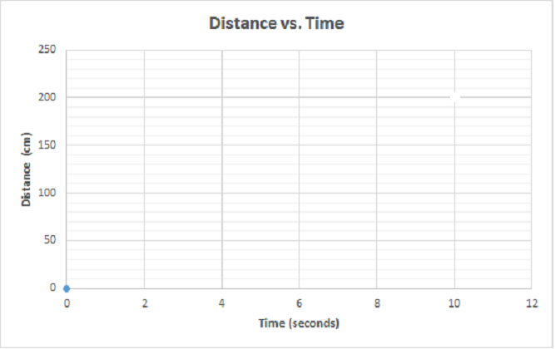

Estimated line of best fit equation: _________________________________________
Average Linear Velocity: __________________

Angular Velocity Graph 1:

Line of best fit equation: ______________________________
Average angular velocity for the class: ___________________________
Your robot’s angular velocity: _____________________________

After making appropriate robot modifications to optimize speed performance:
Wheel diameter = ____________ cm Wheel radius = ____________ cm
Describe any other changes made to your robot:

Data for linear velocity assessment:
Trials | Times [s]
 | 50 [cm] | 100 [cm] | 150 [cm] | 200 [cm]
1
2
3
4
5

Linear Velocity Graph 2:

Questions:
- Which changes affected the robot most positively towards the goal of optimization of its speed? Please justify your answer as to why the data set for the modified robot was faster or slower with reference to what may have changed with the robot.

- What did you notice about the relationship between linear velocity and angular velocity? Are they proportionally related—does angular velocity increase proportionally as with linear velocity?

- Did you find any drawbacks to using the performance-increasing adjustment? Please justify your answer through the expansion and use of the acquired data.

