Deflection Measurement Device Set Up Instructions:
Using an Ultrasonic Sensor along with the EV3 brick

- This is done simply by attaching an ultrasonic sensor onto the EV3 brick so that it points up. There is no additional programming needed. An example of one setup is shown here.

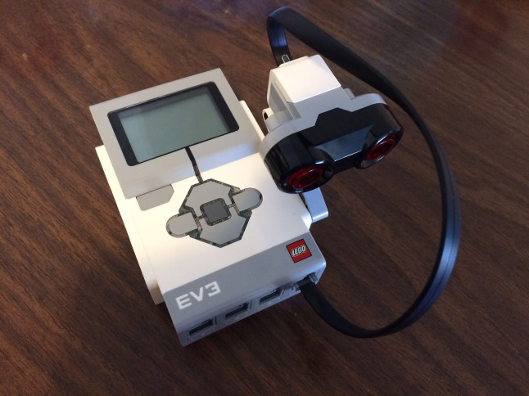
Figure 1: Alternate EV3 sensor setup, with brick and attached ultrasonic sensor.
- In order to view real-time measurements using the sensor and EV3, turn the EV3 on using the center button. At the starting menu, use the left and right buttons to scroll to the “Port View” menu, as shown in Figure 2. Press the center button to select the “Port View” submenu. Then use the left and right buttons to pick the port and sensor/motor you want.

Figure 2: “Port View”, taken from ev3lessons.com.
- In this submenu, scroll to “Ultrasonic cm” in order to view measurements using the ultrasonic sensor in centimeters. There is also an option named “Ultrasonic in”, which allows the user to view measurements in inches. However, smaller units have better measurement resolution, so for the purposes of this activity, use centimeters. Next, select the port that the sensor is connected to. If it is not connected already, connect the ultrasonic sensor to one of the bottom sensor ports by using the black wires included in the kit. Make sure that the selected port corresponds to the port that the sensor is physically connected to.
- Once this is done, the user should be able to read values measured by the EV3. Objects, preferably flat objects, can now be detected by the sensor, and the distance from the object to the sensor can be read out by the EV3. Make sure that the object is positioned directly above the sensor for a proper measurement.

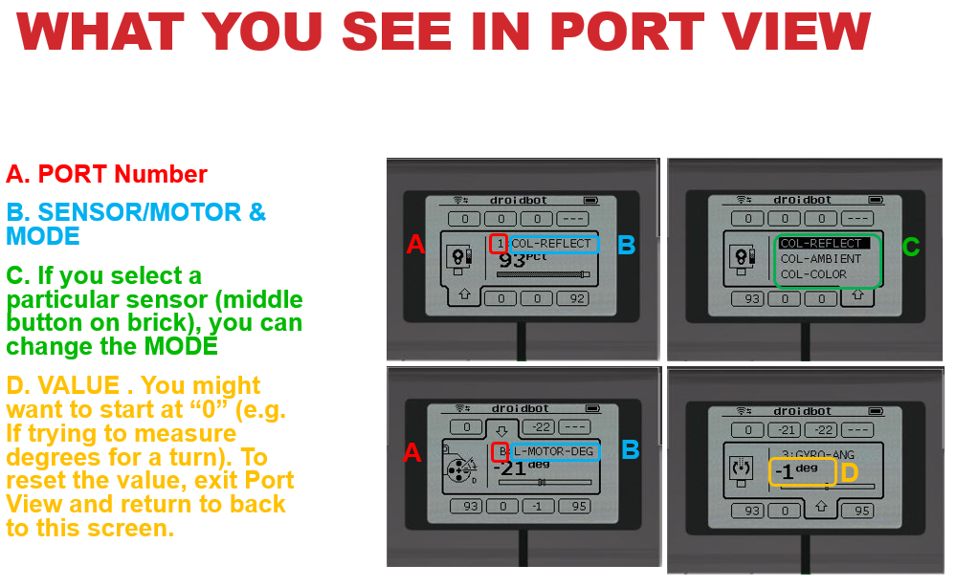
Figure 3: “Port View” submenu, as taken from ev3lessons.com.

