Echolocation Activity Datasheet
Original Design—Data Gathering 1
Threshold | Reaction time for object at 100 cm | Reaction time for object at 200 cm
10 cm
25 cm
50 cm
75 cm
90 cm
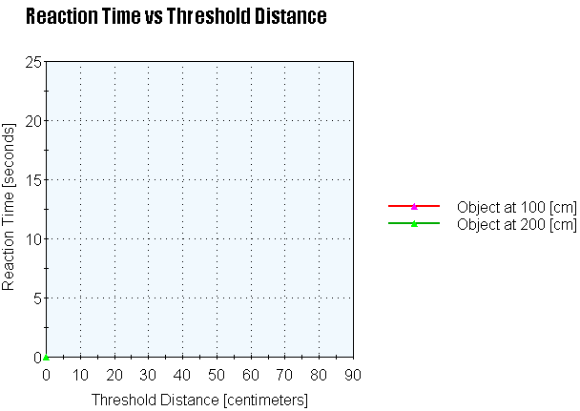
Where is your ultrasonic sensor attached on the robot? Circle one: front middle back

Analysis Notes
After your analysis of the gathered data from your team and other teams, what redesign adjustments will you make to optimize the robot’s ability to avoid the obstacle?
Redesign—Data Gathering 2
Threshold | Reaction time for object at 100 cm | Reaction time for object at 200 cm
10 cm
25 cm
50 cm
75 cm
90 cm
Where is your ultrasonic sensor attached on the robot? Circle one: front middle back

Evaluation Notes
Look at the new data gathered. What changed? What conclusions can you draw?

Evaluation Questions
- Do the redesign results show faster or slower response times than the original design response times?

- Please justify your answer as to why the response time was faster or slower with reference to what may have changed with the robot.

- You have two bats. Bat 1 has the response times listed in the original design data table and Bat 2 has the response times listed in the redesign data table. Assuming the object is a predator, which bat has a higher chance of survival and why?

