Echolocation Activity Datasheet Example Answers
Original Design—Data Gathering 1
Threshold | Reaction time for object at 100 cm | Reaction time for object at 200 cm
10 cm | 7.1 secs | 15.2 secs
25 cm | 5.6 secs | 13.6 secs
50 cm | 3.8 secs | 11.9 secs
75 cm | 2.6 secs | 11.0 secs
90 cm | 1.5 secs | 9.6 secs
Where is your ultrasonic sensor attached on the robot? Circle one: rear middle front
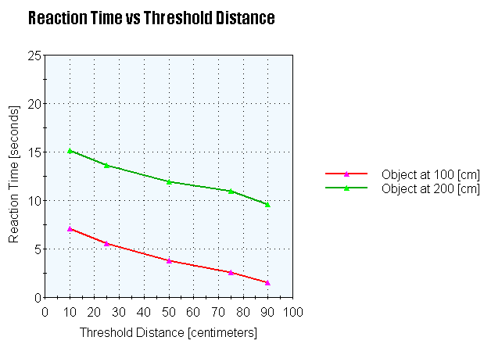

Analysis Notes
After your analysis of the gathered data from your team and other teams, what redesign adjustments will you make to optimize the robot’s ability to avoid the obstacle?
Redesign—Data Gathering 2
Threshold | Reaction time for object at 100 cm | Reaction time for object at 200 cm
10 cm | 6.5 secs | 14.6 secs
25 cm | 5.1 secs | 13.2 secs
50 cm | 3.2 secs | 11.3 secs
75 cm | 1.9 secs | 10.7 secs
90 cm | 0.9 secs | 9.1 secs
Where is your ultrasonic sensor attached on the robot? Circle one: rear middle front
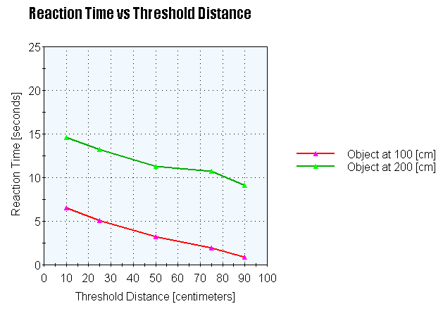

Evaluation Notes
Look at the new data gathered. What changed? What conclusions can you draw?

Evaluation Questions
- Do the redesign results show faster or slower response times than the original design response times?
Example answer: The redesign results show faster response times than the original design response times. The amount is small, but still noticeable.

- Please justify your answer as to why the response time was faster or slower with reference to what may have changed with the robot.
Example answer: I believe the response time was faster in the redesign because the ultrasonic sensor was closer to the object, thus allowing it to detect the obstacle sooner than the original design.

- You have two bats. Bat 1 has the response times listed in the original design data table and Bat 2 has the response times listed in the redesign data table. Assuming the object is a predator, which bat has a higher chance of survival and why?
Example answer: Bat 2 would have a greater chance of survival because it would be able to react to a predator more quickly than Bat 1.

